Contemplation and Conversation: 2nd Sunday of Epiphany, January 14, 2024
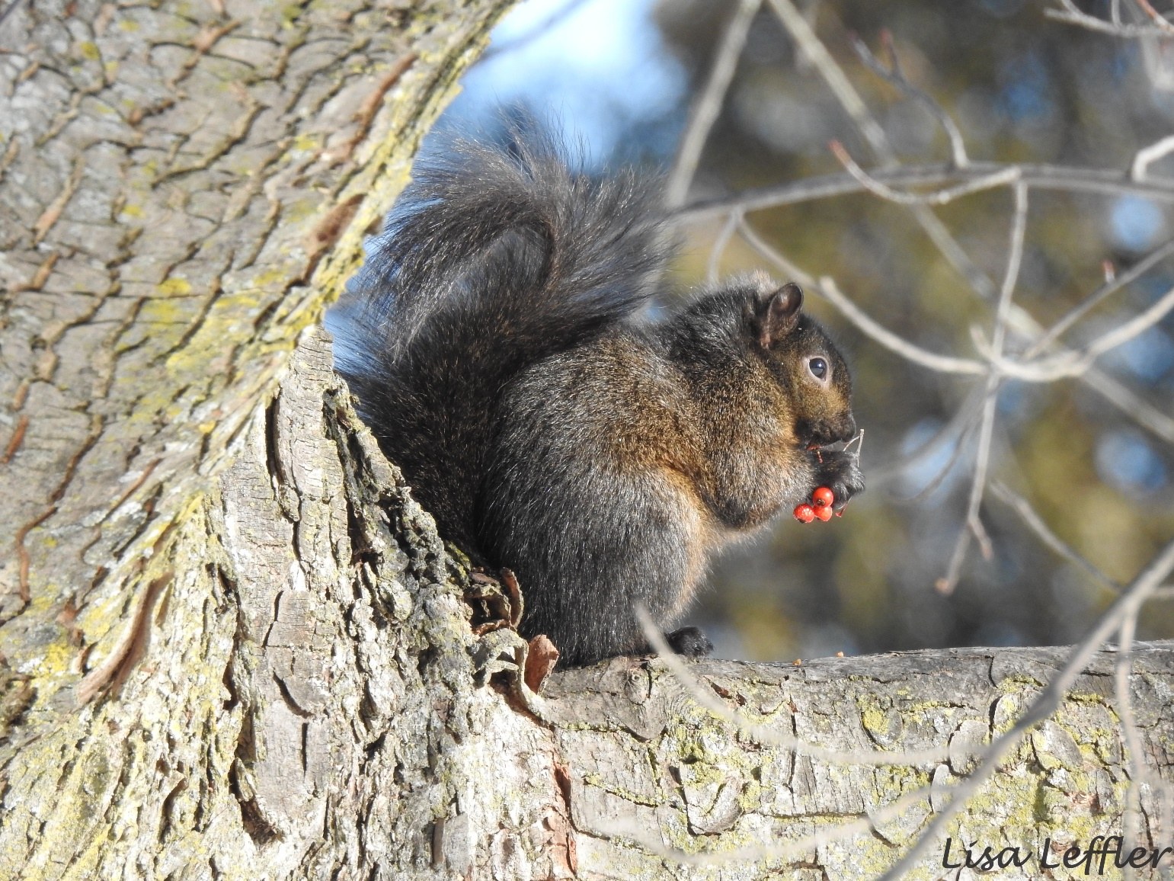
Scripture: Psalm 139:1-6, 13-18 NRSVUE
https://www.biblegateway.com/passage/?search=Psalm+139%3A1-6%2C+13-18&version=NRSVUE
From Lisa Leffler:
What a wondrous thing to be seen and known by God!
Growing up I spent a lot of time hiding pieces of myself, worrying about the right way to things, and often feeling like I wasn’t good enough. Trusting that God made me just as I am, is an invitation to look for the good in all parts of me.
Knowing I am made by God also invites me to come together with other people in the loving embrace of a church family. Being a part of a church has allowed me to find my voice and be more confident in the person God made me to be.
Knowing that we are all fearfully and wonderfully made by God is an invitation to share in the unique gifts and skills of each person that we meet as we learn and grow together.
Contemplation and Conversation
What does being seen by God mean for your life?
Prayer
Creator God, we are so grateful to be a part of your wondrous creation.
Help us to see your gifts in each person we meet
so we can share together in your love. Amen

Further Conversation … Would you like to talk more about today’s reflection? Email Heather at hleffler@rogers.com.

Our Rockwood Stone Family
If you missed today’s worship service, you can watch it here: https://youtu.be/WwYDwm3BOJs
Thanks to everyone who bought tickets for the Outreach Robbie Burns dinner next week. See the attachment for the excellent program we are looking forward to.
From Rev. Heather Leffler…
Please note someone is using my name in emails. This is happening to many ministers and church members right now. I would never ask you for gift cards by email. If you aren't sure, please don't open or respond to an email you are uncertain about. Send me an email at hleffler@rogers.com if you are in doubt.
United Church of Canada
A prayer for peace in the Middle East
Steadfast God,
As we witness to the horrors and heartbreak in Israel and Palestine, we seek your comfort and strength, your shelter and hope, your peace and your blessings.
Bless all those who continually attempt to live your teachings of compassion and reconciliation
through humanitarian aid and advocacy for those most affected by the atrocities of war.
These actions are green leaves on a weakening tree, clear signs of hope, even as fear, death, and grief overwhelm.
Bless all those who mourn, whose heartbreak and sorrow are too deep for words. In their despair may your unshakeable roots protect and hold them in love. And provide us all with the strength to yearn “more than those who watch for morning” for a time when peace prevails globally and in the Middle East.
Bless all who prayerfully seek a peace that leads toward abundant life for all people. Help those of us more removed from the direct conflict to care for and support those of us who are most affected in the Middle East and in our local communities. May we honestly wrestle with our complex emotions, biases, and limited information so that we can work with others toward peace-building that is guided by justice, compassion, and mercy. Together, may we anticipate a time when Israel and Palestine will be a symbol of justice, peace, and liberation for all.
Like an olive tree planted by water,
sending out its roots by the stream,
may our commitment toward a just peace in Israel and Palestine never falter,
may our hope not be uprooted,
may our actions bear good fruit,
may our love be steadfast.
Until freedom and justice for all comes,
may it be so.
Amen.
A gift of belonging to a church is that the practice of gathering together for worship … to pray, sing, listen to scripture and share how God touches our lives – helps us grow in deeper relationship with God and each other. We are offering this practice of sharing beyond Sunday morning to deepen our connection. Each week you are offered a picture, a scripture and a question for contemplation, as well as a short reflection for you to contemplate, have conversation with people in your life and/or join an online conversation on our Rockwood Stone Facebook page.

