Contemplation and Conversation: 3rd Sunday after Epiphany, January 21, 2024
Scripture: – Psalm 62:5-12 NRSVUE
https://www.biblegateway.com/passage/?search=Psalm+62%3A5-12&version=NRSVUE
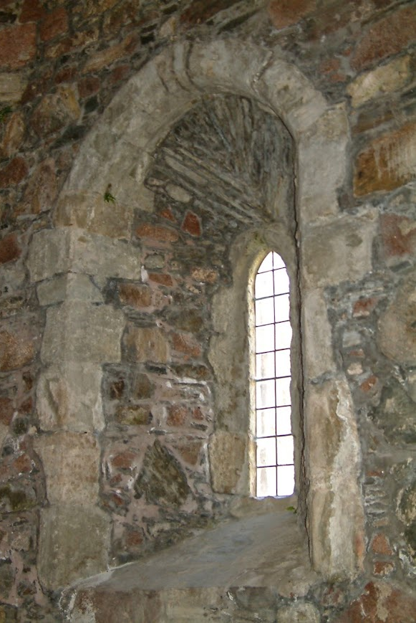
From Rev. Heather Leffler:
It has taken me a long time to learn to wait in silence for God. My family was always busy at church … teaching Sunday School, serving on committees and the Board, planning worship and activities and more. I attended and led studies. I even led a guided meditation when our minister was on a witness for peace pilgrimage in Nicaragua. I could pray in worship, but I didn’t spend time in silent prayer.
That particular minister introduced us to guided prayer and the practice of meditation. He taught us to choose a mantra and repeat it over and over again. Maranatha which means come, Lord Jesus was the mantra he recommended. Still I could not find God in the silence.
It was when I began to help plan Weeks of Guided prayer and came across Psalm 46:10a Be still, and know that I am God, that I began to appreciate the practice of meditation. My friend Bruce taught me to keep a piece of paper beside me when I was meditating to write down things that interrupted my thoughts so I wouldn’t focus on them instead of my prayer.
I still spend far more time in active forms of prayer than in silence. Reading this passage from Psalm 62, took me back to those early experiences of meditation and reminded me how these wonderful images of God from scripture enrich my faith and life.
Contemplation and Conversation
What words of scripture help you connect with the Holy One?
Prayer
God, you are our rock and our refuge.
Help us to take time to be still and be with you
so we can recognize your presence in our lives. Amen.

Further Conversation … Would you like to talk more about today’s reflection? Email Heather at hleffler@rogers.com.

Our Rockwood Stone Family
If you missed today’s worship service, visit our Rockwood Stone YouTube page.

United Church of Canada A message from Moderator Carmen Lansdowne
https://www.youtube.com/watch?v=0NrPGE3tF6U
On December 19, 2023 Moderator Carmen Lansdowne shared how we can be most effective as individuals and The United Church in advocating for a Humanitarian Response to the crisis in the Middle East. She spoke about the importance of partnerships with other denominations and organizations “to show our government that we care for our global siblings and the diasporic communities living here in Canada. This struggle for a just peace will continue until there is freedom for all.
The more constituents write to their elected representatives, the bigger the impact. A letter from the Moderator or the General Secretary is only one letter. Why send one letter, when we can tell our government in 300,000 different ways how we feel about policy changes, their efforts on the climate crisis or, in this case, the conflict in Middle East?
Visit our Pray, Donate, and Advocate page to share your voice with the Government of Canada on this current crisis: https://bit.ly/ucc-mid-east .

Community Events
Jones Funeral Home is hosting a complimentary workshop on estate planning at the Acton Legion on Thursday, January 25th. There will be two sessions, 1:00-2:30pm and 6:30-8:00pm.
To register for one of these sessions, please call Jones Funeral Home at 905-877-3631.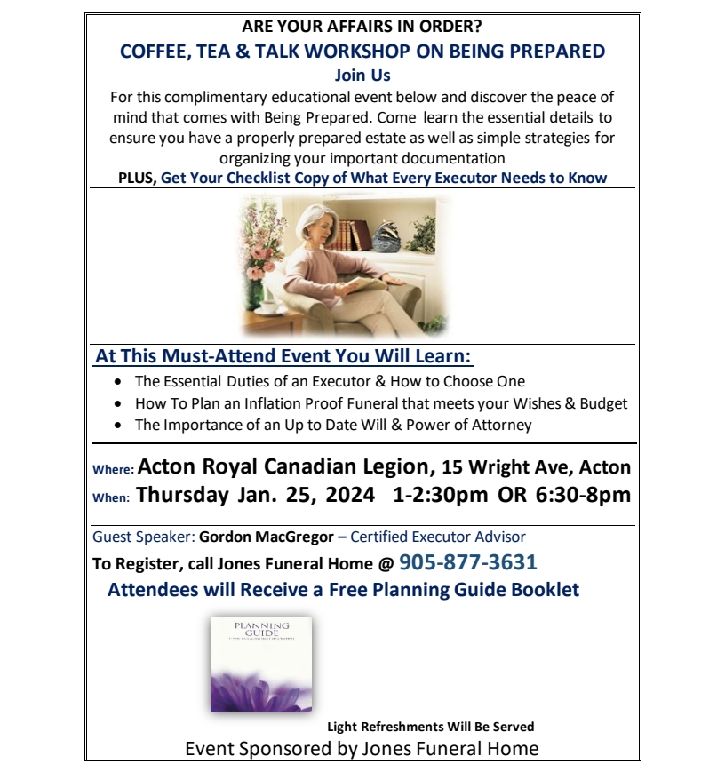A gift of belonging to a church is that the practice of gathering together for worship … to pray, sing, listen to scripture and share how God touches our lives – helps us grow in deeper relationship with God and each other. We are offering this practice of sharing beyond Sunday morning to deepen our connection. Each week you are offered a picture, a scripture and a question for contemplation, as well as a short reflection for you to contemplate, have conversation with people in your life and/or join an online conversation on our Rockwood Stone Facebook page.

