Contemplation and Conversation: 4th Sunday after Epiphany, January 24, 2024
Scripture: – Deuteronomy 18:15-20 NRSVUE
https://www.biblegateway.com/passage/?search=Deuteronomy+18%3A15-20&version=NRSVUE

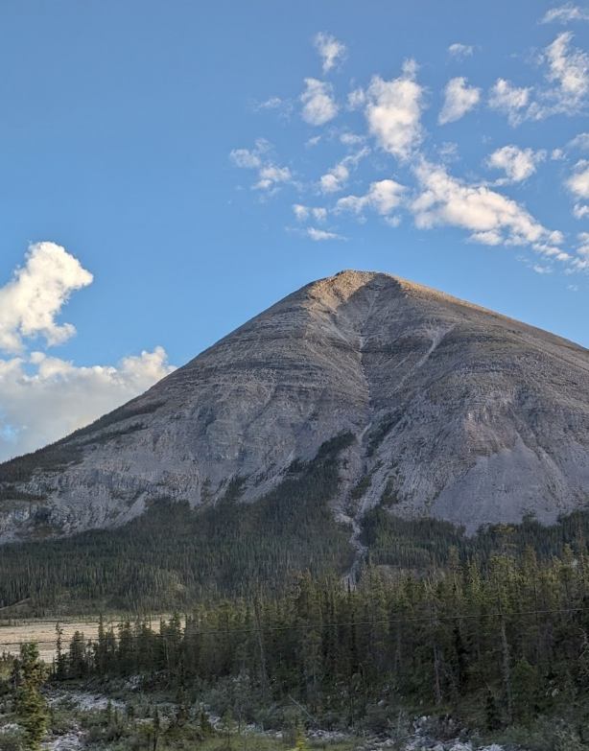
From Rev. Heather Leffler
In this passage from the Torah – the five books of Moses, Moses is preparing the people of Israel for his death and their journey into the promised land. He reminds them that when God spoke on Mount Horeb they were afraid and didn’t want to hear the voice of God or see the fire of God. On their journey through the wilderness God spoke to them through Moses.
Now it was time for a new prophet and Moses was aware of the challenges the people would face. There would be false prophets who came forward and there would be people who wouldn’t listen to the true prophets. Like the people of Israel, it is always a challenge for us to discern the voice of God.
Again and again we need to turn to Jesus and see how he lived out God’s reign in the world. His actions always brought healing and hope and restored people to community. When the community was divided it was because people weren’t willing to follow him and respond to the needs of people around them.
In a world that is seems more and more divided we are invited by Moses, the prophets and Jesus to discern God’s voice and respond in love to God, each other, ourselves and the world. May it be so.
Contemplation and Conversation
What helps you discern the voice of God in your life?
Prayer
Holy One, forgive us when it is easier to follow the crowd
than to listen to the one who calls us to make a difference in the world.
Show us where we can share your love with others. Amen.

Further Conversation … Would you like to talk more about today’s reflection? Email Heather at hleffler@rogers.com.

Our Rockwood Stone Family
If you missed today’s worship service, visit our Rockwood Stone YouTube page.
Annual Meetings
Join us for Stone’s Worship and Annual Meeting on Sunday, February 4 on Zoom at 9:45 am. If you aren't able to join us on Zoom from home, please contact Heather. Worship at Rockwood will be at 11:15 am.
Join us for Rockwood 's Worship, Annual Meeting and Lunch on Sunday, February 11 beginning at 11:15 am. Worship at Stone will be at 9:45 am.
Watch your email for the Annual Report.

United Church of Canada – Joint Statement Addresses Vulnerability of LGBTQI+ Refugees
The recent Global Refugee Forum advocates for more dedicated
pathways and programs for at-risk LGBTQI+ people
Published On: January 4, 2024
By the numbers, there are more than 110 million displaced people in the world; it’s a global refugee crisis of unprecedented scale. Of those, it is unknown how many identify as 2-Spirit, lesbian, gay, bisexual, transgender, queer, intersex or asexual (2SLGBTQIA+). Further, a lack of data means we also don’t know how many seek asylum because of persecution on the basis of their sexual orientation or gender identity (SOGI). We do know that:
- Sixty-five countries around the world criminalize same-sex intimacy.
- Nine countries have national laws that criminalize forms of gender expression that target transgender and gender nonconforming people.
- Twelve countries have legalized the death penalty as a punishment for same-sex intimacy.
At-risk 2SLGBTQIA+ individuals are uniquely vulnerable because of state-sponsored homophobia and transphobia, and often face systemic barriers to accessing safety within the existing global refugee and asylum system.
Statement by LGBTQI+ and Allied Civil Society Organizations
Held every four years, the Global Refugee Forum is the world’s largest international gathering on refugees, and recently met in Geneva. The Forum recognizes the current urgency of the global crisis of LGBTQIA+ forced displacement because of homophobia, transphobia, discrimination, violence, and persecution.
The United Church of Canada was one of more than 75 organizations that signed a statement drafted by allied organizations. The statement calls on countries without punitive impacts for people who are LGTBQIA+ (allied countries) to create more dedicated pathways and programs to help LGBTQI+ people who are at risk of persecution, through funding for essential services and accessible resettlement pathways.
“. . . At-risk LGBTQI+ people often face systemic barriers to accessing safety within the existing global refugee and asylum system,” the statement says. “For LGBTQI+ individuals, drivers of displacement such as conflict, climate disaster and political instability bring pre-existing persecutory conditions sharply into focus.”
Despite growing international recognition of the pressing needs of 2SLGBTQIA+ forcibly displaced people, their voices continue to be excluded and deprioritized within mainstream humanitarian spaces. Noting the resilience, solidarity, and strength of the global LGBTQIA+ movement and its allies, the statement notes that allied countries must do more to hold persecuting countries to account, to address forced displacement.
Building sustained relationships with 2SLGBTQIA+ civil society and leveraging the expertise of 2SLGBTQIA+-led organizations, particularly refugee-led organizations, is key to accessing and identifying at-risk 2SLGBTQIA+ forcibly displaced persons in need of durable solutions.

With Sympathy
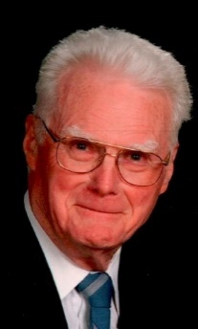
FOUNTAIN, George Edwin 'Ted' Passed away peacefully at the Wellington Terrace in Fergus on Wednesday, January 24, 2024. Ted Fountain, age 92 years, was the beloved husband of the late Mary L. (Barnaby) Fountain (2021). He was the loving father of Georgina Taylor of Elmira, (the late Ken), Barbara Crozier of Olds AB, (Christopher), Nancy of Guelph and the late infant David. Ted was the proud grandfather of Heather (Abner) Gingrich, Tiffany (Steven) Mander, Andrea Taylor (Anthony Rodgers), James (Kyla) Crozier and Sean Crozier (Jessica Templeman). Great-grandfather of Ethan, Lylah, Kendra, Solomon, Carmela, Hunter, Brynn and Rory.
Dear brother of Vera Grills (the late Richard), Alice Woodhouse (the late Bob), Grace Stewart (Harvey), Joyce Morrell (the late Blackie), Don (Jane), Linda Schneider (David), Peter (Janet), Doris Willard (Gerald), Donna Revell (late Steve), Ted will be fondly remembered by his sister-in-law Catherine Johnston.
Predeceased by his siblings infant William, Ken, Jim, Tom and Mary Snow.
Ted was born in Everton Ontario to Charles and Pelma Fountain. He made his home in Guelph. Ted worked at the Ontario Veterinary College for over 30 years. He had a great rapport with animals and birds. Ted spent hours in the garden and participating in the local Ham Radio club. Ted and Mary were both active members of St. Andrews Church.
Resting at the Gilbert MacIntyre & Son Funeral Home, Dublin Chapel, 252 Dublin St N., Guelph. A family graveside service will be held at Woodlawn Memorial Park, Guelph on Thursday, February 1, 2024. All are welcome to join the service via livestream at 11 a.m. by using the following link (https://fweb.tv/117025).
A Celebration of Life Service for Ted and Mary to be held at St. Andrew’s Presbyterian Church 161 Norfolk St., Guelph in June. Details to follow once date and time are confirmed.
As expressions of sympathy, donations to the Canadian Cancer Society or to a charity of one’s choice would be appreciated by the family. Donation cards are available at the funeral home or online at www.gilbertmacintyreandson.com.

A gift of belonging to a church is that the practice of gathering together for worship … to pray, sing, listen to scripture and share how God touches our lives – helps us grow in deeper relationship with God and each other. We are offering this practice of sharing beyond Sunday morning to deepen our connection. Each week you are offered a picture, a scripture and a question for contemplation, as well as a short reflection for you to contemplate, have conversation with people in your life and/or join an online conversation on our Rockwood Stone Facebook page.

