Contemplation and Conversation: 5th Sunday after Epiphany, February 4, 2024
Scripture: Isaiah 40:21-31 NRSVUE
https://www.biblegateway.com/passage/?search=Isaiah+40%3A21-31+&version=NRSVUE
From Rev. Heather Leffler:

In a world where we hear daily of war and violence, political unrest and people one upping each other, discrimination, poverty, homelessness and natural disasters, it is easy to become overwhelmed. Add the challenges of our own lives and we may find ourselves weary, overwhelmed and exhausted.
The gift of being followers of Jesus is that we have one another to share these burdens and we are encouraged to take them to God in prayer. Turning to scripture or singing our favourite hymns gives us hope and opens us up to new possibilities.
Reading these words and remembering the hymn …
I will raise you up on eagle’s wings, bear you on the breath of dawn,
make you to shine like the sun, and hold you in the palm of my hand. – Michael Joncas
When we are weary or life seems overwhelming, may the words of scriptures and hymns and conversations with church family assure us we are held in the palm of God’s hand.
Contemplation and Conversation
Where do you turn when you are weary or exhausted? What gives you energy and hope?
Prayer
Giver of Life,
At times when the world seems too complicated and overwhelming
help us to remember all life comes from you and we are surrounded by your love.

Further Conversation … Would you like to talk more about today’s reflection? Email Heather at hleffler@rogers.com.

Our Rockwood Stone Family
If you missed today’s worship service, you can watch it here: https://youtu.be/wt54ZASvLsk
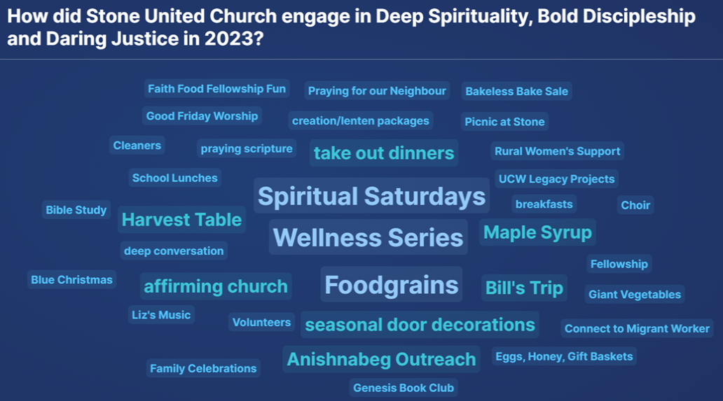
Thanks to everyone who participated in Stone’s Annual Meeting today.

United Church of Canada
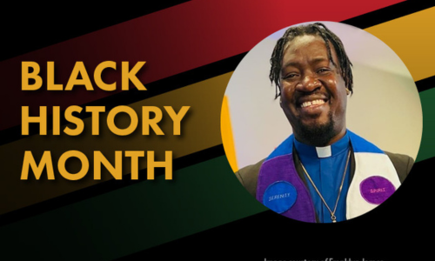
February is Black History (or African Heritage) Month. Officially recognized in Canada since 1996, this is a time to honour the contributions and struggles of people of African descent.
This week we are starting things off with the latest Black History Month blog from the Rev. Franklyn James. Stay tuned for more Black History Month blogs dropping each week in February!
And—in case you missed it—the 2024 Black History Month: Jesus in the Village worship service and video are now available! Find this worship and more under Black History Month Worship Resources.
[Image credit: The United Church of Canada/ Photo courtesy of Franklyn James]

A gift of belonging to a church is that the practice of gathering together for worship … to pray, sing, listen to scripture and share how God touches our lives – helps us grow in deeper relationship with God and each other. We are offering this practice of sharing beyond Sunday morning to deepen our connection. Each week you are offered a picture, a scripture and a question for contemplation, as well as a short reflection for you to contemplate, have conversation with people in your life and/or join an online conversation on our Rockwood Stone Facebook page.

