Contemplation and Conversation: Transfiguration Sunday February 11, 2024 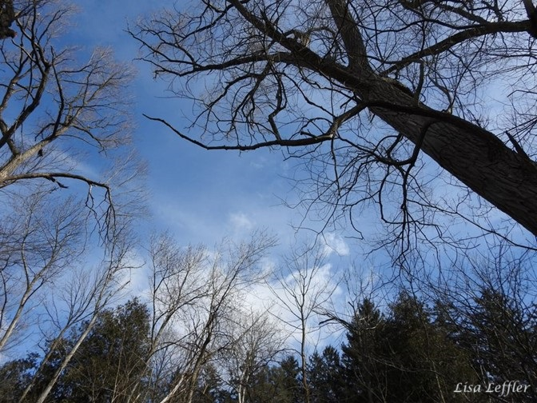
Scripture: – Mark 9:2-9 NRSVUE
² Six days later, Jesus took with him Peter and James and John and led them up a high mountain apart, by themselves. And he was transfigured before them, ³ and his clothes became dazzling bright, such as no one on earth could brighten them. ⁴ And there appeared to them Elijah with Moses, who were talking with Jesus. ⁵ Then Peter said to Jesus, “Rabbi, it is good for us to be here; let us set up three tents: one for you, one for Moses, and one for Elijah.” ⁶ He did not know what to say, for they were terrified. ⁷
Then a cloud overshadowed them, and from the cloud there came a voice, “This is my Son, the Beloved; listen to him!”
⁸ Suddenly when they looked around, they saw no one with them any more, but only Jesus.
⁹ As they were coming down the mountain, he ordered them to tell no one about what they had seen, until after the Son of Man had risen from the dead.
From Rev. Heather Leffler
Jesus went up the mountain to be affirmed he was on the path God had chosen for him and to be strengthened for the challenges ahead. God sent Moses the giver of the law and Elijah the greatest of the prophets to support him. Jesus took the disciples so he could share the experience with someone but also so when they were struggling to carry on his ministry, they would remember the wonder they felt at what they saw and heard and find strength.
In ministry, Jesus and the disciples faced challenges and experienced joys and deepening relationships. This is the incredible gift in being part of a community of faith. The experience the disciples shared of being with Jesus, learning from him, sharing meals with him, listening to him preach, singing together – these are the experiences we continue to share as communities of faith. The words of scripture invite us to discover God’s presence with us again and again so our lives can be changed, and we can be part of bringing about God’s kingdom.
Contemplation and Conversation
How do you experience God’s presence?
Prayer
Holy One, we give thanks the disciples were with Jesus on the day of the transfiguration
and shared their fear and wonder with us through the gospel.
Help us be strengthened by your Word in times of struggle
and to share the gift of being your fallowers with others so they can share our joy. Amen.

Further Conversation … Would you like to talk more about today’s reflection? Email Heather at hleffler@rogers.com.

Our Rockwood Stone Family
Thank you to the Worship and Faith Formation for leading worship at Stone and to Bill Allen for sharing about his Foodgrains trip to Malawi: https://youtu.be/MMljOQFSUOo
Thanks to Rev. Heather Leffler for leading Rockwood in worship: https://youtu.be/fPXLNvcINBk
Stone Spring Wellness Series…
Thank you to Liz Kent for sharing with us the important work that Victim Services does: https://youtu.be/cU_Db_I0IoY
If you are interested in volunteering visit: https://vswguelph.on.ca/volunteer/roles-responsibilities
If you would like to make a donation to support this important work go to: https://vswguelph.on.ca/donate
Coming up… Nifty Native Plants
Master Gardener Sean James teaches about garden aesthetics, eco-initiatives and creating a space that will benefit you and the environment on Saturday, March 10 at 10 am.
Sign up at https://eventbrite.ca/e/2024-wellness-series-2-nifty-native-plants-tickets-771210249617?aff=ebdssbdestsearch&keep_tld=1

United Church of Canada
In our Annual Meetings, Heather invited everyone to sign up for the WOWRC e-newsletter as well as United Church of Canada e-newsletters and on-line content. CHURCH x https://churchx.ca/ offers many United Church webinars that may be of interest to people for free, as well as online courses that you can purchase.
The Deep Spirituality, Bold Discipleship, Daring Justice video can be found on YouTube.

A gift of belonging to a church is that the practice of gathering together for worship … to pray, sing, listen to scripture and share how God touches our lives – helps us grow in deeper relationship with God and each other. We are offering this practice of sharing beyond Sunday morning to deepen our connection. Each week you are offered a picture, a scripture and a question for contemplation, as well as a short reflection for you to contemplate, have conversation with people in your life and/or join an online conversation on our Rockwood Stone Facebook page.

