Contemplation and Conversation: 2nd Sunday of Lent, February 25, 2024
Scripture: Psalm 22:23-31 NRSVUE
https://www.biblegateway.com/passage/?search=Psalm+22%3A23-31&version=NRSVUE
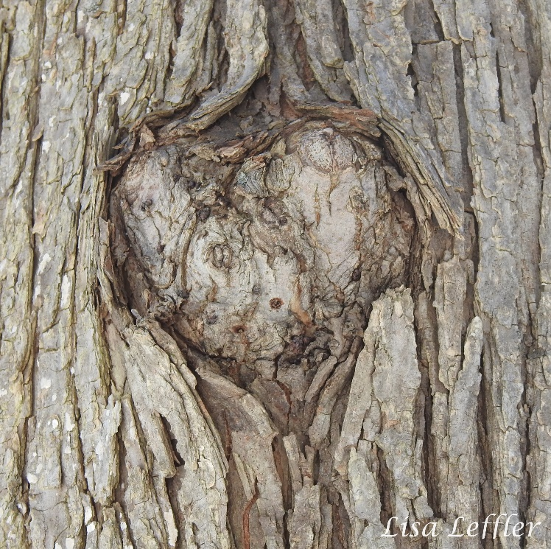
²³ You who fear the Lord, praise him!
All you offspring of Jacob, glorify him;
stand in awe of him, all you offspring of Israel!
²⁴ For he did not despise or abhor
the affliction of the afflicted;
he did not hide his face from me
but heard when I cried to him.
²⁵ From you comes my praise in the great congregation;
my vows I will pay before those who fear him.
²⁶ The poor shall eat and be satisfied;
those who seek him shall praise the Lord.
May your hearts live forever!
²⁷ All the ends of the earth shall remember
and turn to the Lord,
and all the families of the nations
shall worship before him.
²⁸ For dominion belongs to the Lord,
and he rules over the nations.
²⁹ To him, indeed, shall all who sleep in the earth bow down;
before him shall bow all who go down to the dust,
and I shall live for him.
³⁰ Posterity will serve him;
future generations will be told about the Lord
³¹ and proclaim his deliverance to a people yet unborn,
saying that he has done it.
From Rev. Heather Leffler
The world often marginalizes people who seem different or to be outside the norm – those who are hungry or thirsty, homeless or refugees, unemployed or underemployed, struggle with illness or addiction, left out of social situations because of neurodiversity, skin colour, language, religion, gender or sexuality.
The Psalmist paints a picture for us of God’s kingdom and limitless love. The Holy One is present for all people. Jesus came particularly for those who were on the margins. God reaches out to those who are afflicted in any way. The promise is that God’s deep and abiding love is for all people.
This can be challenging for us. Deep down we often struggle with certain people being included in God’s love. It is hard to see someone who has hurt us or a person we love receive mercy and forgiveness. It is not easy to want the well being of leaders who attack their own citizens or are willing to wage war on their neighbours. Yet a world that would leave anyone out cannot be God’s kingdom.
The Giver of Life created a world where all creatures and creation are interdependent. For God’s kingdom to come on earth as it is in heaven, we need to be open to those we might be tempted to exclude and celebrate the diversity God created.
Contemplation and Conversation
When have you felt excluded? When have you struggled to include another?
Prayer
Holy One, instead of seeing people as different and pushing them to the margins,
help us to open our hearts to others and discover the gifts of our diversity. Amen.

Further Conversation … Would you like to talk more about today’s reflection? Email Heather at hleffler@rogers.com.

Our Rockwood Stone Family
If you missed today’s worship service, you can watch it here: https://www.youtube.com/watch?v=7O1IGsDD52M
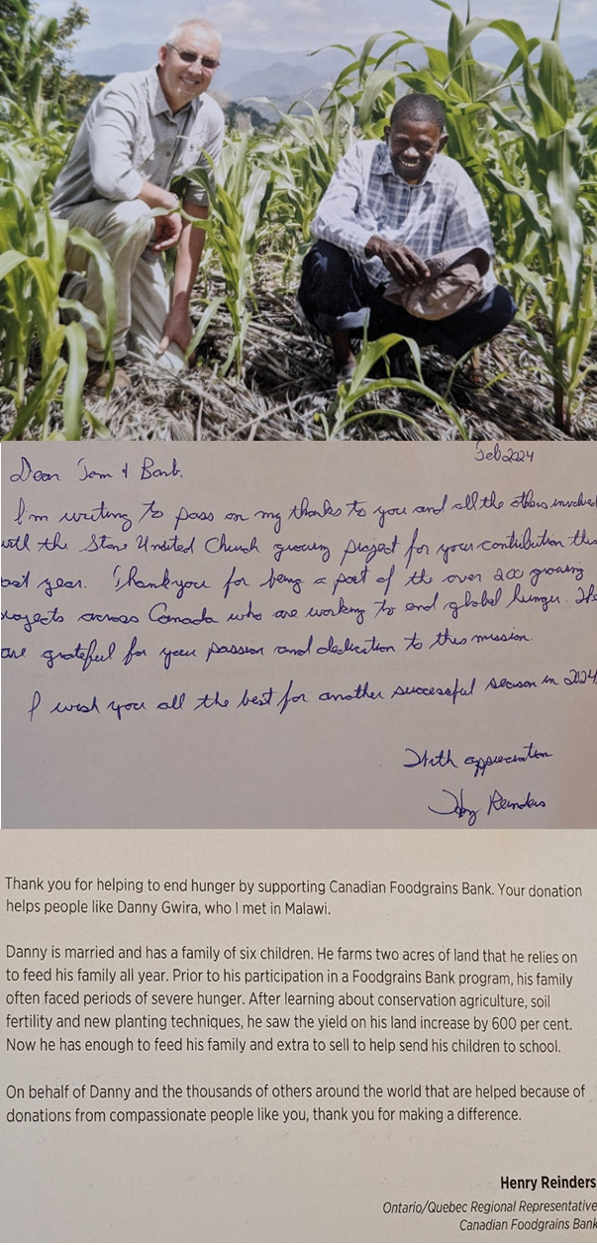

United Church of Canada
An invitation to prayer and hope for peace in Ukraine by supporting refugees, diplomacy, and reconciliation
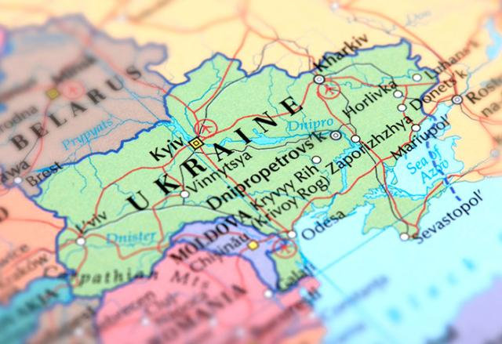
Credit: omersukrugoksu/iStock.com
Published On: February 13, 2024
Russia’s invasion of Ukraine on February 24, 2022, sparked a humanitarian crisis and has left more than 30,000 Ukrainian civilians dead in the two years since. As of January 2024, more than 3.6 million people are displaced within the country and about 6.3 million others have sought refuge abroad.
As the second anniversary approaches, leaders from The Canadian Council of Churches, the Evangelical Fellowship of Canada, and the Peace and Reconciliation Network of the World Evangelical Alliance issued a pastoral letter(opens in a new tab) urging Christians to continue to donate and advocate for pea#downloadsce in Ukraine.
Among the writers of this ecumenical letter are Ukrainian Orthodox, Ukrainian Catholic, Ukrainian Evangelical, and Ukrainian Pentecostal church leaders; organizations and people in Ukraine and in Canada were consulted widely. The letter also references the recent statement(opens in a new tab) from Ukrainian churches made on January 12, 2024.
What can we do? The letter offers six concrete actions to support peace in Ukraine:
- Pray.
- Support Ukrainian refugees.
- Urge diplomatic steps towards a just and sustainable peace in Ukraine.
- Seek cooperative relationships of humanitarian support.
- Remember February 24.
- Hope for reconciliation.
United Church Mission and Service partners continue to respond through ACT Alliance to the protracted crisis through supporting
- immediate life-saving, multi-sectoral emergency support provided to people affected by the conflict (refugees and internally displaced)
- safe access to basic services and supports restored for people affected by conflict
- resilience of host communities and local organizations strengthened, and social cohesion built with internally displaced persons and crisis-affected population in Ukraine, and refugees in Hungary, Moldova, Poland, Romania, and Slovakia
Your support is still needed.

A gift of belonging to a church is that the practice of gathering together for worship … to pray, sing, listen to scripture and share how God touches our lives – helps us grow in deeper relationship with God and each other. We are offering this practice of sharing beyond Sunday morning to deepen our connection. Each week you are offered a picture, a scripture and a question for contemplation, as well as a short reflection for you to contemplate, have conversation with people in your life and/or join an online conversation on our Rockwood Stone Facebook page.

