Contemplation and Conversation: 3rd Sunday of Lent, March 3, 2024
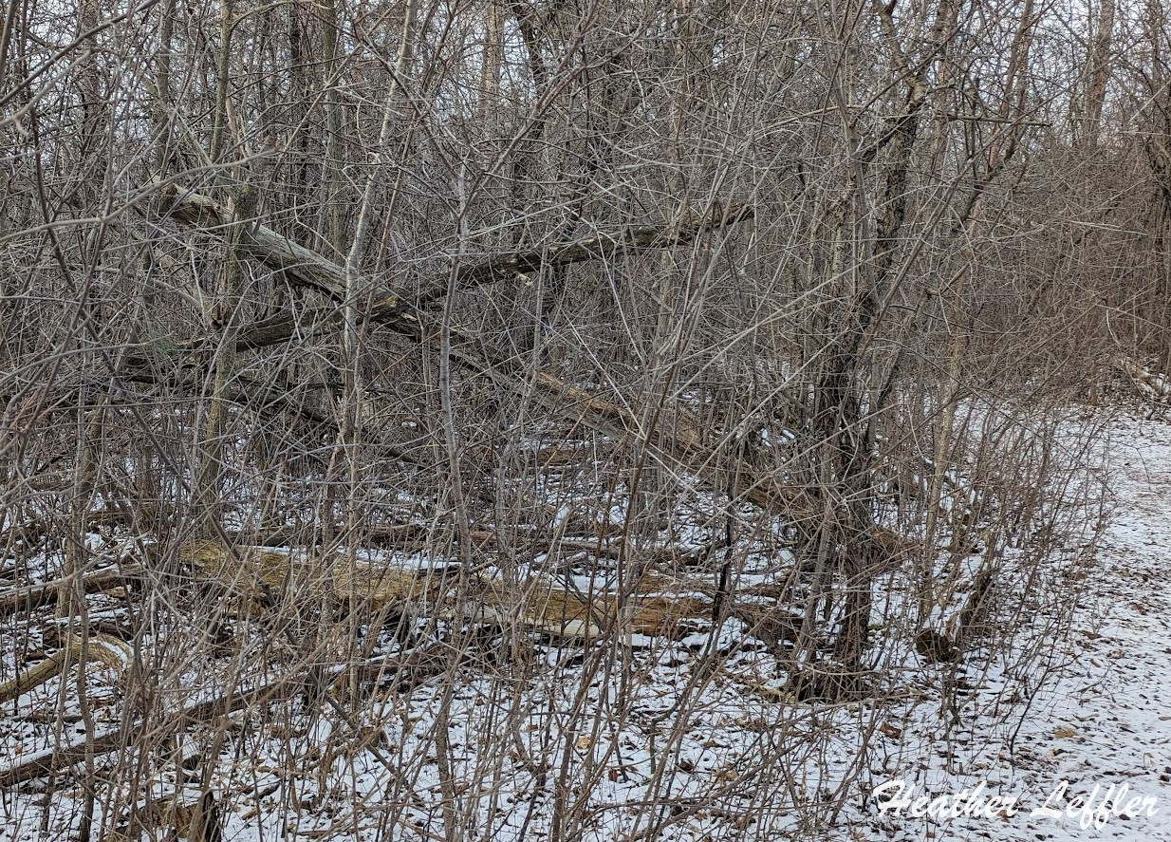
Scripture: 1 Corinthians 1:18-25 NRSVUE
https://www.biblegateway.com/passage/?search=1+Corinthians+1%3A18-25+&version=NRSVUE
¹⁸ For the message about the cross is foolishness to those who are perishing, but to us who are being saved it is the power of God. ¹⁹ For it is written,
“I will destroy the wisdom of the wise,
and the discernment of the discerning I will thwart.”
²⁰ Where is the one who is wise? Where is the scholar? Where is the debater of this age? Has not God made foolish the wisdom of the world? ²¹ For since, in the wisdom of God, the world did not know God through wisdom, God decided, through the foolishness of the proclamation, to save those who believe. ²² For Jews ask for signs and Greeks desire wisdom, ²³ but we proclaim Christ crucified, a stumbling block to Jews and foolishness to gentiles, ²⁴ but to those who are the called, both Jews and Greeks, Christ the power of God and the wisdom of God. ²⁵ For God’s foolishness is wiser than human wisdom, and God’s weakness is stronger than human strength.
From Rev. Heather Leffler:
The wisdom of the world tends to be, “Take care of yourself, your family, your group.” “Watch out for strangers.” “Protect what belong to you.” “Put yourself first.” The message of the cross – sacrificing yourself for others seems to be foolishness in a world where the rich and powerful and even criminals often prosper.
God’s way – the way of the cross, seeks the good of all. When we reach out to strangers, care for those in needs, make sure the solutions that are best for us don’t do harm to someone else, we might be seen as foolish. Definitely we are fools for Christ. Instead of storing up grain for our future, sharing what we have so everyone can eat ensures that others will share their abundance. One person might share food, another knowledge, another money, another labour, another music or laughter – if everyone shares, we create community where each is valued for their gifts, no one lives in fear, and everyone has enough.
Contemplation and Conversation
Where are you being invited to reach out to someone?
Prayer
Loving Christ, help us to follow your example.
Show us how to make space for others in our lives
so we can discover one another’s gifts and build your kingdom together. Amen.

Further Conversation … Would you like to talk more about today’s reflection? Email Heather at hleffler@rogers.com.

Our Rockwood Stone Family
If you missed today’s worship service, you can watch it here: https://youtu.be/s5um22OYirA
If you missed Stone’s Wellness Event yesterday check out Nifty Native Plants with Sean James*: https://youtu.be/K-w9FkgqIgQ
*video available until March 16
Our thoughts and prayers are with Sherol, Jamie, Alex and Noah Steinberg on the death of Roy. Roy faithfully served as our Treasurer since 2014.

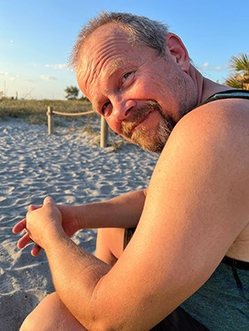
The family of Roy Frederick Steinberg, age 63 of Rockwood are saddened to announce he peacefully passed away with his wife by his side February 26, 2024 after a courageous battle with a rare form of cancer.
Roy was born on August 20, 1960 to John and Gisela Steinberg in Kitchener. After Roy graduated with honours from high school, he went on to excel at University of Waterloo where he graduated with a Degree in Electrical Engineering. He specialized in the telecommunications field and after retiring embraced his love for cars working at Legendary Motorcars and as a driver for car dealerships. He was generous with his time and talents throughout his life volunteering with Stanley Stick Hockey Association as a Coach, Board Member, Board President, Ref and as Sunday School teacher and church treasurer.
In 1986 Roy declared love at first sight when he met Sherol at The University of Waterloo. Roy and Sherol married and went on to have 3 boys Jamie, Alex and Noah.
Roy was predeceased by Gisela (mother), John (father), Raimund (step-father) and Edward (father in law). He is survived by Sherol (wife) and their children Jamie, Alex (Hamida), Noah (Kali), Connie (sister) and Dave Shibitani, Nancy Broege (sister) and Michelle Broege (sister), John (brother-in-law) and Dawn Schamerhorn, Peter (brother-in-law) and Caroline Schamerhorn and Marilyn Schamerhorn (mother-in-law) and nieces and nephews. He is also survived by the other wheeled loves of his life with wheels.
Roy believed life was about the journey. He travelled many highways and byways driving the winding roads, blasting his favourite tunes on his journey through life. It was a privilege to have been on this journey with him. His journey is over but will not be forgotten. Godspeed.
We would like to thank the doctors, nurses and staff at Groves Memorial for their caring support throughout his final hospitalization, and to the kind stranger who gave up his place in line for Emergency Triage so Roy could be seen earlier. A thank you to all doctors, nurses and hospital staff at Credit Valley Hospital who supported Roy throughout his journey, with special thanks to the Oncology Unit and Dr. Manji, Dr. Lui and their nurses Dariya and Lori for their exceptional compassion and efforts on behalf of Roy. We do not have words to express the depths of our gratitude.
A Celebration of Life will be held on Saturday, March 16, 2024 at Rockmosa Community Centre, 110 Rockmosa Drive, Rockwood, Ontario, with a drop-in visitation from 1:00-4:30pm. A time of remembrance and remarks will be at 3:00pm. Refreshments will be served throughout.
Arrangements entrusted to WALL-CUSTANCE FUNERAL HOME & CHAPEL (519-822-0051 / www.wallcustance.com).
In lieu of flowers, the family requests donations can be made in his memory to Rockwood United Church by going to https://www.canadahelps.org/en/dn/48574 and designate your offering in the message box or in person by cash or cheque at the Celebration of Life.


United Church of Canada from The United Church of Canada Facebook Page
God, you have called us to be pilgrims.
Forgive us when we weary of the journey
and seek security
rather than the open road.
Forgive us when we feel
the risk of the journey is too great.
Grant us pilgrim spirits in this Lenten season
and lead us to the new life of Easter. Amen.
—from "Celebrate God's Presence" (5I002).
[Photo: Ale, Flickr (CC BY 2.0)]
#UCCan #Lent

A gift of belonging to a church is that the practice of gathering together for worship … to pray, sing, listen to scripture and share how God touches our lives – helps us grow in deeper relationship with God and each other. We are offering this practice of sharing beyond Sunday morning to deepen our connection. Each week you are offered a picture, a scripture and a question for contemplation, as well as a short reflection for you to contemplate, have conversation with people in your life and/or join an online conversation on our Rockwood Stone Facebook page.

