Contemplation and Conversation: 4th Sunday of Lent, March 10, 2024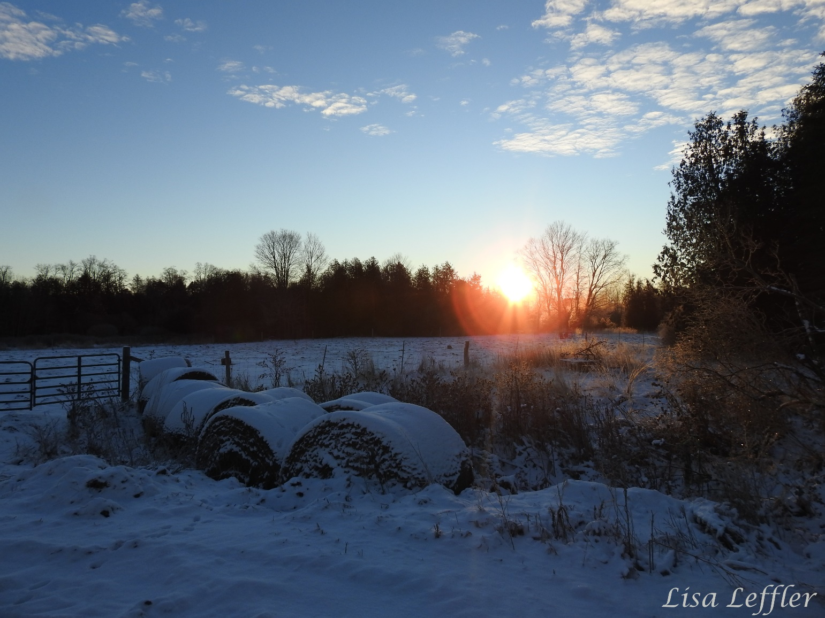
Scripture: Psalm 107:1-3, 17-22 NRSVUE https://www.biblegateway.com/passage/?search=Psalm+107%3A1-3%2C+17-22+&version=NRSVUE
¹ O give thanks to the Lord, for he is good,
for his steadfast love endures forever.
² Let the redeemed of the Lord say so,
those he redeemed from trouble
³ and gathered in from the lands,
from the east and from the west,
from the north and from the south.
¹⁷ Some were sick through their sinful ways
and because of their iniquities endured affliction;
¹⁸ they loathed any kind of food,
and they drew near to the gates of death.
¹⁹ Then they cried to the Lord in their trouble,
and he saved them from their distress;
²⁰ he sent out his word and healed them
and delivered them from destruction.
²¹ Let them thank the Lord for his steadfast love,
for his wonderful works to humankind.
²² And let them offer thanksgiving sacrifices
and tell of his deeds with songs of joy.
From Brian Mack:
Psalm 107 is rather long, but it is worth reading in its entirety. Within the framework of this hymn, the psalmist offers four vignettes. Although the details of the vignettes vary, they all follow the same pattern. Humankind encounters a time of insurmountable trouble. The people cry out to God in the form of a prayer for deliverance from their distress. God hears their prayer and in his loving kindness delivers them from their calamity in response, the people offer praise to the Holy One.
In 2024, calamity seems to be all around us. We are bombarded with images of war, self-destruction, hatred, personal conflict and emotional trauma. The times of difficulty outlined by the psalmist are the universal troubles of history. As a community of believers, we are not immune from these difficulties. Our faith is tested in a world that can seem to be “nasty, brutish, and short” (Thomas Hobbes, The Leviathan, 1651).
The opening lines of Psalm 107 should serve as a guide to our actions in these perilous times. We are to give God thanks. In so doing, we are reminded that we are in a relationship with God that is everlasting. We are strengthened at times when things get messy in our personal lives and in the wider world. God can help. God is good. Creator God enables us to look beyond the pain of the moment and see the beauty and majesty of the world he brought into being. Holy Mystery gives us hope to be alert for the things that he will do next. Thanks be to God.
Contemplation and Conversation
What words of praise would you offer to God today?
Prayer
Holy One, you are the source of our spiritual sustenance.
We give you thanks that whether we are experiencing great joy
or seem hopelessly hemmed in by troubles, you are there.
May you help us to remember to daily offer our praises to you. Amen.
Further Conversation … Would you like to talk more about today’s reflection? Email Heather at hleffler@rogers.com.

Our Rockwood Stone Family
If you missed today’s worship service, you can watch it here: https://youtu.be/Fq3M58thKd0

A Celebration of Life for Roy Steinberg will be held on Saturday, March 16 at Rockmosa Community Centre with a drop-in visitation from 1 to 4:30 pm. A time of remembrance and remarks will be at 3 pm. Refreshments will be served throughout. Arrangements entrusted to WALL-CUSTANCE FUNERAL HOME & CHAPEL (519-822-0051 / www.wallcustance.com).


United Church of Canada
Increasingly, 2SLGBTQIA+ rights and freedoms are under attack in Canada. Published: March 4, 2024
Beamsville, Ontario. Ponoka, Alberta. Summerland and Delta, BC. These are all the towns where United Churches were vandalized during Pride Month last year. The provincial governments of New Brunswick, Alberta, and Saskatchewan have all either considered or implemented so-called parents’ rights bills that restrict consent for trans and questioning youth.
Increasingly, 2SLGBTQIA+ rights and freedoms are under attack in Canada.
There has been an exponential rise in anti-2SLGBTQIA+ hate-fueled movements, hate crimes, and hate speech across Canada. Anti-trans policies and policy proposals are emerging provincially and federally. There is also an alarming wave of anti-2SLGBTQIA+ demonstrations, vandalism, and assaults on affirming clergy and faith communities.
March 14 is PIE Day.
The United Church of Canada joins Affirm United/S’affimer Ensemble and Affirming Connections in urging individuals and communities of faith across Canada to commit to concerted efforts to be Public, Intentional, and Explicit (PIE) in the public square.
Join the call to action to promote and protect the rights and freedoms of 2SLGBTQIA+ people, particularly the outward acts of transphobia. Your voice represents a commitment to fostering welcoming and affirming spaces for all members, regardless of sexual orientation, gender identity, or expression. We believe that all 2SLGBTQIA+ individuals are created in the Divine image and that advocacy for their human rights is not antithetical to faith, but a central tenet of our religious faiths.
Sign onto this open letter to support faith communities committed to upholding the full and comprehensive human rights of 2SLGBTQIA+ individuals.
Communities of faith are also called to show up in public places to support gender and sexual diversity, especially now when challenges to human rights in Canada are leading to vulnerability, silencing, and violence against 2SLGBTQIA+ people.
In her 2024 PIE Day message, The United Church of Canada Moderator, the Right Rev. Dr. Carmen Lansdowne, encourages faithful and intentional witness to this affirming work.
We are all called to be present—to broadly heed the challenge to actively work towards a vision of a more loving, boundless, expansive faith—a faith that breaks binaries and reminds us that we are all created in the diversity of God.

A gift of belonging to a church is that the practice of gathering together for worship … to pray, sing, listen to scripture and share how God touches our lives – helps us grow in deeper relationship with God and each other. We are offering this practice of sharing beyond Sunday morning to deepen our connection. Each week you are offered a picture, a scripture and a question for contemplation, as well as a short reflection for you to contemplate, have conversation with people in your life and/or join an online conversation on our Rockwood Stone Facebook page.

