Contemplation and Conversation: 5th Sunday of Lent, March 17, 2024
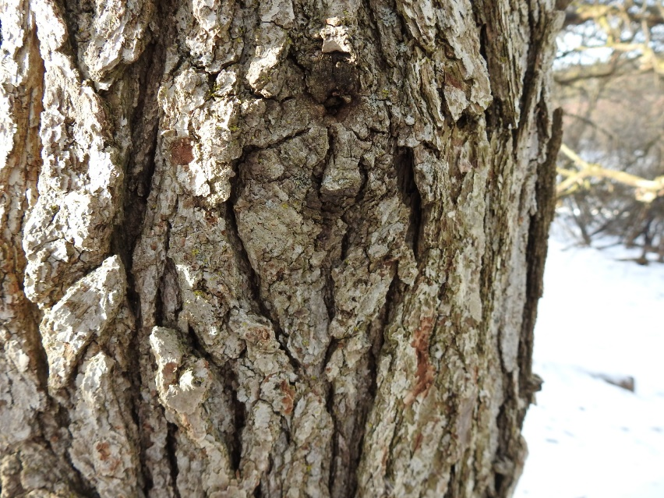
Scripture – Psalm 51:1-12 NRSVUE https://www.biblegateway.com/passage/?search=Psalm+51%3A1-12&version=NRSVUE
¹ Have mercy on me, O God,
according to your steadfast love;
according to your abundant mercy,
blot out my transgressions.
² Wash me thoroughly from my iniquity,
and cleanse me from my sin.
³ For I know my transgressions,
and my sin is ever before me.
⁴ Against you, you alone, have I sinned
and done what is evil in your sight,
so that you are justified in your sentence
and blameless when you pass judgment.
⁵ Indeed, I was born guilty,
a sinner when my mother conceived me.
⁶ You desire truth in the inward being;
therefore teach me wisdom in my secret heart.
⁷ Purge me with hyssop, and I shall be clean;
wash me, and I shall be whiter than snow.
⁸ Let me hear joy and gladness;
let the bones that you have crushed rejoice.
⁹ Hide your face from my sins,
and blot out all my iniquities.
¹⁰ Create in me a clean heart, O God,
and put a new and right spirit within me.
¹¹ Do not cast me away from your presence,
and do not take your holy spirit from me.
¹² Restore to me the joy of your salvation,
and sustain in me a willing spirit.
From Lisa Leffler:
What a wondrous love God offers to us. God recognizes we are imperfect and instead of getting angry and giving up on us God gives us space to learn and grow and loves us into the best version of ourselves.
Sometimes it can be hard to break free from negative patterns. When we do something wrong – something that hurts ourselves, each other or creation – it can seem easier to try to cover up the mistake hoping to avoid feelings of guilt or shame. Invariably that only makes the problem worse.
Being in relationship with God reminds us of the importance of naming our shortcomings so that we can let go of that weight and move forward with a clean heart. Knowing that God will love us through it all gives us the strength and courage to rebuild relationship and live lives of loving relationship.
Contemplation and Conversation
Where do you need to ask for or offer forgiveness?
Prayer
Create in me a clean heart, O God so I may share you love and forgiveness with the world. Amen

Further Conversation … Would you like to talk more about today’s reflection? Email Heather at hleffler@rogers.com.

Our Rockwood Stone Family
If you missed today’s worship service, you can watch it here https://youtu.be/pBOvlRTcW48 .

United Church of Canada
From Western Ontario Waterways
General Council is the decision-making body of the United Church as a whole. It brings together Commissioners (those elected to be members of this meeting of the General Council) to help set the course for the future of the United Church.
GC45 Commissioners will need to be available for education sessions online June 14, 2025 and June 22, 2025. The 45th General Council will meet from August 7 to12, 2025 in person in Calgary, Alberta.
Click here to fill out the General Council 45 Commissioner Nomination form
Western Ontario Waterways Regional Council voted to have a diverse slate of GC45 Commissioners that will be voted on as a whole at the Spring Meeting of the WOWRC, May 24-26, 2024. We will be asked to approve a slate of 12 Commissioners to accompany the President of Western Ontario Waterways Regional Council to General Council 45, for a total of 13 Commissioners.
As you consider General Council 45 Commissioner nominations, remember the importance of reflecting the diversity of our denomination. Also, consider the diversity we as a church want (or need) as we seek to live out God’s mission.
Ask yourself questions, like:
- Whose voices need to be heard in this decision-making body of our church?
- Who is missing from the table?
- Whose wisdom, insights and experience can best contribute to the conversations and actions at GC45?
Let these questions – and others that the Spirit brings – aid you in your decision-making.

March 21 is International Day for the Elimination of Racial Discrimination. Join us at 12:00 PM EST for webinar, Coffee with Adele Halliday – Building on Our History: Our Continued Work on Becoming an Anti-Racist Church. This half-hour webinar offers an opportunity to learn about the United Church's commitment to becoming an anti-racist denomination and what is being done within and beyond our church community as work towards racial justice.
Adele Halliday is the Anti-Racism and Equity Lead at the General Council Office of The United Church of Canada. An experienced anti-racism educator, workshop leader, and award-winning writer, Adele has been engaged in anti-oppression work with churches in Canada and beyond for many years. She is currently the co-moderator of the World Council of Churches’ Reference Group on Overcoming Racism and Xenophobia. She loves teaching, preaching, and leading people in creative processes of discovery, and she lives in Toronto.
Registration for this virtual event is free!

A gift of belonging to a church is that the practice of gathering together for worship … to pray, sing, listen to scripture and share how God touches our lives – helps us grow in deeper relationship with God and each other. We are offering this practice of sharing beyond Sunday morning to deepen our connection. Each week you are offered a picture, a scripture and a question for contemplation, as well as a short reflection for you to contemplate, have conversation with people in your life and/or join an online conversation on our Rockwood Stone Facebook page.

