Contemplation and Conversation: 2nd Sunday of Easter, April 7, 2024

Scripture – 1 John 1:1-2:2 NRSVUE https://www.biblegateway.com/passage/?search=1%20John%201%2C1%20John%202&version=NRSVUE
¹ We declare to you what was from the beginning, what we have heard, what we have seen with our eyes, what we have looked at and touched with our hands, concerning the word of life— ² this life was revealed, and we have seen it and testify to it and declare to you the eternal life that was with the Father and was revealed to us— ³ what we have seen and heard we also declare to you so that you also may have fellowship with us, and truly our fellowship is with the Father and with his Son Jesus Christ. ⁴ We are writing these things so that our joy may be complete.
⁵ This is the message we have heard from him and proclaim to you, that God is light and in him there is no darkness at all. ⁶ If we say that we have fellowship with him while we are walking in darkness, we lie and do not do what is true; ⁷ but if we walk in the light as he himself is in the light, we have fellowship with one another, and the blood of Jesus his Son cleanses us from all sin. ⁸ If we say that we have no sin, we deceive ourselves, and the truth is not in us. ⁹ If we confess our sins, he who is faithful and just will forgive us our sins and cleanse us from all unrighteousness. ¹⁰ If we say that we have not sinned, we make him a liar, and his word is not in us.
^{2:1} My little children, I am writing these things to you so that you may not sin. But if anyone does sin, we have an advocate with the Father, Jesus Christ the righteous, ² and he is the atoning sacrifice for our sins, and not for ours only but also for the sins of the whole world.
From Rev. Heather Leffler:
Like Paul in 1 Corinthians, John is reminding us that he is testifying to his firsthand experience. Unlike Paul who only met Jesus after his resurrection, John, with his brother James and friends, Peter and Andrew, was a disciple of Jesus from the beginning. He spent three years learning from Jesus and traveling with him through Galilee and Judea. He is writing so that we will come together in communion with God, Jesus and the Holy Spirit and know the joy he found in being a disciple.
Key for John is knowing God’s love and forgiveness. If we go through life believing we have it all together and have the only path to truth, we are deceiving ourselves and will set ourselves against others who follow a different path. We cannot know the fullness of Jesus’ love if we separate ourselves from others. It is in recognizing the ways we let God down and hurt others that we open ourselves to God’s healing and love. Jesus helps us to see that belonging to God means opening ourselves to all people and creatures.
Contemplation and Conversation
When has letting go of “being right” let you connect with someone in a new way?
Prayer
Creator God, we give you thanks for
your unconditional love and forgiveness.
Help us to recognize our own failings
and to seek a loving and just relationship
with everyone and all creation. Amen.

Further Conversation … Would you like to talk more about today’s reflection? Email Heather at hleffler@rogers.com.

Our Rockwood Stone Family
If you missed today’s worship service, you can watch it here: https://youtu.be/M_qAKaGo7IM
Stone Wellness Series 4: Exploring End of Life Options: https://youtu.be/ruOuQ4PS8oE
Thanks to Kendra Seymour for helping us gain a deeper understanding of Medical Assistance in Dying (MAiD).
For more information check out the resources mentioned:
Canadian Government: https://www.canada.ca/en/health-canada/services/health-services-benefits/medical-assistance-dying.html​
Ontario Government: https://www.ontario.ca/page/medical-assistance-dying-and-end-life-decisions-support-medical-professionals
​ Home and Community Care: https://healthcareathome.ca/home-care/palliative-care/maid/
Peer Support Group (virtual): https://www.wwhealthline.ca/displayService.aspx?id=197438
​ Bridge C14: https://www.bridgec14.org/
​ Private Counselling: www.thrivingfamiliescounselling.com

United Church of Canada
Moderator visits global partners and projects in Zambia and Kenya
Trip builds stronger partnerships through radical accompaniment, advocacy, solidarity, and people-to-people connections.
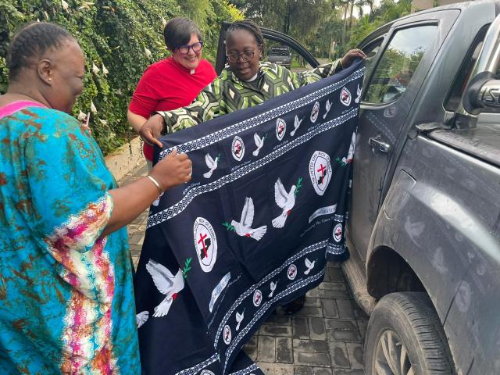
Photo: Dr. Emily Sikazwe and Dr. Mwiche Zulu wrap the Moderator in a beautiful cloth gifted to her.
Credit: Japhet Ndhlovu
Published On: March 21, 2024
“When we are rooted in love, we cannot keep from building community, from practising equity and justice. We cannot keep from using our God-given discernment in mourning, standing up for our siblings, and saying ‘Not in my name. Not in the name of my God.’ We must build relationships that have space for vulnerability and trust and respect so that when we hurt each other—because we are human and we will—we don’t have to live in fear because we have forgiveness, and we are already forgiven. But we must always strive to be worthy of that forgiveness. So, when we know better, we must do better.”
These are the words of The Right Rev. Dr. Carmen Lansdowne, from her sermon to St. Paul’s United Church of Zambia in Lusaka on March 10, Mothering Sunday. It was the first full day of a two-week visit to Zambia and Kenya with Rev. Dr. Japhet Ndhlovu, Executive Minister of the Church in Mission unit of the General Council Office.
The Moderator’s visit in Zambia included a partner round table with the Council of Churches in Zambia(opens in a new tab) and visits with People’s Action Forum(opens in a new tab), Women for Change(opens in a new tab), and the United Church of Zambia University(opens in a new tab) (UCZU). As with local congregations here in Canada, she encouraged global partners with a message of flourishing, urging them to celebrate being alive even when they feel challenged.
“I hope that we will have many more conversations about our mutual flourishing during my time in Zambia,” she concluded her sermon on that first Sunday, “because if we are to survive end stage capitalism, its effects on those made marginal by systems of oppression, and especially its effects on our greatest mother—the earth—we must be hopeful about the promise that we have life and have it in abundance. That abundance requires our flourishing.”
Follow the Moderator’s journey on our social media platforms:
- Moderator's Facebook page(opens in a new tab)
- The United Church of Canada Facebook page(opens in a new tab)
- The United Church of Canada Twitter/X page(opens in a new tab)
- The United Church of Canada Instagram(opens in a new tab)

A gift of belonging to a church is that the practice of gathering together for worship … to pray, sing, listen to scripture and share how God touches our lives – helps us grow in deeper relationship with God and each other. We are offering this practice of sharing beyond Sunday morning to deepen our connection. Each week you are offered a picture, a scripture and a question for contemplation, as well as a short reflection for you to contemplate, have conversation with people in your life and/or join an online conversation on our Rockwood Stone Facebook page.

