Contemplation and Conversation: 3rd Sunday of Easter, April 14, 2024
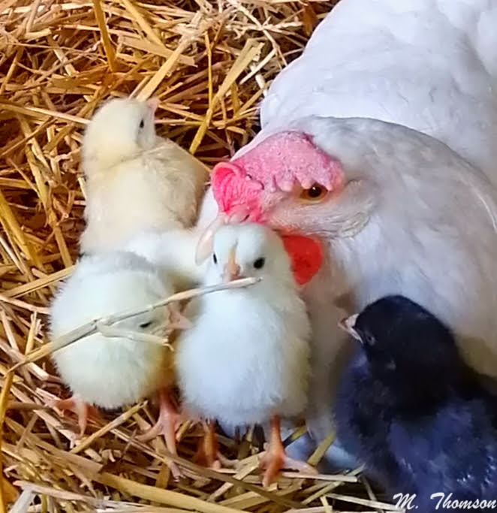
Scripture – 1 John 3:1-7 NRSVUE https://www.biblegateway.com/passage/?search=1+John+3%3A1-7+&version=NRSVUE
¹ See what love the Father has given us, that we should be called children of God, and that is what we are. The reason the world does not know us is that it did not know him. ² Beloved, we are God’s children now; what we will be has not yet been revealed. What we do know is this: when he is revealed, we will be like him, for we will see him as he is. ³ And all who have this hope in him purify themselves, just as he is pure.
⁴ Everyone who commits sin is guilty of lawlessness; sin is lawlessness. ⁵ You know that he was revealed to take away sins, and in him there is no sin. ⁶ No one who abides in him sins; no one who sins has either seen him or known him. ⁷ Little children, let no one deceive you. Everyone who does what is right is righteous, just as he is righteous.
From Rev. Heather Leffler
Through Jesus, we have been adopted into the covenant God made with Abraham. We have become Abraham’s descendants and are part of sharing God’s blessing to all the nations of the earth. Adoption is not for our benefit alone. Rather it is so that we will join with people around the world with different beliefs who believe in love in bringing about God’s kingdom through loving our neighbours as ourselves.
If we focus only on the needs of ourselves, our families or members of our churches – if we set ourselves apart from people of other faiths or people of no faith who are working to care for the earth, God’s creatures and creation, then we have misunderstood God’s promises and call. Jesus invited us into God’s family so we can bring healing and hope to all people not just those who believe what we believe.
Contemplation and Conversation
What does it mean to be a child of God?
Prayer
Shepherding God, we give you thanks
that we live in covenant relationship with you.
Help us to find the courage to follow the example of your Son
to live and work for peace, justice, and reconciliation. Amen.

Further Conversation … Would you like to talk more about today’s reflection? Email Heather at hleffler@rogers.com.

Our Rockwood Stone Family
If you missed today’s worship service, you can watch it here: https://youtu.be/pWCsmeKEfjA

United Church of Canada
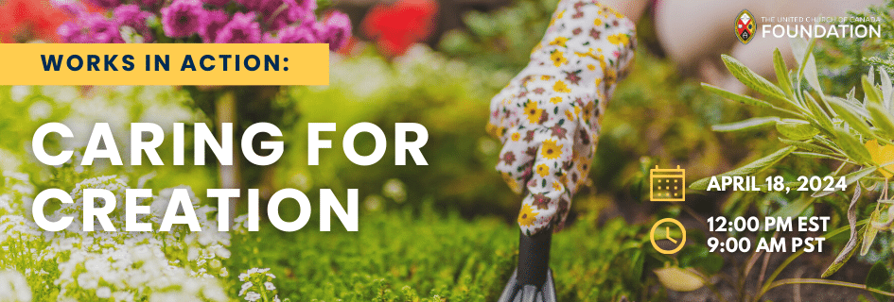
Save the Date! Join us on April 18, 2024 at 12 PM EST for our next webinar "Works in Action: Caring for Creation."
We'll spotlight inspiring projects dedicated to caring for Creation, supported by the United Church of Canada Foundation. Our panel of past grant recipients will share their projects, learnings, and experience working with the Foundation. You’ll hear how communities are taking meaningful steps toward climate justice and protecting the environment.
This webinar will be moderated by Jessica Smith, Foundation Communications & Campaign Associate, and will include stories and reflections from:
- Patty Duquette, Eden United Church (Mississauga, ON)
- Wendy Pope, Denman Island United Church and Gathering Place (Denman Island, BC)
- Jessica Banner, Evergreen (Toronto, ON)

A gift of belonging to a church is that the practice of gathering together for worship … to pray, sing, listen to scripture and share how God touches our lives – helps us grow in deeper relationship with God and each other. We are offering this practice of sharing beyond Sunday morning to deepen our connection. Each week you are offered a picture, a scripture and a question for contemplation, as well as a short reflection for you to contemplate, have conversation with people in your life and/or join an online conversation on our Rockwood Stone Facebook page.

