Contemplation and Conversation: 4th Sunday of Easter, April 21, 2024
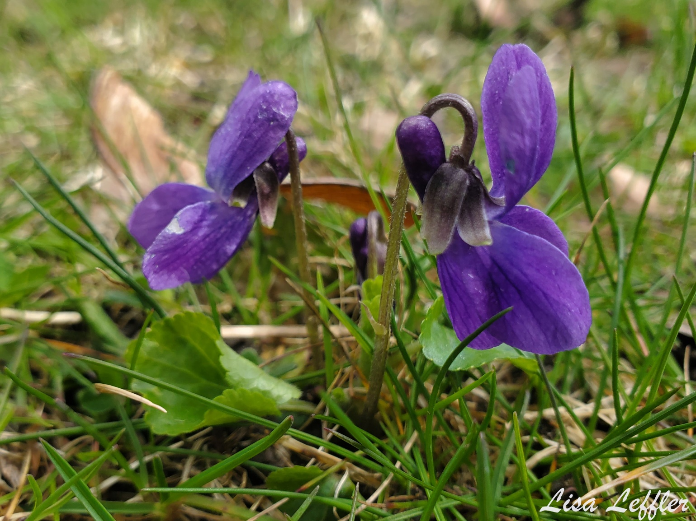

Scripture – 1 John 3:16-24 NRSVUE https://www.biblegateway.com/passage/?search=1+John+3%3A16-24+&version=NRSVUE
¹⁶ We know love by this, that he laid down his life for us—and we ought to lay down our lives for the brothers and sisters. ¹⁷ How does God’s love abide in anyone who has the world’s goods and sees a brother or sister in need and yet refuses help?
¹⁸ Little children, let us love not in word or speech but in deed and truth. ¹⁹ And by this we will know that we are from the truth and will reassure our hearts before him ²⁰ whenever our hearts condemn us, for God is greater than our hearts, and he knows everything. ²¹ Beloved, if our hearts do not condemn us, we have boldness before God, ²² and we receive from him whatever we ask, because we obey his commandments and do what pleases him.
²³ And this is his commandment, that we should believe in the name of his Son Jesus Christ and love one another, just as he has commanded us. ²⁴ All who obey his commandments abide in him, and he abides in them. And by this we know that he abides in us, by the Spirit that he has given us.
From Rev. Heather Leffler
We live in a world that encourages us to take care of ourselves and our own. From the time we are infants, we begin accumulating precious things. We save for the future and to leave our loved ones’ inheritances.
Jesus’ love was never limited to his family or even his followers. He gave his life for all of God’s people, creatures and creation. John urges us to see that all the talk about love in worship and study has little meaning if we don’t respond in love to the people around us in our communities and the world.
John tells us we receive from God what we ask. In loving response we are asked to share what we have to love and care for others.
Contemplation and Conversation
What do you have that you might share with someone in need?
Prayer
Loving God, we give you thanks for the teachings of Jesus.
Help us to lessen our thirst for worldly, temporary goods
and to let our hearts be filled with compassion
as we reach out in love to meet the needs of others. Amen.

Further Conversation … Would you like to talk more about today’s reflection? Email Heather at hleffler@rogers.com.

Our Rockwood Stone Family
If you missed today’s worship service, visit our Rockwood Stone YouTube page.

United Church of Canada
In February 2023, people gathered at the Rated R: Religion, Revolutions, and Rainbows Asian Gender Consultation in the Philippines. Through a series of panel presentations and in worship, participants heard stories from mass movements for social change, “revolutions toward gender justice,” and experiences of advocacy work.
Hear thoughts from some participants on the impact of this initiative: https://www.youtube.com/watch?v=nIrvydIqQbk
Your Mission & Service gifts help support future events that will provide safe spaces for activists and 2SLGBTQIA+ folks to share their personal and collective struggles and gains.

A gift of belonging to a church is that the practice of gathering together for worship … to pray, sing, listen to scripture and share how God touches our lives – helps us grow in deeper relationship with God and each other. We are offering this practice of sharing beyond Sunday morning to deepen our connection. Each week you are offered a picture, a scripture and a question for contemplation, as well as a short reflection for you to contemplate, have conversation with people in your life and/or join an online conversation on our Rockwood Stone Facebook page.

