Contemplation and Conversation: 5th Sunday of Easter, April 28, 2024
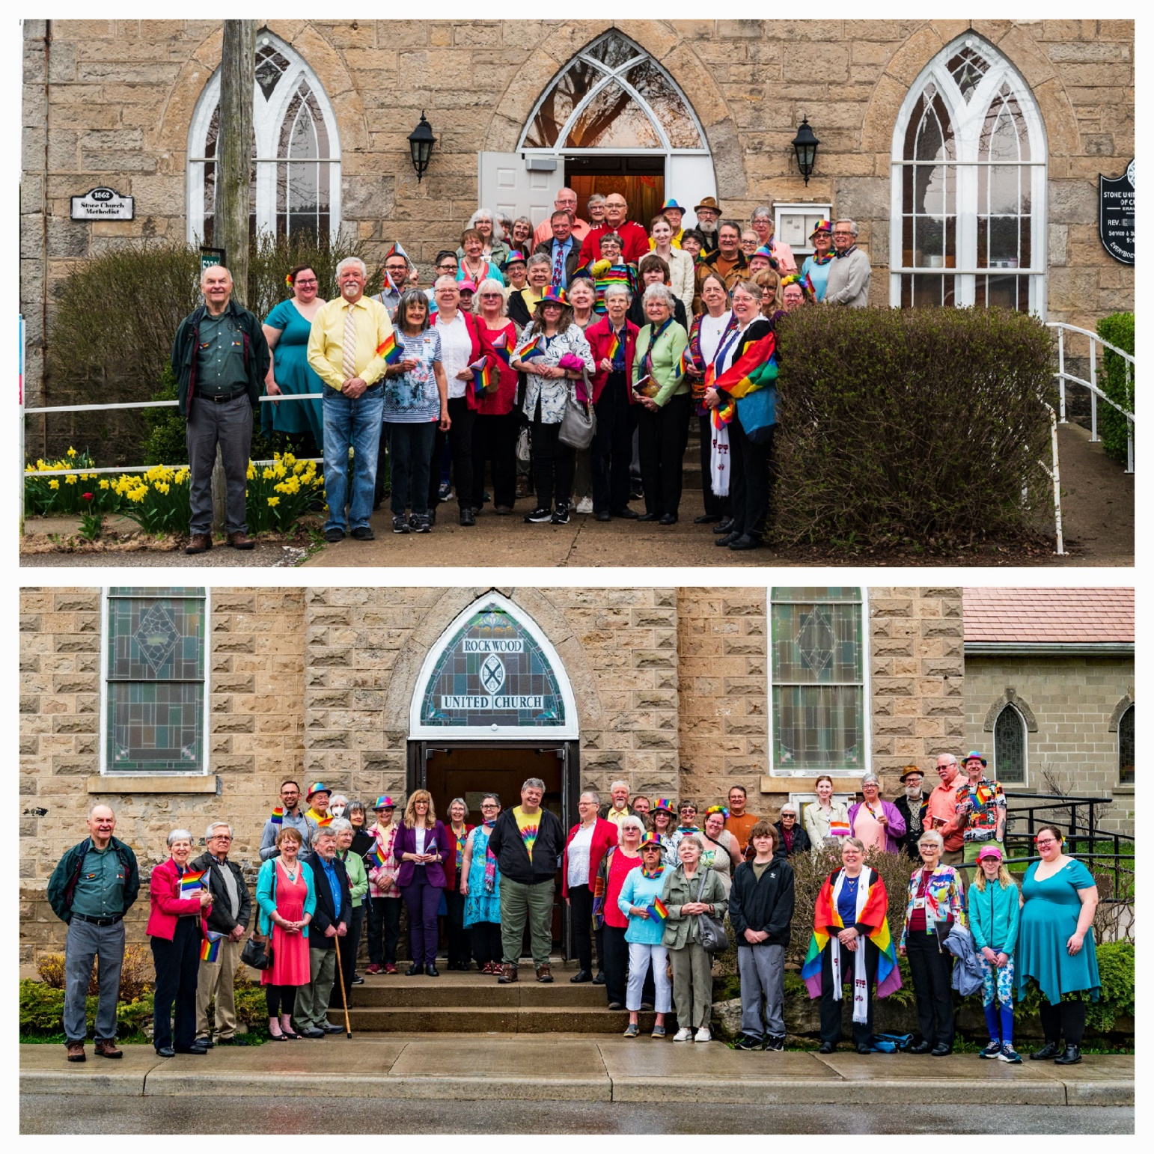
Scripture – 1 John 4:7-21 NRSVUE https://www.biblegateway.com/passage/?search=1+John+4%3A7-21+&version=NRSVUE
⁷ Beloved, let us love one another, because love is from God; everyone who loves is born of God and knows God. ⁸ Whoever does not love does not know God, for God is love. ⁹ God’s love was revealed among us in this way: God sent his only Son into the world so that we might live through him. ¹⁰ In this is love, not that we loved God but that he loved us and sent his Son to be the atoning sacrifice for our sins. ¹¹ Beloved, since God loved us so much, we also ought to love one another. ¹² No one has ever seen God; if we love one another, God abides in us, and his love is perfected in us.
¹³ By this we know that we abide in him and he in us, because he has given us of his Spirit. ¹⁴ And we have seen and do testify that the Father has sent his Son as the Savior of the world. ¹⁵ God abides in those who confess that Jesus is the Son of God, and they abide in God. ¹⁶ So we have known and believe the love that God has for us.
God is love, and those who abide in love abide in God, and God abides in them. ¹⁷ Love has been perfected among us in this: that we may have boldness on the day of judgment, because as he is, so are we in this world. ¹⁸ There is no fear in love, but perfect love casts out fear; for fear has to do with punishment, and whoever fears has not reached perfection in love. ¹⁹ We love because he first loved us. ²⁰ Those who say, “I love God,” and hate a brother or sister are liars, for those who do not love a brother or sister, whom they have seen, cannot love God, whom they have not seen. ²¹ The commandment we have from him is this: those who love God must love their brothers and sisters also.
From Rev. Heather Leffler
These words can offer us comfort and hope. Perfect love casts out fear, urges us to love others as Jesus loves us so that we do not need to be afraid of anything.
We live in a world where there are many things to be afraid of … war and violence, world politics and economics, loss of jobs, illness, accidents, aging and death. Reading that perfect love casts out fear might leave us struggling with whether we have enough faith instead of bringing us hope.
John invites us to see it is when we separate ourselves from others because they are different, that fear finds its way into our lives. When like Jesus, we meet people where they are, we can find compassion and love for each other.
Contemplation and Conversation
What does it mean to live in God?
Prayer
Compassionate God, we give you thanks that
you offer us hope in a turbulent world.
Help us to have an inclusive heart and
to break down barriers that separate us
from our neighbors. Amen.

Further Conversation … Would you like to talk more about today’s reflection? Email Heather at hleffler@rogers.com.

Our Rockwood Stone Family
Thank you to everyone who participated in our Affirming Celebration worship: https://youtu.be/l0Yo7e0cb1I
Thank you to Brent Stiles, Claire Stiles, Gord Carothers, Helen Smith, Heather Leffler, John Leffler, Lisa Leffler, and Liz Guthrie for sharing their pictures of the celebration: https://youtu.be/q_fYJrlJx_I
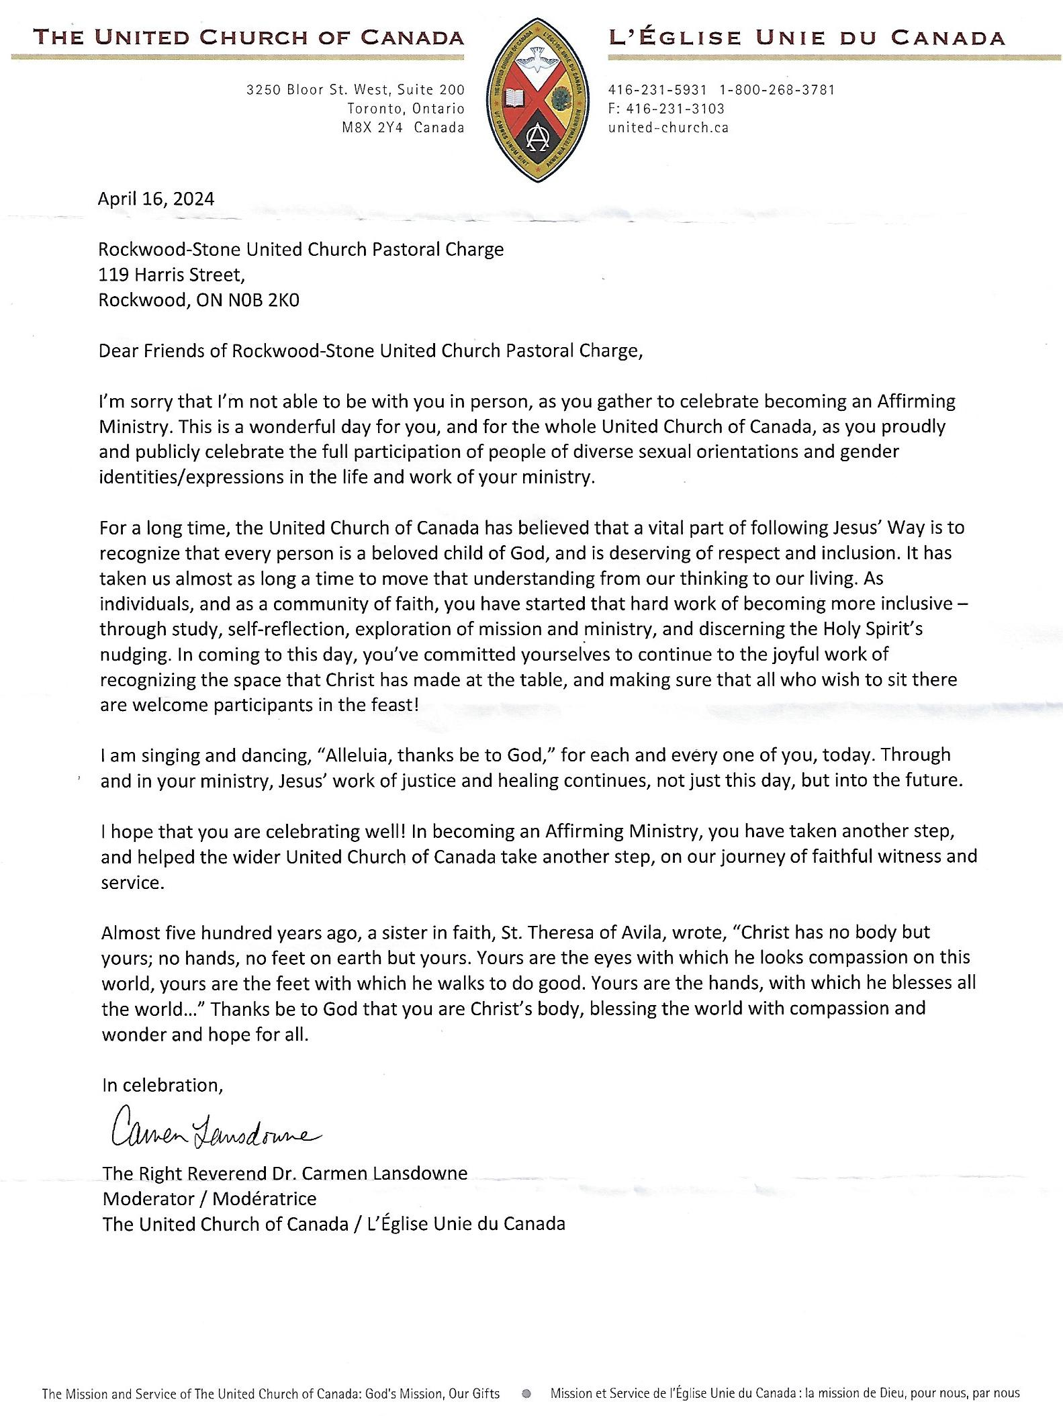
From Moderator Carmen Lansdowne…

A gift of belonging to a church is that the practice of gathering together for worship … to pray, sing, listen to scripture and share how God touches our lives – helps us grow in deeper relationship with God and each other. We are offering this practice of sharing beyond Sunday morning to deepen our connection. Each week you are offered a picture, a scripture and a question for contemplation, as well as a short reflection for you to contemplate, have conversation with people in your life and/or join an online conversation on our Rockwood Stone Facebook page.

