Contemplation and Conversation: 6th Sunday of Easter, May 5, 2024
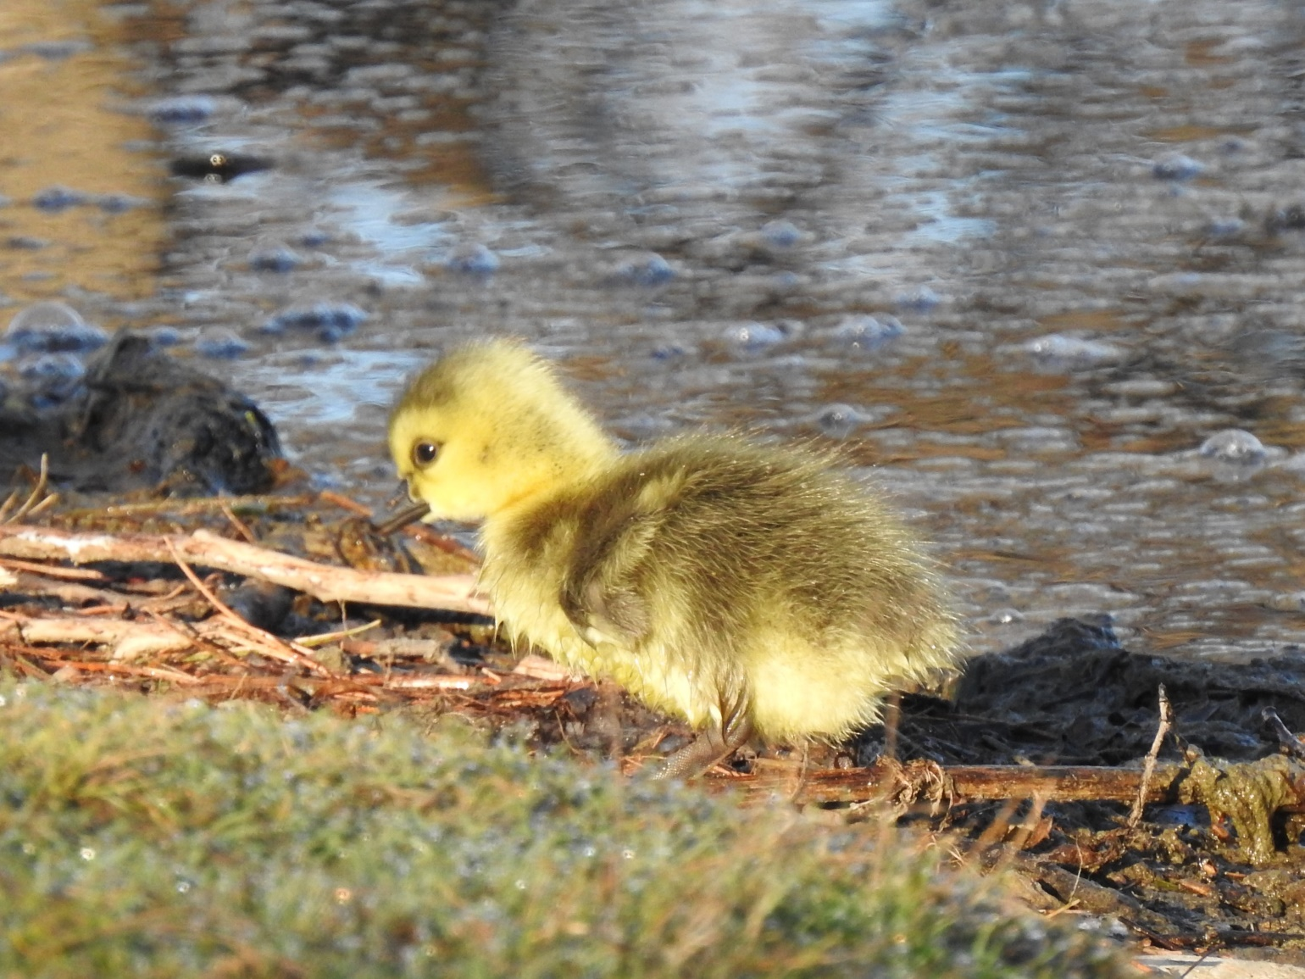
Scripture – 1 John 5:1-6 NRSVUE https://www.biblegateway.com/passage/?search=1+John+5%3A1-6+&version=NRSVUE
¹ Everyone who believes that Jesus is the Christ has been born of God, and everyone who loves the parent loves the child. ² By this we know that we love the children of God, when we love God and obey his commandments. ³ For the love of God is this, that we obey his commandments. And his commandments are not burdensome, ⁴ for whatever is born of God conquers the world. And this is the victory that conquers the world, our faith. ⁵ Who is it who conquers the world but the one who believes that Jesus is the Son of God?
⁶ This is the one who came by water and blood, Jesus Christ, not with the water only but with the water and the blood. And the Spirit is the one that testifies, for the Spirit is the truth.
From Rev. Heather Leffler
From the beginning God created us to be in relationship with God, each other and the earth. When the Holy One sent Moses to lead the people of Israel out of Egypt, they wandered in the wilderness for 40 years. This time helped them let go of the experience of being slaves and become a people. On Mount Sinai Moses received the 10 commandments which invited the people into loving relationship with God and each other. Jesus taught that the commandments and all the laws which grew out of them could be summed up in two – Love the Lord you God with all your heart, mind, soul and strength and love your neighbour as yourself. The Jewish rabbis summed up all the commandments in – do not steal.
Like all parents, longing the best for everyone, God gave commandments not to be burdensome but to help us grow into loving relationships with God and each other. The world tries to separate us according to status, wealth, politics, education, religion, race, gender, sexuality, age and more. We conquer the world when instead of being divided we come together in love to work for peace, justice, reconciliation and to care for this beautiful planet God created for us. May it be so.
Contemplation and Conversation
How does seeing God as your parent
change how you respond to the people you meet?
Prayer
Sustaining God, we give you thanks for the spiritual sustenance
that you provided to the Israelites in the desert.
Help us to draw on your nourishment today
as we seek to grow in deeper relationship
with you and with each other. Amen.

Further Conversation … Would you like to talk more about today’s reflection? Email Heather at hleffler@rogers.com.

Our Rockwood Stone Family
If you missed today’s worship service, visit our Rockwood Stone YouTube page.

United Church of Canada from UCCan Indigenous Ministries…
Today is Red Dress Day, the National Day of Awareness for Missing and Murdered Indigenous Women, Girls and Two-Spirit people (MMIWG2S). Please join this movement to say that you value Indigenous Women, Girls, and Two-Spirit people, and to seek justice for those who have gone missing or been murdered
In the Photo: Indigenous Racialize Youth Gathering delivered an important multilingual message "Search the Landfill" at Camp Morgan in September 2023. Photo taken by IMJ Staff. #MMIWG2S #MMIW #MMIWawareness #MMIWActionNow #MMIW
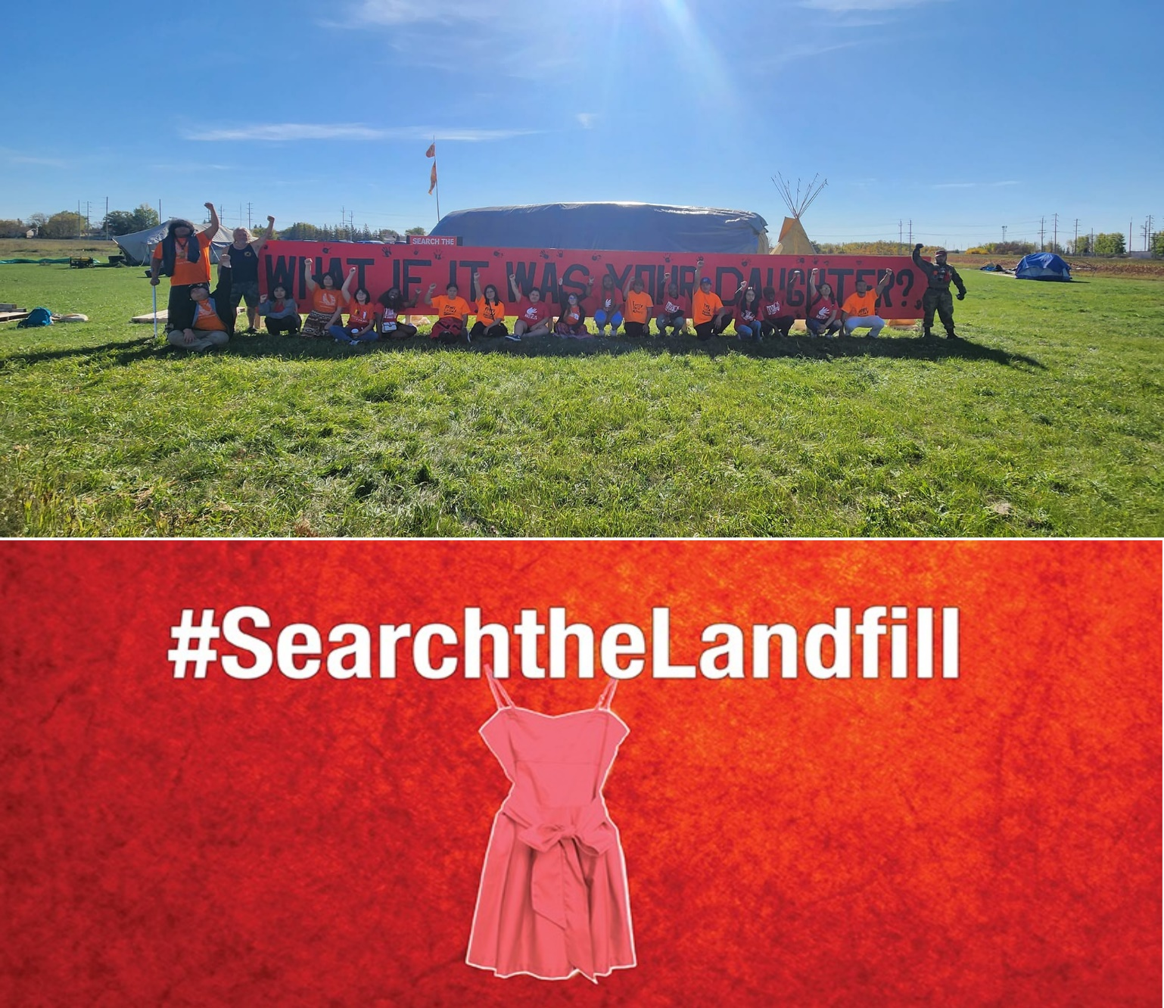
From Gathering…

Prayer
Please respond to the words God of compassion
with the words receive our prayers.
(Practice once.)

Let us pray:
Great and Holy Mystery, Comforter, Advocate,
receive our prayers at this sacred time for families of Missing and Murdered Indigenous Women, Girls and Gender-Diverse People.
God of compassion,
receive our prayers.

God, who gently holds the tears of those grieving,
you know what it is to grieve the loss of a child.
Today we pray for each Indigenous family who is remembering and grieving.
They have waited for a very long time to share their stories.
They have waited for a very long time to obtain a true sense of justice and reach a true place of peace.
God of compassion,
receive our prayers.

God of the broken and the broken-hearted,
you know what it is to be vulnerable and broken.
Today we remember
the beautiful Indigenous girls whose lives were cruelly shortened,
the beautiful Indigenous women who were robbed of their potential,
and the beautiful gender-diverse people who were targeted because of bigotry.
God of compassion,
receive our prayers.

God, Creator of all, we pray:
For the beautiful Indigenous girls growing up across this country,
that they may always be able to enjoy times of learning, times of play, and time at home, safely moving wherever they go.
For the beautiful Indigenous women working hard for their families and communities, that they may always be able to enjoy times of relaxation and respite from their cares, securely and free from fear.
For the beautiful gender-diverse people blessing all those with whom they come into contact, that they may always be able to enjoy the cities, the towns, and the countryside of this great land in comfort and in welcome wherever they go.
God of compassion,
receive our prayers.

On this National Day of Awareness and Action for Missing and Murdered Indigenous Women, Girls and Gender-diverse people,
God of compassion,
receive our prayers.
In the name of all our relations. Amen*.
*Adapted from a prayer for use during the Inquiry for Missing and Murdered Indigenous Women, Girls and Gender-Diverse peoples found on united-church.ca

A gift of belonging to a church is that the practice of gathering together for worship … to pray, sing, listen to scripture and share how God touches our lives – helps us grow in deeper relationship with God and each other. We are offering this practice of sharing beyond Sunday morning to deepen our connection. Each week you are offered a picture, a scripture and a question for contemplation, as well as a short reflection for you to contemplate, have conversation with people in your life and/or join an online conversation on our Rockwood Stone Facebook page.

