Contemplation and Conversation: Sunday, May 19, 2024
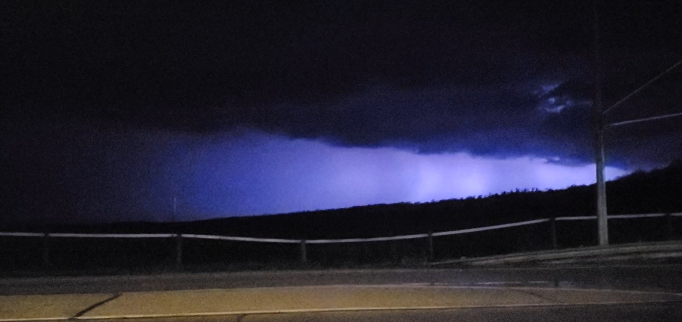
Scripture – Psalm 29
https://www.biblegateway.com/passage/?search=psalm+29&version=NRSVUE
From Brian Mack
My Dad loved thunderstorms. He would often recount tales of going to the bush to round up our milk cows during a storm with his faithful dog “Skip” hanging close as she was deathly afraid of thunder and lightening. Of course, there was sometimes a toddler in arms who had created a storm of his own when his dad had tried to sneak out of the house without him.
My Mother hated thunderstorms. Raised on an isolated farm in Saskatchewan, storms meant wind, hail, and danger. A storm could come up quickly and she and her four siblings would find their outside play time interrupted by their worried parents who would whisk them away to hoped for safety in the storm cellar. Spending several hours in dark, cramped quarters with the winds howling just beyond two outside trap doors didn’t always offer her a great sense of security.
Whether you like thunderstorms or not, Psalm 29 leaves one breathless. The song begins with a call to worship. It continues with David’s detailed description of a mighty thunderstorm which rises from the west over the Mediterranean Sea. It breaks in full fury over the Mountains of Lebanon and Mermon and down the length of Canaan. The storm finally passes out of sight and sound into the desert of Kadesh. For me, his description of the storm acts as a metaphor for the power of the Creator which is beyond comprehension. We are not to fear this power as the psalm ends with references to the Lord offering us strength in times of trouble and the assurance that we will be blessed with a peace beyond all understanding. As the opening lines tell us, our responsibility is to heed the call to continuously worship the Lord. Whether done in community or in solitude, when we offer an outpouring of gratitude and awe to God, we are still heeding that ancient call in 2024. Thanks be to God.
Contemplation and Conversation
What are the ways in which you best like to offer an outpouring of gratitude and awe to God?
Prayer
God, we give you thanks for David’s song of a thunderstorm. Help us to find the words to offer you praise and honor for all the ways in which you bless us. Amen

Further Conversation … Would you like to talk more about today’s reflection? Email Heather at hleffler@rogers.com.

Our Rockwood Stone Family
If you missed today’s worship service, you can watch it here: https://youtu.be/8eiwmFus_G8

United Church of Canada
Dive deeper into Asian Heritage Month with a special webinar on May 28, 2024, at 7:00 p.m. ET:
"Stories and Narratives: God-Talks from Diasporic Filipino Ministers in The United Church of Canada" will explore the faith journeys and experiences of Filipino ministers.
Our panellists will share how immigrating to Canada shaped their understanding of God and offer insights into Filipino theologies. You'll gain a richer perspective on themes like:
Women in ministry
Christian activism in Filipino diasporic communities
Emerging Filipino theologies
This is a unique opportunity to learn and be inspired by the experiences of Filipino ministers. Register now and broaden your understanding of faith and heritage during Asian Heritage Month! https://churchx.ca/local/shop/product.php?id=174


A gift of belonging to a church is that the practice of gathering together for worship … to pray, sing, listen to scripture and share how God touches our lives – helps us grow in deeper relationship with God and each other. We are offering this practice of sharing beyond Sunday morning to deepen our connection. Each week you are offered a picture, a scripture and a question for contemplation, as well as a short reflection for you to contemplate, have conversation with people in your life and/or join an online conversation on our Rockwood Stone Facebook page.

