Contemplation and Conversation:
Creation Time 3 Sunday, September 27, 2020
Scripture: Philippians 2:1-4 NRSV
https://www.biblegateway.com/passage/?search=phillipians+2%3A1-4&version=NRSV
Contemplation and Conversation: Who has been a blessing in your life and encouraged you to share your beauty with the world? How can you be a blessing to others?
From Lisa Leffler:
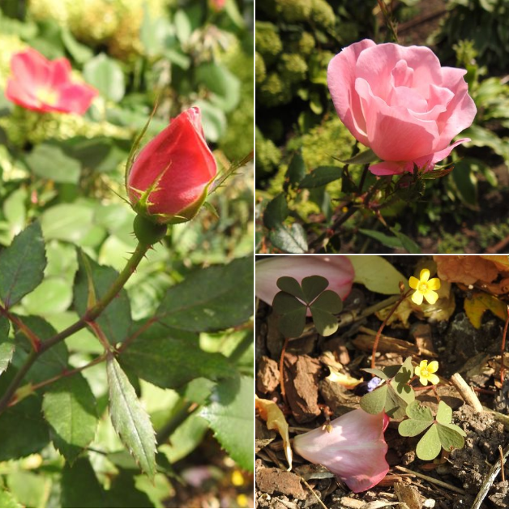
Roses have always been my favourite flower. I think that is because they are beautiful at every stage of growth. Like roses we too go through cycles of growth in life.
At times we are like a rosebud – closed off and keeping what makes us beautiful held tightly inside ourselves. There are many reasons why you may feel the need to close yourself off to the world. Maybe you a grieving a loss, or afraid the world won’t accept you as you are. Maybe you are just taking in the world and taking the time to learn who you truly are. This introspective stage of life is important. It is okay to take the time you need to reflect and recentre.
But when the time is right don’t be afraid to open up. Just a rose gathers energy from the sun and nourishment from the soil and water so may you gather strength from the world around you. Surround yourself with people you love and people who love you so that you can begin to grow to your full potential and let your beauty shine for all to see.
When a rose blossoms and shares its beauty with the world it is also opening itself up to greater risks from insects that eat the petals and inclement weather. As others open up to you remember to help nourish them. Try not to be the thing that tears someone down. And don’t be afraid to take care of yourself. Don’t let others take away what makes you beautiful.
The final stage of a rose’s development is to have the petals fall and return to the earth. This is a reminder to live in a way that provides a lasting blessing to each person you come in contact with. Live a life of love and you will inspire others to do the same.
Whether you are at home trying to help slow the spread of the virus,
working to help care for those who are impacted most by COVID-19
or working to keep some normalcy in this time,
may you know God’s deep and abiding love in your life.
Know you are a valued part of our Rockwood and Stone United Church families.

KAIROS Canada
Prayer on Orange Shirt Day
Vibrant God
Your creation explodes with the colours of the rainbow
Your peoples reveal the beauty of diversity
We remember today when the joy and dignity of a precious child was destroyed.
We lament today for the childhoods lost through the residential school system.
We mourn for the spirits crushed and the futures compromised.
Celebrate the hope and joy of every child
Tell the stories of resistance that make us stronger
Build the bonds of solidarity to ensure “never again”
In the name of the one who was child among us
Amen
https://www.kairoscanada.org/spirited-reflection-orange-shirt-day
Phyllis Webstad’s story shared in worship today: https://www.youtube.com/watch?v=E3vUqr01kAk
Every Child Matters: https://www.youtube.com/watch?v=riSqg53AJb8

A gift of belonging to a church is that the practice of gathering together for worship … to pray, sing, listen to scripture and share how God touches our lives – helps us grow in deeper relationship to God and each other. With COVID-19 keeping us at home and physically distant from our Stone or Rockwood families, we are missing each other. We are offering this practice of sharing beyond Sunday morning to deepen our connection. Each week you will be offered a picture, a scripture and a question for contemplation, as well as a short reflection for you to contemplate, have conversation with people in your life and/or join an online conversation on our Rockwood Stone Facebook page.

