Contemplation and Conversation: Sunday, June 2, 2024
2nd after Pentecost
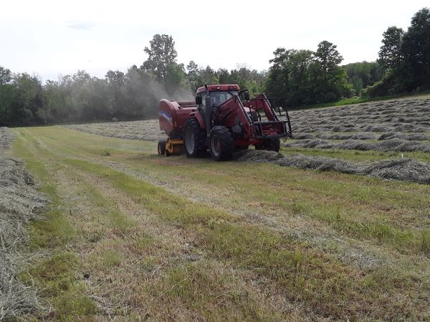
Scripture – Mark 2:23-36
https://www.biblegateway.com/passage/?search=Mark2:23-3:6&version=NRSVUE
²³ One Sabbath he was going through the grain fields, and as they made their way his disciples began to pluck heads of grain. ²⁴ The Pharisees said to him, “Look, why are they doing what is not lawful on the Sabbath?” ²⁵ And he said to them, “Have you never read what David did when he and his companions were hungry and in need of food, ²⁶ how he entered the house of God when Abiathar was high priest and ate the bread of the Presence, which it is not lawful for any but the priests to eat, and he gave some to his companions?” ²⁷ Then he said to them, “The Sabbath was made for humankind and not humankind for the Sabbath, ²⁸ so the Son of Man is lord even of the Sabbath.”
3 Again he entered the synagogue, and a man was there who had a withered hand. ² They were watching him to see whether he would cure him on the Sabbath, so that they might accuse him. ³ And he said to the man who had the withered hand, “Come forward.” ⁴ Then he said to them, “Is it lawful to do good or to do harm on the Sabbath, to save life or to kill?” But they were silent. ⁵ He looked around at them with anger; he was grieved at their hardness of heart and said to the man, “Stretch out your hand.” He stretched it out, and his hand was restored. ⁶ The Pharisees went out and immediately conspired with the Herodians against him, how to destroy him.
From Barb Parker
Mark’s gospel gives us two examples of Jesus’s teachings which challenge the Pharisees about keeping the Laws of The Sabbath. In the first, the Pharisees take issue with the disciples gleaning some grain to eat, from a field, on the Sabbath. Jesus responds by telling the story of King David and his men, entering the House of God on the Sabbath, and eating bread which was to be offered to God. In the second, Jesus questions some people at the synagogue (Pharisees) if the laws of the Sabbath allow helping or harming? Or, saving a man’s life or destroying it? Their silence angers him; he then proceeds to heal a man with a paralyzed hand, on the Sabbath, in the synagogue, no less.
“… what better way to understand the purpose of the Sabbath than literal restoration and fulfillment? As hunger being satiated and wounds and defects being made well… As rest and a break from having our needs run the show and so that we might remember and know the goodness, generosity, and bounty of God.” – C. Harman, Center for Excellence in Preaching
Society has changed considerably since biblical times, and even since the 1906, Lords Day Act.
The Lord's Day Act was a Canadian law that prohibited commercial activity on Sundays, but was declared unconstitutional in 1985, during a court challenge by a major retailer.
Many people in the service industry, health care, and essential services, have to work on weekends; many people chose to use Sunday to shop, and participate in sporting activities.
In the world of livestock farming, animals must be fed and milked every day. The challenges of spring and summer weather often mean planting and baling in the narrow windows of dry weather. In our case, we seem to all too often have to bale and wrap hay on Sunday’s. Our preference would obviously be to rest and enjoy time with family and friends. Interestingly, it seems that it is on the occasions when we actually choose to work on a Sunday, that is when the machinery will break!
Providing for basic necessities, and doing good things for others and ourselves, on Sundays, seem like simple common-sense actions to me. Jesus, self- declared as Lord of the Sabbath” tells us it is so.
Contemplation and Conversation
What is a good Sabbath for you?
Prayer
Creator God,
We remember the Creation Story; you rested on the seventh day.
We remember the Psalm: This is the Day the Lord has made, rejoice and be glad in it.
We remember Sundays of our youth; seeing our neighbours at church,
making time for naps, visiting, and family suppers.
We pray today that your word and the examples of Jesus, help us keep the Sabbath,
however we are able and find restoration of body and soul. Amen

Further Conversation … Would you like to talk more about today’s reflection? Email Heather at hleffler@rogers.com.

Our Rockwood Stone Family
If you missed today’s worship service, you can find it here: https://youtu.be/Nankoi6WurQ
Sunday, June 9 at 10 am join us at Rockwood or on Zoom to celebrate their 157th Anniversary. There will be a breakfast and dessert after the service.
United Church of Canada
Join the Queer Interfaith Coalition for their first annual Interfaith Pride Service. Led by and for queer people of all faith traditions, you are welcome to come and be affirmed, celebrated, and cheered on. Online: Thursday, June 6, at 4 pm PT / 8pm AT / 7pm ET. Find out more and register: https://united-church.ca/.../online-interfaith-pride...

#UCCan #UCCanPRIDE #DeepBoldDaring

A gift of belonging to a church is that the practice of gathering together for worship … to pray, sing, listen to scripture and share how God touches our lives – helps us grow in deeper relationship with God and each other. We are offering this practice of sharing beyond Sunday morning to deepen our connection. Each week you are offered a picture, a scripture and a question for contemplation, as well as a short reflection for you to contemplate, have conversation with people in your life and/or join an online conversation on our Rockwood Stone Facebook page.

