Contemplation and Conversation: Sunday, July 7, 2024
7th Sunday after Pentecost
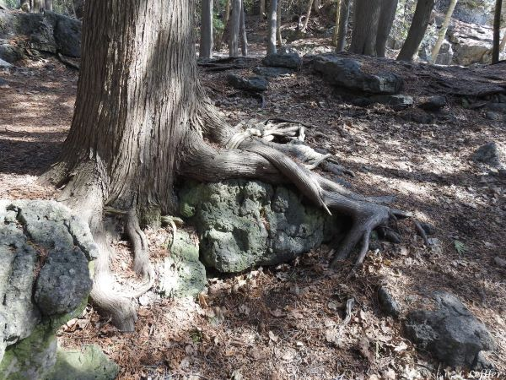
Scripture – Psalm 123
https://www.biblegateway.com/passage/?search=psalm+123&version=NRSVUE
¹ To you I lift up my eyes,
O you who are enthroned in the heavens!
² As the eyes of servants
look to the hand of their master,
as the eyes of a maid
to the hand of her mistress,
so our eyes look to the Lord our God,
until he has mercy upon us.
³ Have mercy upon us, O Lord, have mercy upon us,
for we have had more than enough of contempt.
⁴ Our soul has had more than its fill
of the scorn of those who are at ease,
of the contempt of the proud.
From Brian Mack
The Jewish pilgrims who were journeying to Jerusalem for one of the three main annual festivals (the Feast of Unleavened Bread, the Feast of Weeks, or the Feast of Booths) undoubtedly felt much frustration along the way. Imagine yourself in their sandals putting one foot forward and then another hour after hour. Depending on your point of origin, you might have already been on the rough and rocky road for ten days…some folks have offered to share shelter and sustenance while most have not…your feet are aching…your back is hurting from carrying your possessions...some members of your caravan are quarrelsome…children are fussing and some have wandered…your clothes are covered in dust from the never ceasing winds…you are fearful that robbers will accost you and take your money that you will need to buy a dove to sacrifice….you know that as you near the end of your journey, you will need to make a steep climb as Jerusalem is situated on a high hill and you must make every effort to reach the Temple so you can fulfil your obligations to meet God….you are obsessed with those who scoff at you and look upon you with contempt… In short, you are at your wits end.
And then…you start to really listen to the words you and your companions have been singing over and over again. The lyrics remind you of God’s presence in times of distress. They encourage you to be patient as you turn to God for help. They offer you the opportunity to make a joyful noise in thanksgiving. The frustrations of the journey begin to fade… the rough spots that you are enduring on your larger life journey seem more manageable. You raise your eyes skyward and offer simple words of gratitude. You are strengthened for the journey. Thanks be to God.
Contemplation and Conversation
How has this psalm of ascent (or the words of another psalm) encouraged you to reach out to God on your life’s journey?
Prayer
Holy One, we give thanks for your presence in our lives.
Help us to remember that we can turn to you at any time for help on life’s journey. Amen.

Further Conversation … Would you like to talk more about today’s reflection? Email Heather at hleffler@rogers.com.

Our Rockwood Stone Family
If you missed today’s worship service, visit our Rockwood Stone YouTube page.

United Church of Canada
Our Call and Vision
https://www.youtube.com/watch?v=asZ1m26p-oI&t=48s
The United Church of Canada is a community of hope, a vibrant and vital church with both purpose and vision. We live in a time of rapid change in religious life, great inequities between peoples, and collective harm to our earth community. As church, we have been complicit in injustice. And yet we have this hope. We believe we continue to be called to witness in love and justice to the liberating, healing Christ risen in this place and time. Together, we strive towards repentance, repair, and right relations with all peoples and the planet. Our call and vision statement speaks to how we boldly embody the Christian story in this time, filled with the certainty of resurrection and hope for new life.
Living purposefully into this call and vision anticipates becoming what Dr. Martin Luther King Jr. and others called the Beloved Community—the ever inbreaking, ever transforming, ever reconciling realm of God, realized in our time.
Call
The United Church of Canada Call reflects the core of our purpose, sharing who we seek to be in “such a time as this” (Esther 4:14).
Deep Spirituality
Bold Discipleship
Daring Justice
Vision
The United Church of Canada vision reflects what the church aspires to be over a 5- to 10-year span.
Called by God, as disciples of Jesus, The United Church of Canada seeks to be a bold, connected, evolving church of diverse, courageous, hope-filled communities united in deep spirituality, inspiring worship, and daring justice.
After a sustained consultation process, these interlinked statements were adopted by the Annual Meeting of General Council 43 on October 23, 2021.
The Call and Vision is commended to regional councils, communities of faith, and United Church incorporated ministries for engagement and discernment for their ministry. It is shared with the broader community as a pledge of identity and hope. These statements also provide purpose and direction within the 2022‒2025 Strategic Plan of the General Council Office.

A gift of belonging to a church is that the practice of gathering together for worship … to pray, sing, listen to scripture and share how God touches our lives – helps us grow in deeper relationship with God and each other. We are offering this practice of sharing beyond Sunday morning to deepen our connection. Each week you are offered a picture, a scripture and a question for contemplation, as well as a short reflection for you to contemplate, have conversation with people in your life and/or join an online conversation on our Rockwood Stone Facebook page.

