Contemplation and Conversation: Sunday, July 14, 2024
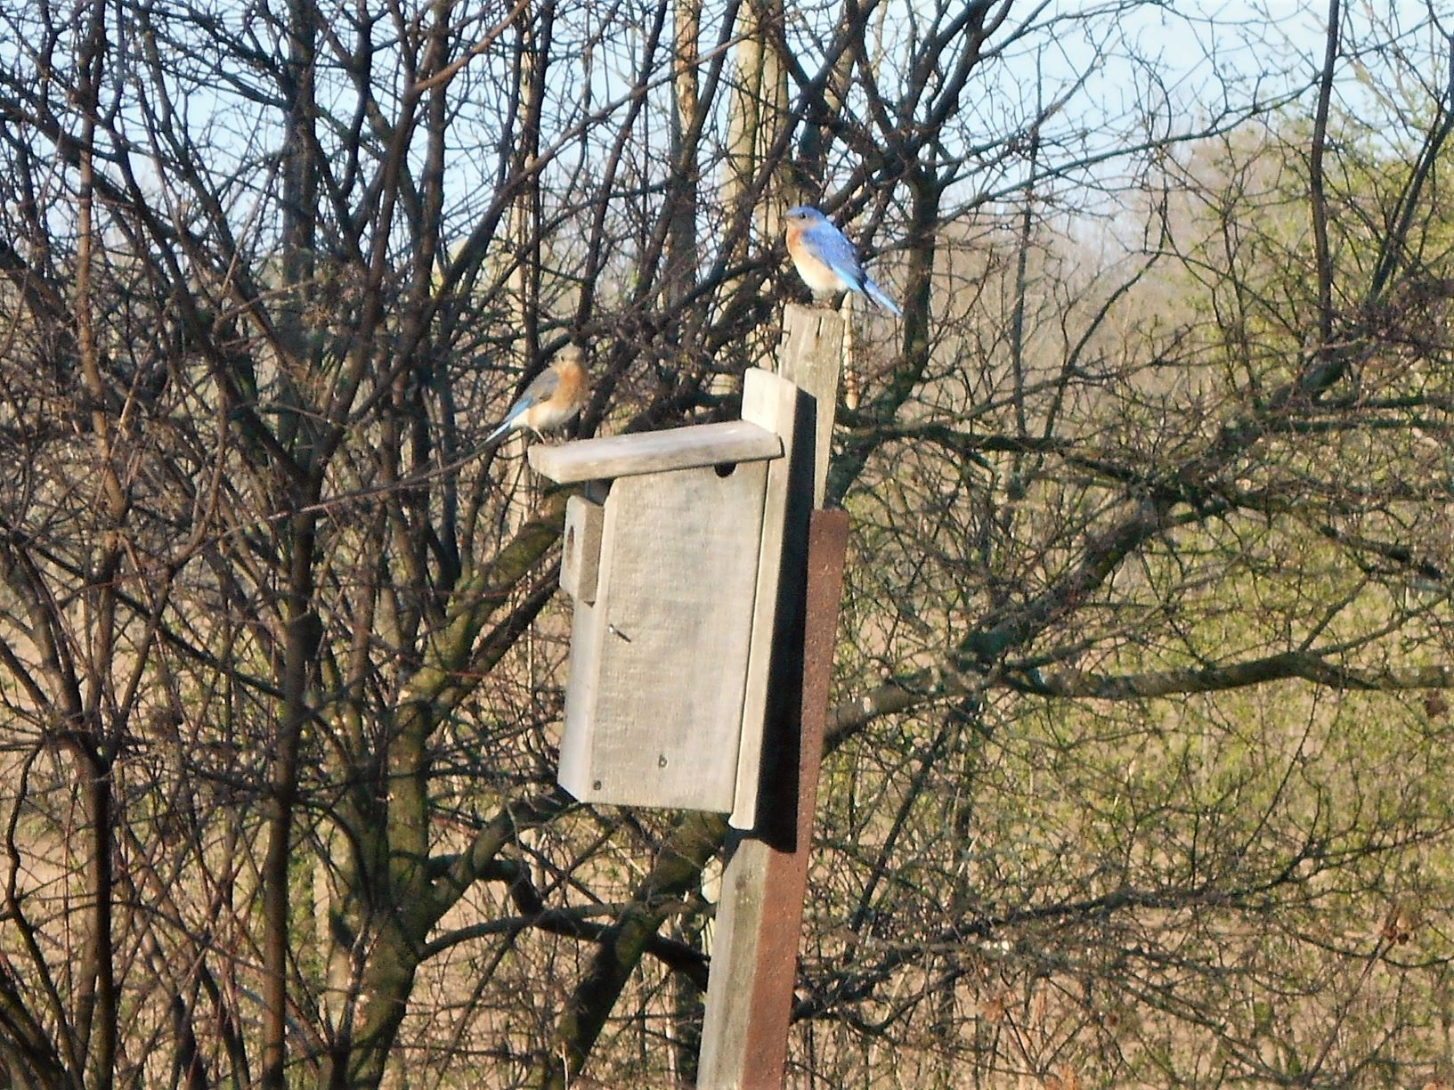
Scripture – Ephesians 1:3-14 GNT
https://www.biblegateway.com/passage/?search=Ephesians+1%3A3-14&version=GNT
³ Let us give thanks to the God and Father of our Lord Jesus Christ! For in our union with Christ he has blessed us by giving us every spiritual blessing in the heavenly world. ⁴ Even before the world was made, God had already chosen us to be his through our union with Christ, so that we would be holy and without fault before him.
Because of his love ⁵ God^{[a]} had already decided that through Jesus Christ he would make us his children—this was his pleasure and purpose. ⁶ Let us praise God for his glorious grace, for the free gift he gave us in his dear Son! ⁷ For by the blood of Christ^{[b]} we are set free, that is, our sins are forgiven. How great is the grace of God, ⁸ which he gave to us in such large measure!
In all his wisdom and insight ⁹ God did what he had purposed, and made known to us the secret plan he had already decided to complete by means of Christ. ¹⁰ This plan, which God will complete when the time is right, is to bring all creation together, everything in heaven and on earth, with Christ as head.
¹¹ All things are done according to God's plan and decision; and God chose us to be his own people in union with Christ because of his own purpose, based on what he had decided from the very beginning. ¹² Let us, then, who were the first to hope in Christ, praise God's glory!
¹³ And you also became God's people when you heard the true message, the Good News that brought you salvation. You believed in Christ, and God put his stamp of ownership on you by giving you the Holy Spirit he had promised. ¹⁴ The Spirit is the guarantee that we shall receive what God has promised his people, and this assures us that God will give complete freedom to those who are his. Let us praise his glory!
From Karen Richardson
When Heather asked for volunteers to do Contemplation and Conversation for the summer, she sent us the lectionary verses for the Sundays that needed to be filled but also said we could pick other verses. I read the verses over many times for this week, and although parts of the readings resonated with me, none completely. I was very tempted to choose another reading and actually did and then decided to go back to the one that most spoke to me at this time and concentrated on the one theme that jumped out: that of grace. Since the beginning of COVID my greatest fear was not so much getting COVID but passing it onto people who were vulnerable. Unfortunately, that is the exact situation that I found myself in on June 24th. I had just come home from a visit with my friends that day when suddenly I felt exhausted. After realizing my temperature had risen, I took a COVID test not for one second thinking it would be positive – this is what I have been doing for 5 years (calling it my COVID paranoia) - but sure enough it was positive. I had been with my sister who was starting chemo that week, been with my classmates from 1984 for our reunion, been with my church family at the Parker farm celebration, been with the members of my Breast Cancer Support Group and been with my friends one of whom was having surgery that week. Could it have possibly been a worse week – it certainly did not seem like it. Although I was reminded that clearly someone had passed the virus onto me and that I was not intentionally spreading it around, it was still hard not to blame myself for the worry of numerous people, the two people who did come down sick as well as a family member of theirs and the concern of what other problems might still arise.
I have not worked through the spiritual lessons of this situation totally. It was not easy to turn the fear and worry over to the care of God. It was not easy to not be with my sister to support her through her first chemo week. It was not easy to hear that people with very vulnerable people living with them had come down with COVID. Could I trust that everything would work out for the best? How deep was my belief in God’s grace when I found it hard to accept other’s word of grace for me. Fortunately, as I send this everyone is recovered or on the mend.
Contemplation and Conversation
What helps you to turn those difficult and painful situations over to God? How fully do you accept God’s grace, other’s grace toward you, grace towards yourself? How easy is it to extend grace?
Prayer
Holy mystery, help us to turn our lives over to you in times of challenge and in doing so,
give to others and ourselves the grace you have offered us. Amen.

Further Conversation … Would you like to talk more about today’s reflection? Email Heather at hleffler@rogers.com.

Our Rockwood Stone Family
If you missed today’s worship service, you can watch it here: https://youtu.be/gdvVJfSh-BE

United Church of Canada
That's a Wrap for Rendez-vous 2024: Audacious Hope!
Audacious Hope, the national youth and young adult event, brought together over 450 energetic young people and passionate youth leaders from July 3-6, 2024 for an unforgettable experience at Brock University in St. Catharines, ON. With the combined efforts of The United Church of Canada Rendez-vous team and the Presbyterian Church in Canada's Uplift team, this landmark event marked the first-ever collaborative youth event by the two denominations.
Each day included inspiring and vibrant worship led by the incredible Adele Halliday and Mitchell Anderson. Attendees were captivated by a lineup of phenomenal speakers and workshop leaders, including the Moderator, The Rev. Dr. Carmen Lansdowne.
This compilation from Audacious Hope celebrates the rejuvenated spirit and boundless optimism these young people bring to the church. With such audacious hope, nothing can hold us back!
Watch all of the Audacious Hope videos and more on our YouTube channel.

A gift of belonging to a church is that the practice of gathering together for worship … to pray, sing, listen to scripture and share how God touches our lives – helps us grow in deeper relationship with God and each other. We are offering this practice of sharing beyond Sunday morning to deepen our connection. Each week you are offered a picture, a scripture and a question for contemplation, as well as a short reflection for you to contemplate, have conversation with people in your life and/or join an online conversation on our Rockwood Stone Facebook page.

