Contemplation and Conversation: Sunday, July 28, 2024
Scripture – Psalm 145:10-18 GNT
https://www.biblegateway.com/passage/?search=Psalm+145%3A10-18&version=GNT
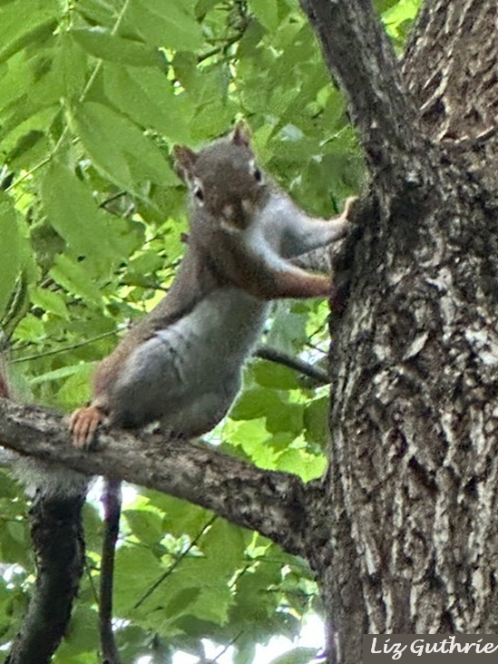
¹⁰ All your creatures, Lord, will praise you,
and all your people will give you thanks.
¹¹ They will speak of the glory of your royal power
and tell of your might,
¹² so that everyone will know your mighty deeds
and the glorious majesty of your kingdom.
¹³ Your rule is eternal,
and you are king forever.
The Lord is faithful to his promises;
he is merciful in all his acts.
¹⁴ He helps those who are in trouble;
he lifts those who have fallen.
¹⁵ All living things look hopefully to you,
and you give them food when they need it.
¹⁶ You give them enough
and satisfy the needs of all.
¹⁷ The Lord is righteous in all he does,
merciful in all his acts.
¹⁸ He is near to those who call to him,
who call to him with sincerity.
From Tammy Smits
Today the robins, finches, cardinals and blue jays greet each other loudly, and the bunnies, squirrels and chipmunks romp merrily through my flowerbeds whose fragrance fills the air. It is warm, food is abundant, and life is good – it is an easy time for all creation to offer praise. This may have been written several thousand years ago, but I like to think that the writer was also enjoying a fine day much like myself.
Sadly, not every day is this idyllic. The writer reminds us that God is also there for us when times are tough. Notice that it is not written that God will remove all obstacles from our path – there is no heavenly “helicopter parenting” solving our problems before they rear their ugly heads. It also does not say God will give us everything we want; however, it does say God will provide for our needs when requested with sincerity and truth.
We could learn a lot from the flora and fauna around us, who manage the perils of their lives while trusting God to meet their needs and continuing to shout praise in their various forms, saying thanks for what they receive in good times and bad.
Contemplation and Conversation
Has there been a time when you clearly felt God supporting you?
Prayer
Dear God – thank you for your everlasting love and supporting. Forgive us when we forget to be grateful for all you provide and help us to turn to you with truth and sincerity for both help and praise. Amen.

Further Conversation … Would you like to talk more about today’s reflection? Email Heather at hleffler@rogers.com.

Our Rockwood Stone Family
If you missed today’s worship service, you can watch it here: https://youtu.be/t4hCtntY3nQ
To watch the full video with the clip shared in the sermon visit: https://www.tpt.org/art-medicine/video/art-medicine-disability-culture-tfppdv/?fbclid=IwY2xjawEQvWhleHRuA2FlbQIxMQABHdJNL6TBgGhEYIIpHb6NwSeHbNtkbOzJJzbpTrZ1OKJMOFIVSUdY2UkCVQ_aem_xr1Cpd6eGNFKfCi0s7ZZDA
Rockwood United Church Trustees met on June 4 and June 14, 2024 with the four Trustees, Rosslyn Bentley (Chair), Darryl Nichol, David Smelsky, Christine Wenger and Rev. John Benham (filling in for Rev. Leffler).
The sale of the vacant land (present church parking lot) was due to be concluded by 5pm May 31, 2024 – an extension from May 15, 2024. This purchaser had asked for several extensions for closing and as a result the Trustees negotiated a $60,000 non-refundable deposit to be held by our lawyer until either a successful completion of sale or forfeit of sale occurred.
In the afternoon of May 31, the purchaser indicated they were having difficulties obtaining title and were still finalizing funding. The deal did not close. The day after the purchaser also indicated that the language on the ownership/deed was archaic and was causing difficulties in obtaining insurance.
In good faith, the Trustees allowed a final extension of the sale contract to 5pm June 7, 2024, EST in order for the purchaser to obtain title insurance. The Trustees met again on June 14 and concluded the sale is null and void. On July 26 2024 Chris Wood advised the failed purchaser of the church’s intention to cash the deposit cheques and are now in the legal wait time required. Our lawyer indicates that legal action may be required to collect the moneys currently owed to the Church by the purchaser. The
Trustees have requested an estimate of the legal fees incurred to date.
Given the lengthy period of time and the current state of the church finances, the Trustees felt it prudent to bring the congregation up-to-date and to request a review of the current direction (i.e. to continue to attempt to sell the parking lot) to ensure ongoing support of the plan.
Council Chairs will be contacted to set a meeting and there will be further announcements and updates to the congregation

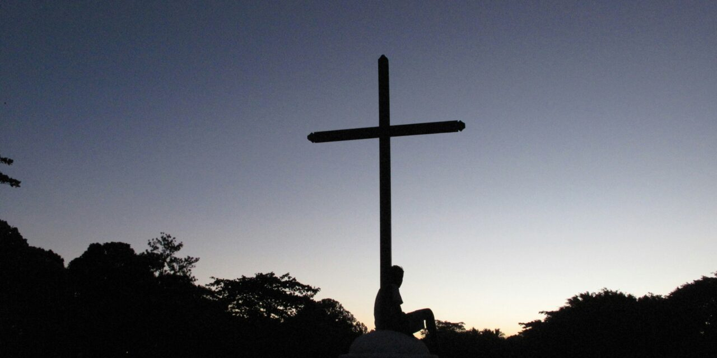
United Church of Canada from Northern Spirit Regional Council
From the Regional Council chair, Rev Helen Reed: “at 12:30 p.m. today (Sunday July 28), the Municipality of Jasper released a map and a list of where the fire left buildings and where it took them.
In the list is confirmation that the United Church of Jasper has been destroyed by the fire. We thought this was so, but this stark listing leaves no room for hope that it survived.
But hope, itself, survives. Hope because there were many places spared, hope because people were not killed, hope because we hear of the determination of those who evacuated to return to and rebuild in this community that they love.
Hope because we know that through valleys God is with us, walking with us to what is at the other end of a journey we don't know or recognize yet.
To all those who have lost their homes, businesses and churches in this fire, please know that we are standing with you, we are grieving with you. God is right beside you, accepting your tears, holding you in your grief, filling you with strength and courage for what lies ahead, deeply loving you as only God can do.”
The situation within and around Jasper National Park continues to weigh heavily upon our hearts. The Northern Spirit Regional Council has been in contact with the leadership of Jasper United Church and their minister. We have put into place supports for the interim and will be seeking to build plans for the future weeks and months. It is with heavy hearts that we can now confirm that the Jasper United Church and manse were both destroyed by the fire.
Our hearts are warmed, however, by the response from those within the wider region and national church who are wanting to do everything they can to support this community. We request that you continue to offer prayers for the community of faith, the wider community of Jasper, surrounding communities and people, and importantly the first responders who are doing everything they can to mitigate the devastation.
Should your communities of faith, or individuals within and beyond, wish to contribute financial support to support relief efforts, you are welcome to do so by donating to the emergency relief fund of the Northern Spirit Regional Council by e-transfer to northernspirit@united-church.ca or via cheque sent to the Northern Spirit office: 8510 95 ave NW, Edmonton, AB, T6C 1Y7. Please indicate in the memo line that the money is being sent for wildfire emergency relief, and include your contact information (name, address, and phone number) for tax receipt purposes. If you do not provide contact information the Region will not be able to issue you a tax receipt for your donation.
Thank you for your support and prayers.

A gift of belonging to a church is that the practice of gathering together for worship … to pray, sing, listen to scripture and share how God touches our lives – helps us grow in deeper relationship with God and each other. We are offering this practice of sharing beyond Sunday morning to deepen our connection. Each week you are offered a picture, a scripture and a question for contemplation, as well as a short reflection for you to contemplate, have conversation with people in your life and/or join an online conversation on our Rockwood Stone Facebook page.

