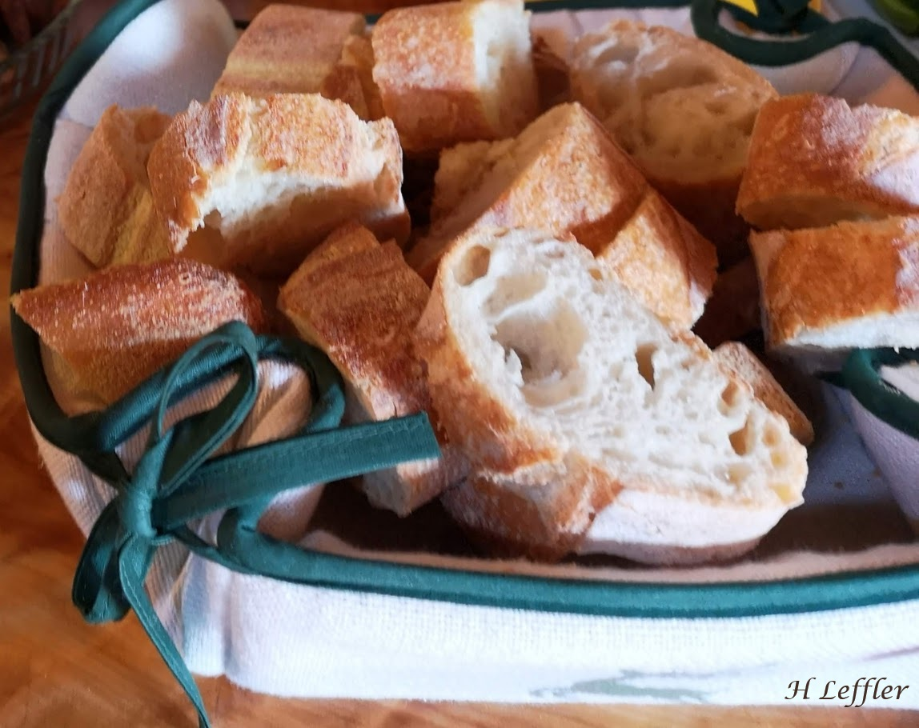
Contemplation and Conversation: Sunday, August 11, 2024
Scripture – John 6:24-35, 41-51
https://www.biblegateway.com/passage/?search=John+6%3A24-35%2C+41-51&version=NRSVUE
²⁴ So when the crowd saw that neither Jesus nor his disciples were there, they themselves got into the boats and went to Capernaum looking for Jesus.
²⁵ When they found him on the other side of the sea, they said to him, “Rabbi, when did you come here?” ²⁶ Jesus answered them, “Very truly, I tell you, you are looking for me not because you saw signs but because you ate your fill of the loaves. ²⁷ Do not work for the food that perishes but for the food that endures for eternal life, which the Son of Man will give you. For it is on him that God the Father has set his seal.” ²⁸ Then they said to him, “What must we do to perform the works of God?” ²⁹ Jesus answered them, “This is the work of God, that you believe in him whom he has sent.” ³⁰ So they said to him, “What sign are you going to give us, then, so that we may see it and believe you? What work are you performing? ³¹ Our ancestors ate the manna in the wilderness, as it is written, ‘He gave them bread from heaven to eat.’ ” ³² Then Jesus said to them, “Very truly, I tell you, it was not Moses who gave you the bread from heaven, but it is my Father who gives you the true bread from heaven. ³³ For the bread of God is that which comes down from heaven and gives life to the world.” ³⁴ They said to him, “Sir] give us this bread always.”
³⁵ Jesus said to them, “I am the bread of life. Whoever comes to me will never be hungry, and whoever believes in me will never be thirsty.
From Liz Guthrie
The people following Jesus are looking for “miraculous signs” but Jesus says they must believe in God. Jesus goes on to say that he is “the living bread that came down from heaven.” The people can understand physical hunger and thirst but find it hard to understand that their spiritual hunger and thirst can also be quenched.
This unbelief is illustrated in a recent Genesis Book Club pick entitled, “Fire Weather: A True Story from a Hotter World” by John Vaillant. The 2016 fire is burning outside of Fort McMurray. The towns people are told to go to work and the kids to school as usual. However, later in the day, workers are told to go home, collect important items and evacuate now. They know the fire is drawing closer but being asked to believe that this could happen to them is impossible to grasp right now. Belief gradually comes as they slowly drive on the one highway out of town through the billowing clouds of smoke, flying embers and the heat from the raging fire.
Let’s look at the ingredients of bread making that we need to help us on our faith journeys. Flour gives us backbone. Water keeps us hydrated while sugar provides food for the journey. Yeast helps us to rise up with courage as we add new experiences and strength with salt. The loaf is taking shape and we come to believe.
Contemplation and Conversation
What ingredient will be added next to your journey of faith?
What ingredient can you share?
Prayer
Supporting God, help us to share the ingredients of our faith with others. Amen.

Further Conversation … Would you like to talk more about today’s reflection? Email Heather at hleffler@rogers.com.

Our Rockwood Stone Family
If you missed today’s worship service, visit our Rockwood Stone YouTube page.

United Church of Canada Published On: August 9, 2024 on https://united-church.ca/news/new-data-shows-spike-hate-crimes-targeting-2slgbtqia-communities?fbclid=IwY2xjawEl1etleHRuA2FlbQIxMAABHfm0dlfVX3waIhq62llXVTng9BbHBZBIsa-CjhNH5eFOZwEu39NTytooMA_aem_9ve_3YSuJtvTfv7LjjfVYg

Congregations and communities of faith are encouraged to report incidents of 2SLGBTQIA+ hate whenever they occur
Statistics Canada’s recently released data on police-reported hate crimes(opens in a new tab) reveals a significant increase in hate crimes targeting individuals based on their sexual orientation. These crimes increased by 69% in 2023, up from 3% in 2020, 70% in 2021 and 16% in 2022. Based on this data, this is an increase of 225% in the past five years (2019-2023).
Hate crimes and incidences targeting The United Church of Canada-Affirming communities are also on the rise. Motivated by intersecting prejudices—including religious-induced homophobia, biphobia and transphobia—reported incidents are occurring in many forms including vandalism, assault, harassment, or abuse, and are happening both online and in person. A number of United Church-Affirming ministries have also reported receiving hate mail. The United Church of Canada congregations and communities of faith are encouraged to report incidents of 2SLGBTQIA+ hate whenever they occur.
Victims or witnesses of hate crime or incidences can take some steps as we work together to create a safer and more welcoming church and society for all people.
- Get medical help, if necessary.
- Write down any of the details of the crime as soon as possible after the incident and include details of the perpetrator(s), including gender, age, height, clothes and other distinguishing characteristics. If any threats or biased comments were made (such as anti-gay epithets), include them in the report.
- File a police report. While not all hate incidents will amount to criminal offences, it is equally important that these are reported and recorded by the police. If you believe the incident was bias-motivated, urge the officer to check the “hate/bias-motivation” or “hate crime/incident” box on the police report. You can also request the officer’s name and badge number for any follow-up.
- Notify your church minister or Regional Council staff about the incident. Find support as needed with friends and family, or professional help from a 2SLGBTQIA+ affirmative professional.
- If mail received by post is suspected to be hate correspondence, without opening it, you can report it as suspicious to the Canada Border Services Agency (CBSA) using their online form(opens in a new tab) if it has come from outside of Canada. Select: “Check this box if this is an update to an existing tip,” enter this unique reference number: BL1706905520630, and proceed with the report.
- If you do open the mail, do not insert any USB keys into any of your devices and be aware that the letters may contain disturbing messages targeting gay, lesbian, bisexual and transgender individuals. Report it to the CBSA.

A gift of belonging to a church is that the practice of gathering together for worship … to pray, sing, listen to scripture and share how God touches our lives – helps us grow in deeper relationship with God and each other. We are offering this practice of sharing beyond Sunday morning to deepen our connection. Each week you are offered a picture, a scripture and a question for contemplation, as well as a short reflection for you to contemplate, have conversation with people in your life and/or join an online conversation on our Rockwood Stone Facebook page.

