Contemplation and Conversation: Sunday, August 18, 2024
Scripture – Psalm 19 NRSVUE
https://www.biblegateway.com/passage/?search=psalm%2019&version=NRSVUE
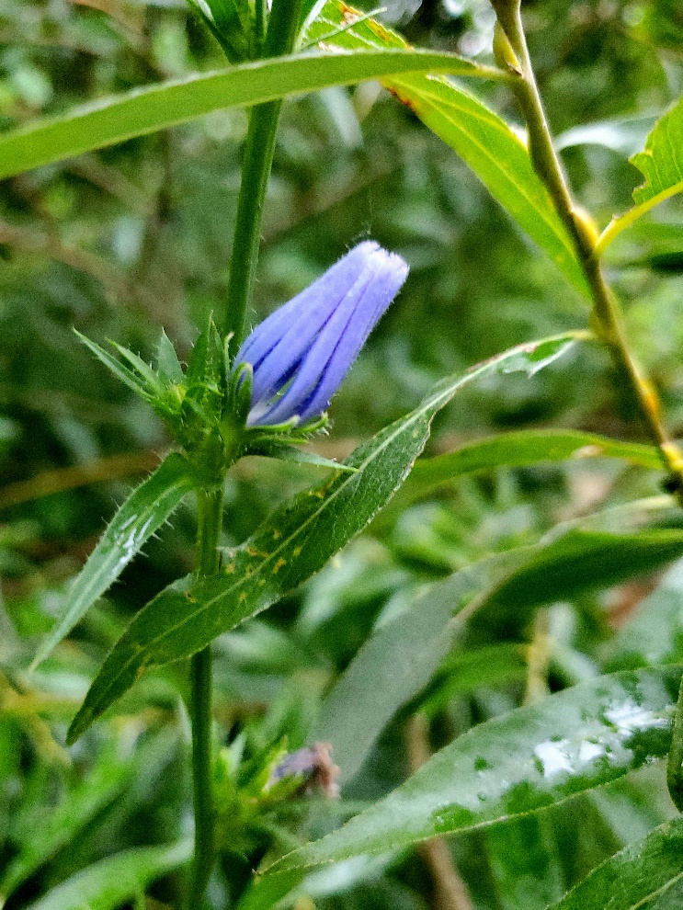
¹ The heavens are telling the glory of God,
and the firmament proclaims his handiwork.
² Day to day pours forth speech,
and night to night declares knowledge.
³ There is no speech, nor are there words;
their voice is not heard;
⁴ yet their voice goes out through all the earth
and their words to the end of the world.
In the heavens he has set a tent for the sun,
⁵ which comes out like a bridegroom from his wedding canopy,
and like a strong man runs its course with joy.
⁶ Its rising is from the end of the heavens
and its circuit to the end of them,
and nothing is hid from its heat.
⁷ The law of the Lord is perfect,
reviving the soul;
the decrees of the Lord are sure,
making wise the simple;
⁸ the precepts of the Lord are right,
rejoicing the heart;
the commandment of the Lord is clear,
enlightening the eyes;
⁹ the fear of the Lord is pure,
enduring forever;
the ordinances of the Lord are true
and righteous altogether.
¹⁰ More to be desired are they than gold,
even much fine gold;
sweeter also than honey
and drippings of the honeycomb.
¹¹ Moreover, by them is your servant warned;
in keeping them there is great reward.
¹² But who can detect one’s own errors?
Clear me from hidden faults.
¹³ Keep back your servant also from the insolent;
do not let them have dominion over me.
Then I shall be blameless
and innocent of great transgression.
¹⁴ Let the words of my mouth and the meditation of my heart
be acceptable to you,
O Lord, my rock and my redeemer.
From Lisa Leffler
As I was walking through Marden Park early the other morning, I noticed that the chicory flowers – that are usually wide-open soaking up the sunlight and inviting in pollinators to enjoy their nectar – were closed in the dim early morning. These flowers close at night to preserve energy and protect themselves from nighttime bugs that would harm them. It was a little late in the day for the flowers to still be closed as it was just after sunrise, but it was an overcast morning, and the flower wasn’t rushing to open before the sun was out.
This is one of the many places we gain wisdom by observing God’s creation. How often do we do things (or don’t do things) or rush around because that is what we think we are supposed to without pausing to think about the toll it is taking on ourselves or the world around us. The flower wasn’t thinking, “It is already 7:30 am I better open up my petals quickly!” It was taking the time to observe the world – to recognize that it is about to rain the pollinators won’t be flying around and if there is little sunlight there is no reason to open up and risk its delicate petals.
God’s wisdom is all around us if we are willing to pause, feel our connection to the earth and take the time to discern where God is calling us.
Contemplation and Conversation
What is God inviting you to through creation?
Prayer
God of all creation,
We give thanks for the wisdom of the world around us. Help us to set aside the busyness of life and take the time to focus on how you are calling us to take part in the natural rhythms of life. Amen.

Further Conversation … Would you like to talk more about today’s reflection? Email Heather at hleffler@rogers.com.

Our Rockwood Stone Family
If you missed today’s worship, you can watch it on the Rockwood Stone YouTube Channel

United Church of Canada
Mission and Service Stories: Nothing Can Hold Us Back

Audacious Hope, the national youth and young adult event, brought together over 450 energetic young people and passionate youth leaders July 3-6, 2024, for an unforgettable experience charged with rejuvenated spirit and boundless optimism.
Your generosity through Mission and Service helps continue programs and workshops that encourage youth in their faith.

A gift of belonging to a church is that the practice of gathering together for worship … to pray, sing, listen to scripture and share how God touches our lives – helps us grow in deeper relationship with God and each other. We are offering this practice of sharing beyond Sunday morning to deepen our connection. Each week you are offered a picture, a scripture and a question for contemplation, as well as a short reflection for you to contemplate, have conversation with people in your life and/or join an online conversation on our Rockwood Stone Facebook page.

