Contemplation and Conversation: Sunday, September 1, 2024
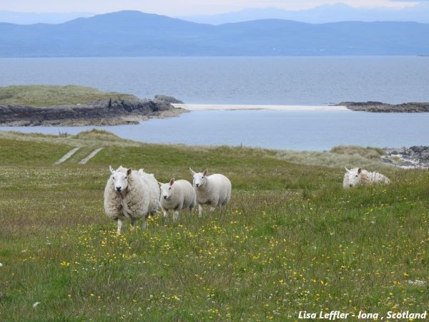
Scripture – Psalm 121 NRSVUE
https://www.biblegateway.com/passage/?search=psalm%20121&version=NRSVUE
¹ I lift up my eyes to the hills—
from where will my help come?
² My help comes from the Lord,
who made heaven and earth.
³ He will not let your foot be moved;
he who keeps you will not slumber.
⁴ He who keeps Israel
will neither slumber nor sleep.
⁵ The Lord is your keeper;
the Lord is your shade at your right hand.
⁶ The sun shall not strike you by day
nor the moon by night.
⁷ The Lord will keep you from all evil;
he will keep your life.
⁸ The Lord will keep
your going out and your coming in
from this time on and forevermore.
From Brian Mack
Farmers worry. Will there be enough rain? Will there be too much rain? Will it be too cold? Will it be too hot? Will the seed sprout? Will an early frost cause a short fall in yield? Will my animals be born easily? Will my animals grow quickly or slowly? Will commodity prices rise or fall? Will enough snow accumulate to cover the land to provide for plants to rest and rejuvenate? The list of things to worry about is endless. Whatever our station is in life, we worry. We hesitate. We face uncertainty.
When I find myself overthinking things which I cannot control, I often turn to this song of pilgrimage. The people of Israel who were travelling to Jerusalem for one of the various festivals also had much worry in their lives. The song offered them courage in the face of immediate danger on the way to the temple. Just as importantly, the song provided them with a sense of strength for their individual and collective journey on the “road of life”.
Fast forward to the late summer of 2024. This song of pilgrimage which gave great comfort to the people of Israel so long ago gives me hope in times of uncertainty. The opening words remind me to “look up” to God as a source of strength and encouragement. I am reminded of the historical perspective. God is the God of Creation. Holy Mystery has been watching over all that was formed since the Spirit moved over the waters as recorded in Genesis 1. God preserved the people of Israel through times of trouble and that same God is walking with us today. Finally, Creator God is the God of eternity. In life, in death, and in life beyond death, God is with us. We can be confident that the words of Psalm 121 are words meant for us. Thanks be to God.
Contemplation and Conversation
How do you experience the strength and peace granted to us by Holy Mystery?
Prayer
Holy God, in you I place all my trust.
Strengthen my faith in you.
Increase my sense of hope and courage as I travel on life’s journey. Amen.

Further Conversation … Would you like to talk more about today’s reflection? Email Heather at hleffler@rogers.com.

Our Rockwood Stone Family
If you missed today’s worship service, visit our Rockwood Stone YouTube page.

United Church of Canada
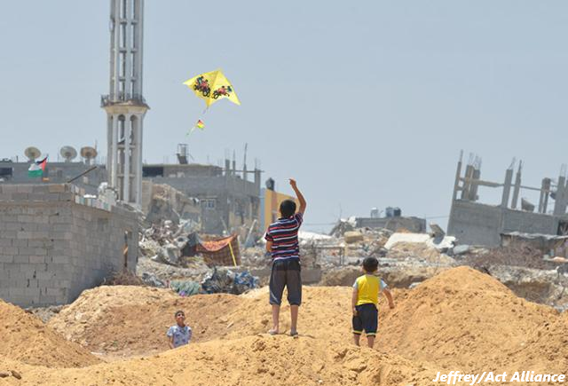
Support Justice and Peace in Palestine and Israel
Act today: The international community cannot stay quiet in the face of atrocities in Gaza.

People in Gaza are experiencing utter destruction, loss of lives, and inhumane conditions without access to basic necessities for life. Famine is imminent. Children are particularly impacted. Our faith and our humanity calls us to act now to ensure to ensure a just and lasting peace in Gaza.
It will take all of our efforts to get the Government of Canada to do everything in its power to help bring an end to the military atrocities in Gaza and to not be complicit in genocide and famine.
Please join us in action: advocate, pray, and donate.
Helping those in urgent need
The United Church of Canada's Mission and Service partners are responding to those impacted by wide-reaching human suffering happening in the West Bank and East Jerusalem. They will rapidly expand their activity into Gaza and provide aid when a safe humanitarian corridor opens.

The United Church is working with Mission and Service partners ACT Alliance and Department of Service to Palestinian Refugees(opens in a new tab) (DSPR). As a member of the Canadian Foodgrains Bank, we are also working with Foodgrains Bank partners on the ground to offer lifesaving support to Palestinians in the West Bank and East Jerusalem, and Gaza.
Take Action
Pray
Pray for peace with justice for the people of Palestine and Israel. As people of faith, we bring the grief, compassion and concerns of a hurting world to God. Additional prayers can be found here and at Canadian Council of Churches(opens in a new tab).
Links to traditional Palestinian music can be found with materials for World Day of Prayer 2024 Palestine(opens in a new tab).
Donate
Online via our secure donation page.
Phone toll-free 1-800-465-3771 and use your Visa or MasterCard.
Send a cheque or money order to:
The United Church of Canada
Philanthropy Unit - Emergency Response
3250 Bloor Street West, Suite 200
Toronto, ON M8X 2Y4
Please be sure to note "Emergency Response—Middle East" on the face of your cheque.
Note: As part of the United Church’s Emergency Response Fund, 100% of your donation goes directly to emergency relief, with 85% of your donation responding to this designated emergency and 15% responding to future emergencies that do not receive intense media coverage. Donations to Mission and Service enable the United Church to cover all of the costs of emergency response work without deducting any fees from your donation.
Advocate
The United Church of Canada urges the Government of Canada to do everything in its power to bring an end to the large-scale human suffering in Palestine and Israel and to not be complicit in genocide and famine. We need Canada to act on three fronts:
- First, a permanent ceasefire is essential to allow for safe delivery of critical humanitarian relief into Gaza—food, medicine, potable water—and also to create conditions for a just and lasting peace and basic human dignity in the region.
So, we call on Canada to use all diplomatic channels and leverage points to secure an immediate and permanent ceasefire, and for Canada to implement a comprehensive and binding arms embargo.*
- Second, humanitarian aid—including from The United Church of Canada Mission and Service partners—needs to reach those in need, urgently and abundantly.
So, we call on Canada to use all diplomatic, political and economic channels and leverage points to urge Israel to ensure safe passage of humanitarian aid to Gaza. Canada should also increase its aid envelope and help support refugees.
- Third, we must support building the conditions for a just and lasting peace—where safety, respect for rights, justice, and human dignity are safeguarded for all.
Therefore, we call on Canada to support international efforts to hold all parties accountable for violations of international law to ensure this situation is never repeated, and to commit to long-term engagement in support of human rights and international law, without exception, in the region.
Canada has a legal and moral duty to do everything in its power to prevent acts of genocide and avoid complicity in any such acts, because it is a signatory to the Convention on the Prevention and Punishment of the Crime of Genocide and the Convention on the Rights of the Child.
* For more on this, see UN Special Rapporteur Francesca Albanese’s findings of genocide and state obligation to impose an arms embargo (testimony(opens in a new tab) to UNHRC; written report(opens in a new tab)) and Project Ploughshares 2023 report(opens in a new tab) noting “substantial risk” that Canadian military goods could contribute to abuses in Gaza.
Write your MP

A gift of belonging to a church is that the practice of gathering together for worship … to pray, sing, listen to scripture and share how God touches our lives – helps us grow in deeper relationship with God and each other. We are offering this practice of sharing beyond Sunday morning to deepen our connection. Each week you are offered a picture, a scripture and a question for contemplation, as well as a short reflection for you to contemplate, have conversation with people in your life and/or join an online conversation on our Rockwood Stone Facebook page.

