Contemplation and Conversation: Sunday, September 8, 2024
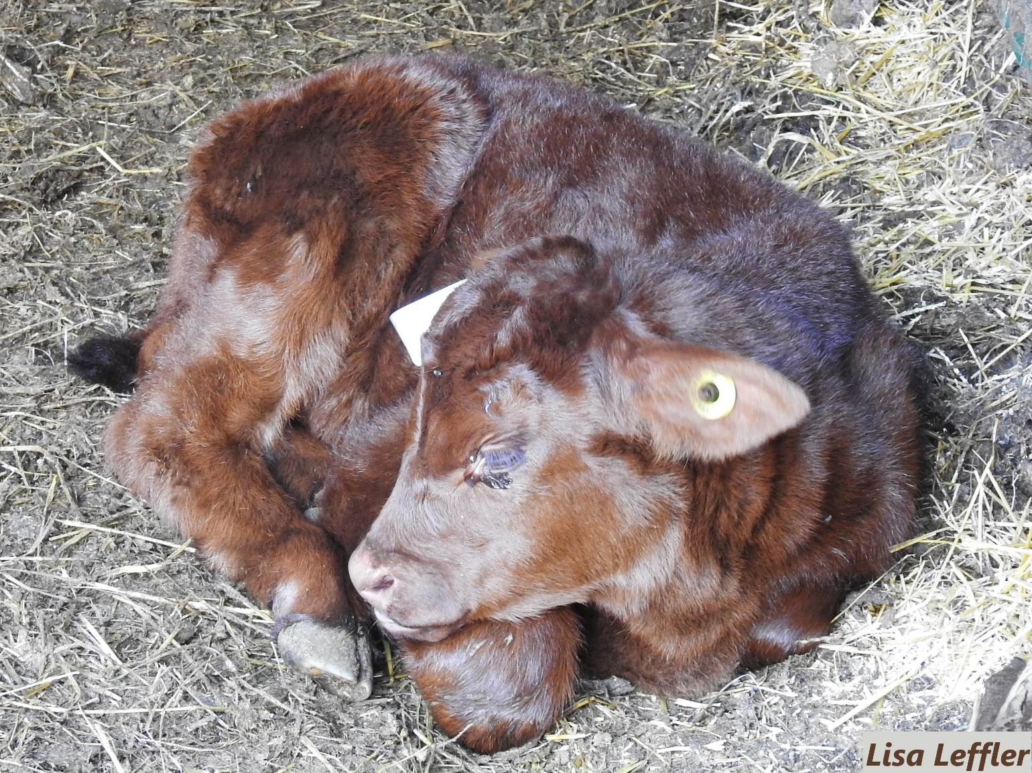
Scripture – Psalm 139:7-18 NRSVUE https://www.biblegateway.com/
passage/?search=Psalm%20139%3A7-18%20&version=NRSVUE
⁷ Where can I go from your spirit?
Or where can I flee from your presence?
⁸ If I ascend to heaven, you are there;
if I make my bed in Sheol, you are there.
⁹ If I take the wings of the morning
and settle at the farthest limits of the sea,
¹⁰ even there your hand shall lead me,
and your right hand shall hold me fast.
¹¹ If I say, “Surely the darkness shall cover me,
and night wraps itself around me,”
¹² even the darkness is not dark to you;
the night is as bright as the day,
for darkness is as light to you.
¹³ For it was you who formed my inward parts;
you knit me together in my mother’s womb.
¹⁴ I praise you, for I am fearfully and wonderfully made.
Wonderful are your works;
that I know very well.
¹⁵ My frame was not hidden from you,
when I was being made in secret,
intricately woven in the depths of the earth.
¹⁶ Your eyes beheld my unformed substance.
In your book were written
all the days that were formed for me,
when none of them as yet existed.
¹⁷ How weighty to me are your thoughts, O God!
How vast is the sum of them!
¹⁸ I try to count them—they are more than the sand;
I come to the end—I am still with you.
From Sarah Leffler
We are not alone; we live in God’s world
Psalm 139 is one of my favourite psalms. The image of being knit together in my mother’s womb is comforting and makes me think of creation as an expression of love. At the same time my mind jumps to high school and seeing a cell dividing to become something the same but in the larger picture something new.
The psalmist searches creation to find a space beyond God but ultimately comes to the weighty understanding that the Creator is all knowing and the source of us. While exploring the big picture of life, science, philosophy, theology or any attempt at understanding beyond our lived experience can be fascinating, it can also be overwhelming, cause division and be a source of fear.
The beauty of knowing we are not alone and that we were intricately woven in the depths of the earth brings us back to the tangible source, reminding us we are a part of creation. As a people we strive to expand our understanding leading to amazing innovations that let us fly and settle farther than our ancestors could have imagined. Yet we have only started to scratch the surface of the Creator’s knowledge of this amazing world of which we are a part. We can hold fast to the comforting knowledge that we are known by our Creator as a wonderful work that was formed in secret and held in God’s love. When we are overwhelmed by our thoughts or feeling alone, we are not. God is with us and has more writings for us to discover about ourselves and how to shine a light on the wonder that is creation.
Contemplation and Conversation
When have you felt overwhelmed or in awe of Creation?
When have you experienced comfort in knowing you are a loved creation of God?
Prayer
Holy One, who knows us wholly,
Help us to remember we are a valuable part of your creation. Help us to be expressions of your love, in your awe-inspiring world, as we strive to know you more fully. Amen.
Spiritual Practice
Connecting with God in Creation
Take your camera or a sketch book and find a place to be in nature. Wander around. Take your time. Notice the world around you. How are the animals and insects interacting with one another? What plants catch your eye? Is there any water nearby? Take a picture of whatever catches your eye and pause to reflect on how we are all connected through God’s good earth, so we are truly never alone.
If you are unable to get outside, close your eyes and think of a place where you felt God’s presence in creation. Take a moment to sit with the image – inspecting every detail. Open your eyes and draw what you remember. Don’t worry if it doesn’t look exactly “right” just let your hand flow over the page and do your best. God doesn’t expect us to be perfect. When you are done the image, consider sharing the memory and the picture with someone you care about.
Activity
Make Your Own Puzzle
Step 1: On the unlined side of your puzzle cardstock print, draw or glue your favourite picture. To add stability to your puzzle you could glue a cereal box between the cardstock and the picture. Just make sure you leave the lines facing out, so you know where to cut.
Step 2: Cut along the lines of your puzzle.
Step 3: Enjoy your puzzle! Put it together yourself or share it with a friend.

Further Conversation … Would you like to talk more about today’s reflection? Email Heather at hleffler@rogers.com.

Our Rockwood Stone Family
If you missed today’s worship service, visit our Rockwood Stone YouTube page.
This week marks the first week of the Season of Creation – a time to reflect on the gifts we have been given through creation and how we can care for the earth and everything in it.
For the next six weeks, in addition to our usual Contemplation and Conversation reflections, you will receive a spiritual practice and activity you can do from our creation packs. If you are on our Creation Pack List you should receive a print copy this week. Attached to this email you will find a copy of the creation pack booklet (in a print friendly and screen friendly version) as well as a puzzle template and bookmarks you can print if you want extra copies. If you would like to share any pictures from your activities and spiritual practices or reflections from the contemplation questions visit our Rockwood Stone Facebook page and share in the comments.
If you are not receiving packages (Easter, Creation Time, Advent/Christmas) and would like to please contact the church office at rockwoodstoneuc@gmail.com so we can make sure you receive the next package. We will continue to send digital copies of the booklet in Contemplation and Conversation.

United Church of Canada 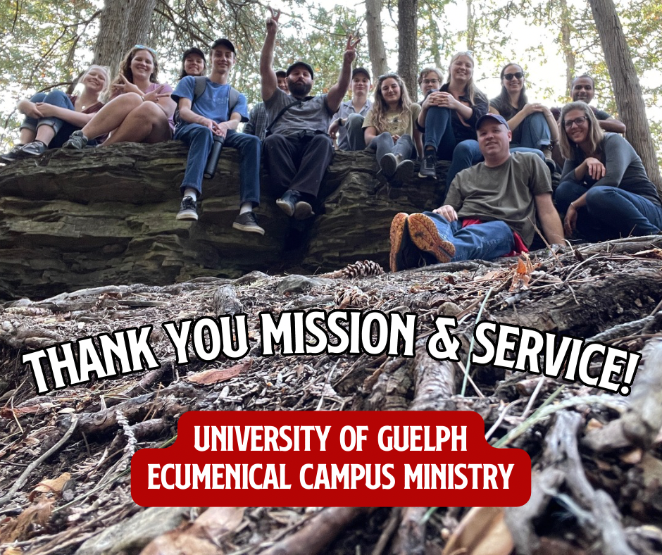
Mission and Service Good News Story – Back to School Edition!
Read below about Guelph Ecumenical Ministry, which received a Mission Support Grant last year from the WOW Discipleship and Justice Commission to fund its work with young adults.
Thanks to support from United Church Mission & Service, the Ecumenical Campus Ministry at the University of Guelph has been able to support the UofG community and accompany young adults during some of the most transformative years of their lives.
The Ecumenical Campus Ministry has been a partnership of the Anglican, Presbyterian, and United Church at UofG since 1968. The chaplaincy is fully supported by alumni, parents, and grants from partner churches – the university does not fund faith programming.
Over the 2023/24 academic year, ECM was able to serve 25 free meals to university students, provide weekly worship services right on campus, conduct field trips to 10 local churches, hold 3 public presentations on issues of faith and inclusivity, mentor 5 student leaders, host 2 different weekend retreats, and coordinate the Queer Christian Community for 2SLGBTQIA+ students at UofG. This just scratches the surface!
This kind of ministry presence is made possible because of ECM’s vision of having a full-time chaplain, something that would be unthinkable without support from United Church Mission & Service.
So from all the students at UofG, thank you for your gifts to United Church Mission & Service! Your support is making a difference in the lives of young adults at the University of Guelph.
The 2023/24 ECM Highlight Video can be viewed here.

A gift of belonging to a church is that the practice of gathering together for worship … to pray, sing, listen to scripture and share how God touches our lives – helps us grow in deeper relationship with God and each other. We are offering this practice of sharing beyond Sunday morning to deepen our connection. Each week you are offered a picture, a scripture and a question for contemplation, as well as a short reflection for you to contemplate, have conversation with people in your life and/or join an online conversation on our Rockwood Stone Facebook page.

