Contemplation and Conversation: Sunday, September 15, 2024
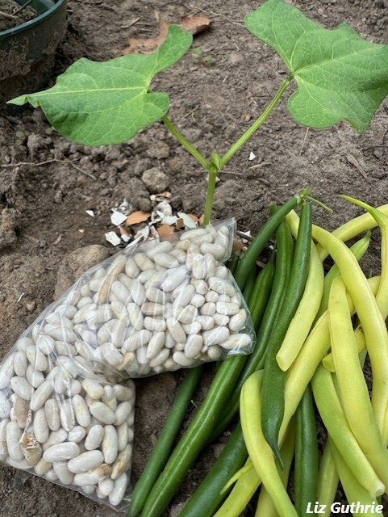
Scripture – Mark 4 :1-9 NIV https://www.biblegateway.com/passage/ ?search=Mark%204%3A1-9&version=NIV
4 Again Jesus began to teach by the lake. The crowd that gathered around him was so large that he got into a boat and sat in it out on the lake, while all the people were along the shore at the water’s edge. ² He taught them many things by parables, and in his teaching said: ³ “Listen! A farmer went out to sow his seed. ⁴ As he was scattering the seed, some fell along the path, and the birds came and ate it up. ⁵ Some fell on rocky places, where it did not have much soil. It sprang up quickly, because the soil was shallow. ⁶ But when the sun came up, the plants were scorched, and they withered because they had no root. ⁷ Other seed fell among thorns, which grew up and choked the plants, so that they did not bear grain. ⁸ Still other seed fell on good soil. It came up, grew and produced a crop, some multiplying thirty, some sixty, some a hundred times.”
⁹ Then Jesus said, “Whoever has ears to hear, let them hear.”
From Liz Guthrie
We believe in God: who has created and is creating,
We believe that God created night and day, the sun, moon and stars, dry land, fowl of the air, fish of the sea and humankind. He continues to create.
who has come in Jesus, the Word made flesh,
to reconcile and make new,
God created Jesus, who came to us as an infant. Jesus grew up learning the ways of his people – not only their hopes and fears, but their need to know about God’s love. Jesus was that “seed” that used parables to show the way to a new way of being.
who works in us and others by the Spirit.
We may be scattered as seeds in war torn countries, in famine-stricken areas, in a homeless population, in the 2SLGPTQIA+ community, in faith communities, in an Indigenous community, in service organizations, in educational institutions or in long term care. No matter where we find ourselves, we can show God’s love by saying a prayer, holding a hand, holding open a door, providing food, clothing and shelter, bringing words of encouragement, listening, or sharing a smile. Alydia Smith says, “In God’s Garden, we are all seeds, full of promise and potential.”
Contemplation and Conversation
What communities have you been “scattered” in?
What “seeds” are taking root?
Prayer
Creating God, we ask for your blessing as we help to grow new seeds
in the communities we have been scattered in. Amen.
Spiritual Practice
Listening for God’s Word
Read The New Creed on the bookmark and highlight, underline or illustrate the words that stand out for you.
Reflect on the words that stood out for you and consider:
- Where is God calling you to something new?
- What seeds are being planted on you?
While you are reflecting it may be helpful to colour the bookmark on the back to help relax your mind.

Activity
Sharing the Gifts of Creation
Part of being “in community” involves sharing the gifts we are given. Many of us have a favourite recipe that has been passed down in our families. Consider sharing your recipe with a friend this week and/or send it into the church office (rockwoodstoneuc@gmail.com), so we can share your great recipes with our church family.

Further Conversation … Would you like to talk more about today’s reflection? Email Heather at hleffler@rogers.com.

Our Rockwood Stone Family
If you missed today’s worship service, visit our Rockwood Stone YouTube page.

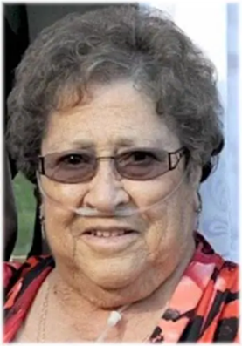
FERGUSON (nee Fletcher), Georgina Jane – Of Guelph, passed away peacefully at Hospice Wellington on Wednesday, September 11th, 2024, in her 91st year.
Beloved wife of Eugene (predeceased). Loved Mother of Randy (predeceased) (Chris) Ferguson, Mike (Edit) Ferguson, Brenda (Steve) Farlow, Jim (Joan) Ferguson and Tim (Heather) Ferguson. Loving grandmother of Kyle, Candice, Chad, Nicole, Laszlo, Chibi, Keltie, Kallen, Megan and Kristen, great Grandmother of Nine and great-great Grandmother of Two. Dear sister of Deb (predeceased), Al, George (predeceased), Joan, Mary and Maggie. Will be fondly remembered by many nieces, nephews, extended family and friends.
Friends and family will be received at the WALL-CUSTANCE FUNEREAL HOME & CHAPEL 206 Norfolk Street, Guelph, Ontario on Tuesday, September 17, 2024 from 9:00 am to 11:00 am. Service to follow at 11:00 am in the Wall-Custance Chapel. For anyone that would like to watch the service remotely, please use this Zoom link. Reception to follow in the Wall-Custance Family Reception Centre. Burial to take place at 1:30 pm at Memory Gardens, Breslau.
Arrangements entrusted to the WALL-CUSTANCE FUNERAL HOME & CHAPEL 519-822-0051 / www.wallcustance.com.
Memorial contribution to Hospice Wellington or the Canadian Cancer Society would be appreciated.
A tree will be planted in memory of Georgina J. Ferguson in the Wall-Custance Memorial Forest.

If you would like to share any pictures from your activities and spiritual practices or reflections from the contemplation questions visit our Rockwood Stone Facebook page and share in the comments.

United Church of Canada

A gift of belonging to a church is that the practice of gathering together for worship … to pray, sing, listen to scripture and share how God touches our lives – helps us grow in deeper relationship with God and each other. We are offering this practice of sharing beyond Sunday morning to deepen our connection. Each week you are offered a picture, a scripture and a question for contemplation, as well as a short reflection for you to contemplate, have conversation with people in your life and/or join an online conversation on our Rockwood Stone Facebook page.

