Contemplation and Conversation: Sunday, September 22, 2024

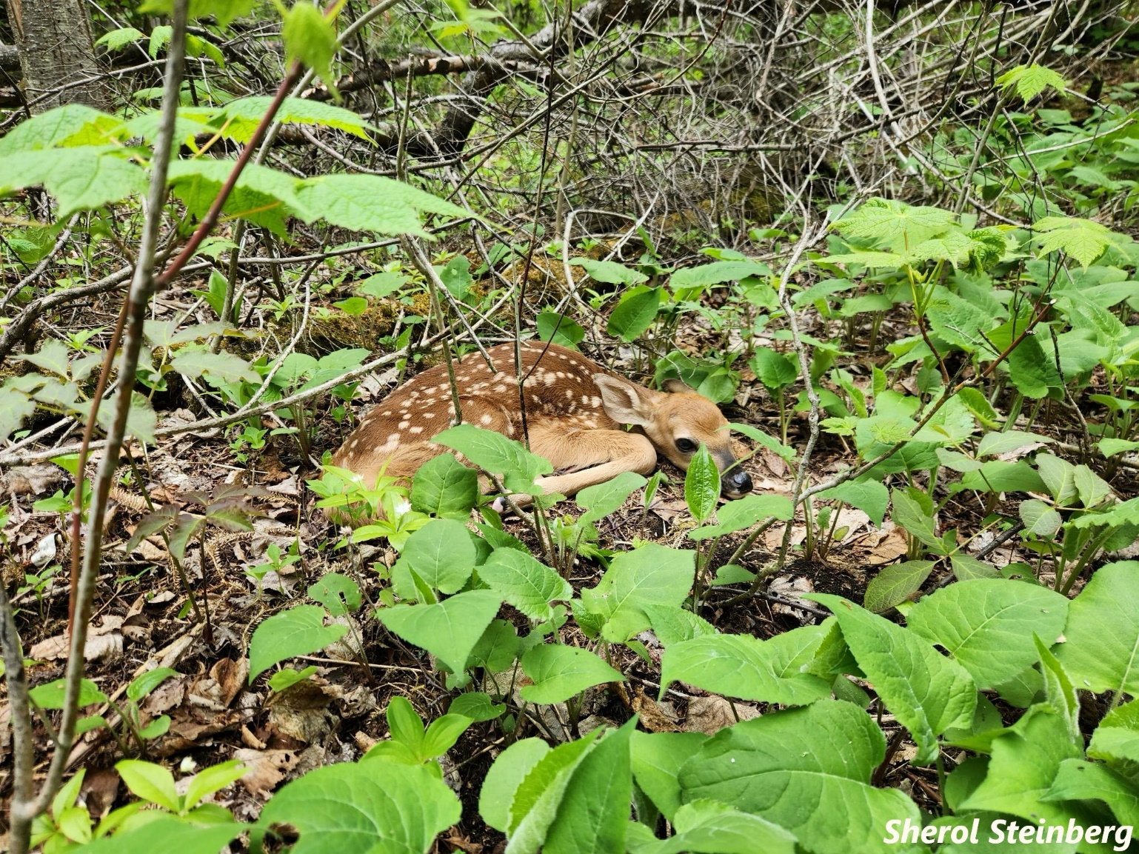
Scripture – Jeremiah 17: 5-8 NIV https://www.biblegateway.com/passage/ ?search=Jeremiah%2017%3A%205-8&version=NIV
⁵ This is what the Lord says:
“Cursed is the one who trusts in man,
who draws strength from mere flesh
and whose heart turns away from the Lord.
⁶ That person will be like a bush in the wastelands;
they will not see prosperity when it comes.
They will dwell in the parched places of the desert,
in a salt land where no one lives.
⁷ “But blessed is the one who trusts in the Lord,
whose confidence is in him.
⁸ They will be like a tree planted by the water
that sends out its roots by the stream.
It does not fear when heat comes;
its leaves are always green.
It has no worries in a year of drought
and never fails to bear fruit.”
From Tammy Smits
We Trust in God
Trust. It is a word used often, both in the church and outside, but what exactly is trust? An emotion? An action? How do you make yourself trust when it doesn’t come easily?
The Oxford dictionary, in part, defines trust as both a noun (the firm belief in the reliability, truth, ability, or strength of someone or something, as in “relations have to be built on trust”) and a verb (to believe in the reliability, truth, ability, or strength of, as in “I should never have trusted her”).
Reliability. Truth. Ability. Strength. Powerful words that can have a huge impact! No wonder trust is such a precious thing to place in the hands of others and have placed upon us in return. No wonder Jeremiah explicitly tells us to place our trust in God, as opposed to people.
We have all had the unpleasant experience of putting our trust in someone who fails us, be it purposefully or inadvertently, and have also had the unfortunate experience of being the one who lets someone down. Life is complex, and breaking trust can be complicated when issues and perspectives are many shades of grey instead of clear black and white, and the best of intentions are coloured with unrecognized biases and accumulated life trauma.
God can see through the shades and layers and knows our hearts and intentions even when we don’t understand ourselves. More importantly, God has our best interest at heart and wants to guide us to being our best selves; although the path may not always be the road we want to travel, we know that God is pointing us in the right direction and will not lead us astray. We can put our trust in God because there is nothing and no one else as reliable, true, capable and strong.
Contemplation and Conversation
Do you have “trust issues”?
Do you find it difficult to trust people, God, or both?
Prayer
Dear Lord, help us to remember that when all else is a mess, you are the one constant we can rely on, and that sometimes the mess is the best way to get us where we need to be. Amen.
Spiritual Practice
Grounding Ourselves in Creation
“Be still and know that I am God.”
Find a quiet spot in your home or in nature each day this week.
- turn off all devices
- sit quietly for a few minutes
- breathe deeply
- and be one with Holy Mystery.
Activity
Connecting with God in the World
Choose a book or a movie.
Watch how the characters interact.
- Do they trust easily or are they slow to connect? How do they build trust with each other?
- How do you build trust in your own life?
- Does trust in God help you to learn to trust others?
- How do you build trust with others?
- How do you know when to trust your own boundaries?
If you have time, you may wish to re-read or re-watch the movie to gain additional insights.

Further Conversation … Would you like to talk more about today’s reflection? Email Heather at hleffler@rogers.com.

Our Rockwood Stone Family
If you missed today’s worship service, visit our Rockwood Stone YouTube page.
If you would like to share any pictures from your activities and spiritual practices or reflections from the contemplation questions visit our Rockwood Stone Facebook page and share in the comments.

United Church of Canada

A gift of belonging to a church is that the practice of gathering together for worship … to pray, sing, listen to scripture and share how God touches our lives – helps us grow in deeper relationship with God and each other. We are offering this practice of sharing beyond Sunday morning to deepen our connection. Each week you are offered a picture, a scripture and a question for contemplation, as well as a short reflection for you to contemplate, have conversation with people in your life and/or join an online conversation on our Rockwood Stone Facebook page.

