Contemplation and Conversation: Sunday, September 29, 2024
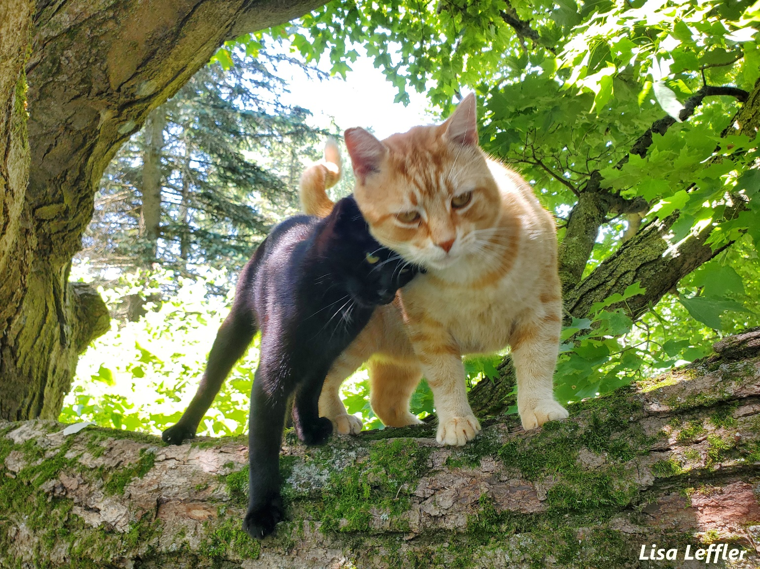
Scripture – Psalm 8 NRSVUE https://www.biblegateway.com/passage/
?search=Psalm%208&version=NRSVUE
¹ O Lord, our Sovereign,
how majestic is your name in all the earth!
You have set your glory above the heavens.
² Out of the mouths of babes and infants
you have founded a bulwark because of your foes,
to silence the enemy and the avenger.
³ When I look at your heavens, the work of your fingers,
the moon and the stars that you have established;
⁴ what are humans that you are mindful of them,
mortals that you care for them?
⁵ Yet you have made them a little lower than God
and crowned them with glory and honor.
⁶ You have given them dominion over the works of your hands;
you have put all things under their feet,
⁷ all sheep and oxen,
and also the beasts of the field,
⁸ the birds of the air, and the fish of the sea,
whatever passes along the paths of the seas.
⁹ O Lord, our Sovereign,
how majestic is your name in all the earth!
From Brian Mack
We are called to be the Church:
to celebrate God’s presence,
to live with respect in Creation,
to love and serve others,
to seek justice and resist evil,
to proclaim Jesus,
crucified and risen,
our judge and our hope.
I’m sitting outside on a day filled with sunshine and beautiful fluffy clouds. The swallows are busy attending to their noisy second group of babies. The raccoons born in the spring and nourished by protein rich milk are now beginning to accumulate layers of fat which will be so necessary for their winter survival. The fox kits have learned to hunt, and the coyote pups have realized that a tasty morsel of mouse is readily available in the long grass. Baby turtles have emerged from the eggs deposited in the sand so diligently by their mother and have made the pilgrimage to a pond. On a day such as this it is easy to think that all is right in the world conceived by Creator God.
When I step back inside my house and turn on my computer, I am confronted with quite a different perspective. I am bombarded with a series of disturbing images. Bombs are exploding. Homelessness and drug addiction abounds. People are despised because of their sexual orientation. Political infighting is characterized by racism and ageism rather than dialogue. Forest fires rage and devastating floods wreak havoc as our collective home convulses in response to human induced climate change. It is hard to think that anything is right in the world conceived by Creator God.
God entrusted all of his creation to us. Holy Mystery made us responsible for what was formed and for what God continues to form. As individuals and as a church, much is expected of us. Just as the Spirit of God hovered over the surface of the waters as described in Genesis, that same Spirit is nudging us to action in 2024 to open ourselves to new possibilities to build peace, ensure justice, provide dignity for all, and to heal the Earth. As Pope Francis suggests, “Let yourself be pulled along, shaken up, challenged…Stop and pray… Read the gospel...And then act.” (Let Us Dream by Pope Francis, p. 137). Thanks be to God.
Contemplation and Conversation
How are you serving God to create "the common good"?
Prayer
Holy Mystery, we honor you as we remember the opening words of the gospel of John: “In the beginning there was the Word, and the Word was in God’s presence, and the Word was God.” As God of Formation, encourage us to pause and decenter. Help us to see with new insight the needs of the those around us and open our hearts to new areas of service. Amen.
Spiritual Practice
Take a piece of paper and draw a foundation stone at the base of the page to represent your birth. Write on the stone your date of birth and the circumstances. Then build upon that stone, adding other stories to represent the major events of your life (both those bringing great joy and those that brought sorrow). Then add notations about major political or cultural events that have occurred in your lifetime. When you have finished, look at the whole picture and reflect on the question: What might God be doing in my life and around the world?
(adapted from Discernment by Henri J Nouwen with Michael J. Christensen and Rebecca I. Laird, p. 93)
Activities
Living in Respect in Creation
To live with respect in creation we need to care for God’s good earth. We can do this by trying to reduce our carbon footprint and the waste we produce. Do you have groceries you can buy in bulk? Could you carpool with a neighbour to the grocery store? Do you have items you could reuse, recycle or donate instead of throwing them in the trash?
How can you reduce waste in your daily life to care for creation?

Further Conversation … Would you like to talk more about today’s reflection? Email Heather at hleffler@rogers.com.

Our Rockwood Stone Family
If you missed today’s worship service, visit our Rockwood Stone YouTube page.
If you would like to share any pictures from your activities and spiritual practices or reflections from the contemplation questions visit our Rockwood Stone Facebook page and share in the comments.

United Church of Canada
Moderator’s Orange Shirt Day Message 2024
On September 30th, and every day, we must remember that every child matters.
Click here for the video.
On September 30th we observe the National Day for Truth and Reconciliation, or Orange Shirt Day. We witness and honour the healing journey of survivors and families of the residential school experience, and we remember those who didn’t make it home.
There is still a very long journey ahead of us as we seek to make things right. Racist or colonial policies continue to harm Indigenous children and their families.
On September 30th, and every day, we must remember that every child matters.

Anishnabeg Outreach
Join Anishnabeg Outreach’s September 30th Event!
Attend our Truth & Reconciliation Event on September 30 from 10 am to 1 pm. at 1160 Spitzig Rd., Woolwich, ON, N0B 1M0 (Additional parking will be available at 1058 Spitzig Rd.)
We’re gathering with Sustainable Waterloo Region, Home Depot & others at our Spirit Garden for Everyone, Eminidowang Kitigaan. Together, we will finish planting & mulching our edible micro-forest, plant more cedar hedges & fruit trees, enjoy a BBQ hosted by Home Depot & listen to a keynote speech from AO CEO, Stephen Jackson. If you have the day off & would like to get active, please join us in honour of the upcoming National Day for Truth & Reconciliation.

A gift of belonging to a church is that the practice of gathering together for worship … to pray, sing, listen to scripture and share how God touches our lives – helps us grow in deeper relationship with God and each other. We are offering this practice of sharing beyond Sunday morning to deepen our connection. Each week you are offered a picture, a scripture and a question for contemplation, as well as a short reflection for you to contemplate, have conversation with people in your life and/or join an online conversation on our Rockwood Stone Facebook page.

