Contemplation and Conversation: Sunday, October 13, 2024
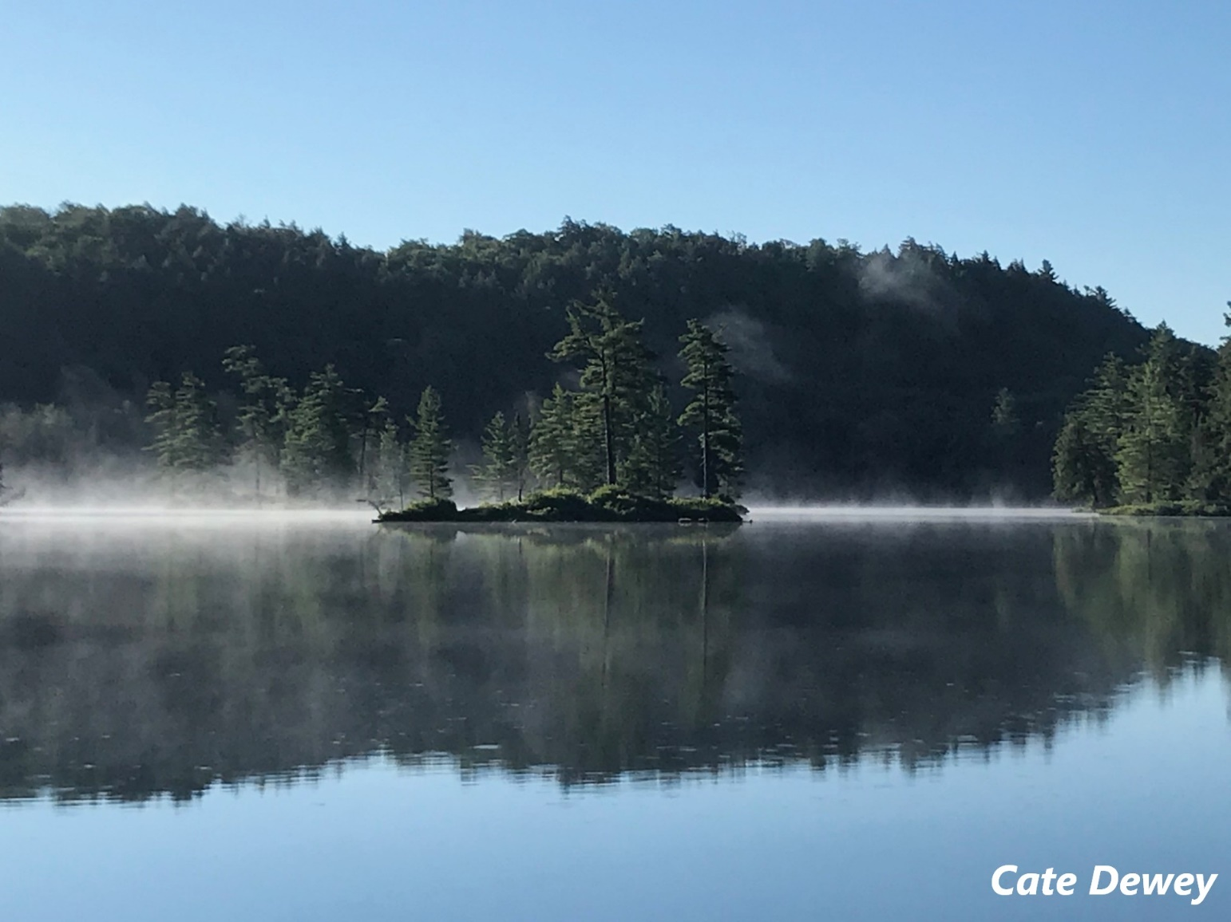
Scripture – Psalm 100 NRSVUE https://www.biblegateway.com/passage/?search=Psalm%20100&version=NIV
¹ Shout for joy to the Lord, all the earth.
² Worship the Lord with gladness;
come before him with joyful songs.
³ Know that the Lord is God.
It is he who made us, and we are his;
we are his people, the sheep of his pasture.
⁴ Enter his gates with thanksgiving
and his courts with praise;
give thanks to him and praise his name.
⁵ For the Lord is good and his love endures forever;
his faithfulness continues through all generations.
From Cate Dewey
Thanks be to God.
For many years, I have made a solo trip to the wilderness of Algonquin. Reaching the campsite by canoe, in a place where I may not see another person for days on end, a place with no electricity, no cell phone service, just my dog, and the beauty of the world that God created. I understand that this is not for everyone – but for me it is a time to reconnect with my inner self, to complete a bible study, pray, journal about my past and future self and experience the AWE of God’s creation.
For a week, I live in a tent. I get up to see the sun rise. I hear only the sounds of God’s creation, the lapping of the water against the rocks, the birds in the trees and the gulls and loons flying overhead, the rain, and the crash of a tree falling in the woods. I watch nature – turtles and fish, snakes and spiders, flowers, trees, mushrooms, and the natural cycle of life and death around me. My life slows, I am open to spirituality and from this experience, my faith and purpose and wholeness as a Christian grow. I begin new ways of connecting to God, Jesus, and the Holy Spirit. A few years ago, I began starting my day with a gratitude prayer – It begins with “This is the day the Lord has made, let me rejoice and be glad in it’, followed by my gratitude list.
Contemplation and Conversation
When do you experience a sense of AWE at the natural world that God created?
Prayer
God, in your infinite creativity, you made the natural world that surrounds us. We pray that you open our hearts and minds to the feeling of awe that this gift inspires. Let us find time in our busy lives to rejoice and be glad in it. Amen.

Spiritual Practice
Gratitude List
This is the day that the Lord has made; let us rejoice and be glad in it. Psalm 118:24 NRSVUE

Activities

Word Search: This is God’s Wondrous World

ancestors
birds
blue moon
canoe
cell
clouds
coyote pups

Creator
crop
eclipse
fish
flowers
grain
gulls

hands
loons
mushrooms
pond
raccoons
road
seeds

snakes
spiders
stars
sunshine
super moon
trees
turtles

Further Conversation … Would you like to talk more about today’s reflection? Email Heather at hleffler@rogers.com.

Our Rockwood Stone Family
If you missed today’s worship service, visit our Rockwood Stone YouTube page.
If you would like to share any pictures from your activities and spiritual practices or reflections from the contemplation questions visit our Rockwood Stone Facebook page and share in the comments.

United Church of Canada
Moderator's Thanksgiving Message 2024
video: https://www.youtube.com/watch?v=j3td1cptW88&t=1s
Transcript:
Greetings. I am the Right Rev. Dr. Carmen Lansdowne, Moderator of The United Church of Canada.
This fall, with Thanksgiving upon us, I invite you to join with me in prayers of thankfulness for the blessings in our lives. If we have food before us, a warm and safe home, and loved ones to gather with, we have good reason to give thanks. And as we give thanks, it is important to remember those who do not have these good gifts and to take action to bring them comfort.
United Church members are compassionate and eager to help others. So, I urge you to join with me in sharing the gifts in our lives with those who are in need. Your gift to Mission and Service this fall will be used to provide food to those who are hungry, shelter to those who have none, and comfort to our siblings in Christ who most need it. Your compassion and generosity are true gifts that will make a difference.
Thank you for your prayers, your actions, and your willingness to help.
May God bless you and those around you this Thanksgiving.

A gift of belonging to a church is that the practice of gathering together for worship … to pray, sing, listen to scripture and share how God touches our lives – helps us grow in deeper relationship with God and each other. We are offering this practice of sharing beyond Sunday morning to deepen our connection. Each week you are offered a picture, a scripture and a question for contemplation, as well as a short reflection for you to contemplate, have conversation with people in your life and/or join an online conversation on our Rockwood Stone Facebook page.

