Contemplation and Conversation
24th after Pentecost, Sunday, November 3, 2024
Scripture – Hebrew 9:11-14 https://www.biblegateway.com/passage/?search=hebrews%209%3A11-14&version=NRSVUE
¹¹ But when Christ came as a high priest of the good things that have come, then through the greater 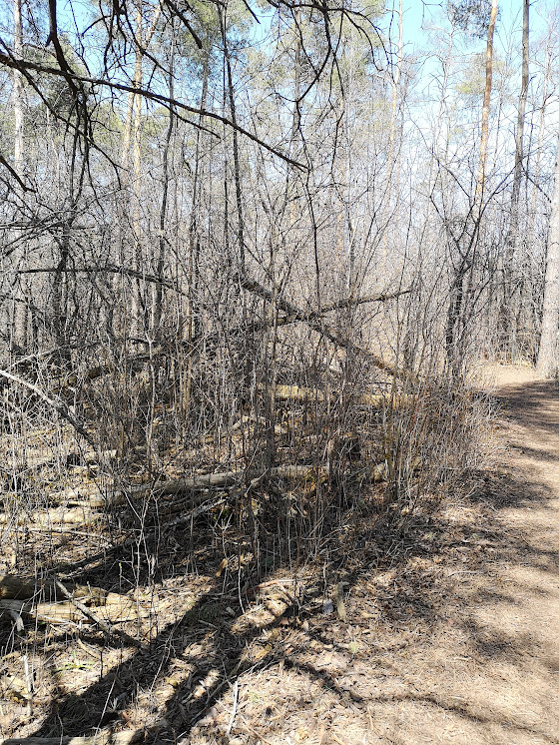
and more perfect tent (not made with hands, that is, not of this creation), ¹² he entered once for all into the holy place, not with the blood of goats and calves but with his own blood, thus obtaining eternal redemption. ¹³ For if the blood of goats and bulls and the sprinkling of the ashes of a heifer sanctifies those who have been defiled so that their flesh is purified, ¹⁴ how much more will the blood of Christ, who through the eternal Spirit offered himself without blemish to God, purify our conscience from dead works to worship the living God!
From Rev Heather Leffler
Temple worship included different kinds of sacrifices. Animal offerings – burnt offerings, peace offerings, guilt offerings and sin offerings were each different. In some, the whole animal was burned. For others, part would be burned to God in gratitude or penance and part eaten by the priest. With peace offerings, part was burned, and part was given to the family to celebrate. Animals were to be the best people had – first born and without blemish to show gratitude to God.
The writer of Hebrews grew up in this tradition and knew how much this practice meant in people’s lives. It was through offerings that people gave thanks for the birth of children, as when Mary and Joseph took two pigeons for the purification offering and presented Jesus in the temple. Offerings were given when someone confessed their sins or were cured of leprosy or other illness. This sacred action allowed them to be restored to community.
Instead of the tent – the Tabernacle that the Israelites worshipped in on their journey from Egypt to the promised land, Hebrews tells us that Jesus offers something much greater. He offers himself as a one-time sacrifice for all people. His death and resurrection invite us to enter into God’s kingdom.
God’s kingdom on earth is not limited to a tent or temple, church or other building. God’s kingdom is wherever we experience and share love for another. Jesus gave his life so that we would understand that God longs for us to be in loving relationship with God and others.
At the Lester Randall Preaching Fellowship I attended this week, a speaker said that often we are afraid that God can’t forgive us. They said that when we assume we are beyond forgiveness we deny Jesus’ sacrifice for us. May we live our lives in gratitude for God’s forgiveness and love.
Contemplation and Conversation
What does Jesus’ death and resurrection mean to you?
Prayer
Loving Saviour, some of us seek your love and forgiveness,
others long for meaning in our lives.
Help us live our lives in the shadow of your cross,
so we are reminded to share your love with others. Amen.

Further Conversation … Would you like to talk more about today’s reflection? Email Heather at hleffler@rogers.com.

Our Rockwood Stone Family
If you missed today’s worship service, you can watch it here: https://youtu.be/OOVd-NAeK3c
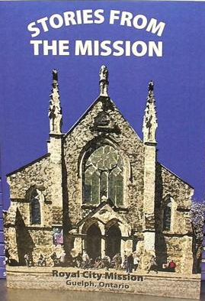
Sunday, November 10 join our Worship Committees for our Remembrance Sunday Worship at Rockwood at 10 am. Zoom will open for conversation at 9:45 am.
Our guest Marion Reidel will be sharing stories of Royal City Mission. Following worship, Marion will have copies of her book for sale for $25 to support Royal City. If we have missed someone, please contact Heather hleffler@rogers.com.
In our Worship this morning, we missed remembering Barb Marshall who transferred to Stone from Eden Mills where she had been a very active in the church and community. We give thanks for the lives she touched in Eden Mills and Stone Churches and the Eden Mills Community.

Stone United Church’s Foodgrains project helps the Canadian Foodgrains Bank to provide emergency food aid around the world and supports families in finding long-term solutions to feed themselves. One of the places they are currently active in is Lebanon. Learn more at www.foodgrainsbank.ca . The Canadian government partners with the CFGB matching donations 3-1. Join in this faithful response to the good things God has given us by sending a donation to Stone. Etransfers can be sent to stoneuc.treasurer@gmail.com. Cheques to Stone United Church, PO Box 57 Rockwood, ON N0B 2K0 or donate through Canada Helps https://www.canadahelps.org/en/dn/80455. Please designate your gift for Foodgrains.

United Church of Canada
Centering Prayer: Introductory Workshop on Saturday, November 23, 2024 from 1:00-4:00 pm at Harcourt Memorial United Church 87 Dean Ave. Guelph.
Are you interested in learning more about a new way to pray?
Centering prayer is an ancient form of Christian prayer that moves beyond word, image and thought into silence. It has its roots in the wisdom sayings of Jesus and the writings of Christian contemplative masters such as Teresa of Avila, John of the Cross and Thomas Merton.
Presenter: The Rev. Kevin Steeper Registration: office@harcourtcommunity.ca
Registration deadline: November 22, 2024

A gift of belonging to a church is that the practice of gathering together for worship … to pray, sing, listen to scripture and share how God touches our lives – helps us grow in deeper relationship with God and each other. We are offering this practice of sharing beyond Sunday morning to deepen our connection. Each week you are offered a picture, a scripture and a question for contemplation, as well as a short reflection for you to contemplate, have conversation with people in your life and/or join an online conversation on our Rockwood Stone Facebook page.

