Contemplation and Conversation
25th after Pentecost, Sunday, November 10, 2024

Scripture – Mark 12:38-44 NRSVUE
https://www.biblegateway.com/passage/?search=Mark%2012%3A38-44&version=NRSVUE
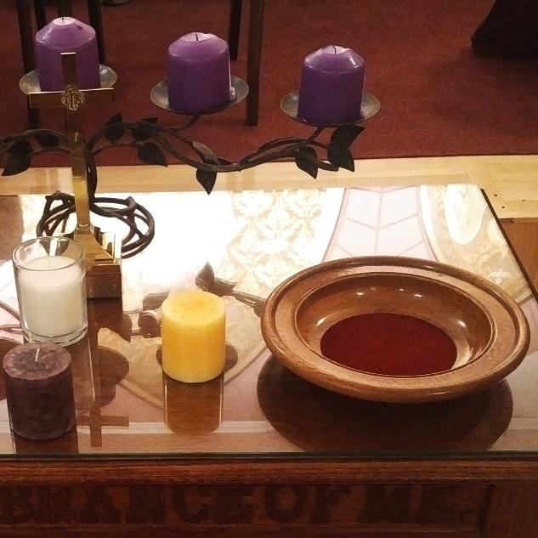
³⁸ As he taught, he said, “Beware of the scribes, who like to walk around in long robes and to be greeted with respect in the marketplaces ³⁹ and to have the best seats in the synagogues and places of honor at banquets! ⁴⁰ They devour widows’ houses and for the sake of appearance say long prayers. They will receive the greater condemnation.”
⁴¹ He sat down opposite the treasury and watched the crowd putting money into the treasury. Many rich people put in large sums. ⁴² A poor widow came and put in two small copper coins, which are worth a penny. ⁴³ Then he called his disciples and said to them, “Truly I tell you, this poor widow has put in more than all those who are contributing to the treasury. ⁴⁴ For all of them have contributed out of their abundance, but she out of her poverty has put in everything she had, all she had to live on.”
From Brian Mack
Imagine yourself as Jesus. Having just answered a series of tricky questions posed to you in the temple, you are weary and have chosen a place to rest in full view of the colonnade which surrounded the Court of the Women. You notice up to thirteen different alms-boxes shaped like trumpets with large open mouths and narrow necks. Long lines have formed as the well-to-do fashionable businessmen and the religious elite, both Pharisees and Sadducees, make a pretense of their giving. From your vantage point, perhaps at the top of a flight of stairs, you are able to see clearly that these folks have taken their duty to give alms seriously and were generous in their contributions.
Out of the corner of your eye, you catch sight of a widow woman. Shabbily dressed and with downcast eyes, she shuffles forward. Beaten down by the difficulties of life, she has a hollow look in her eyes. You think to yourself that she might be reciting psalms, as was often the custom as people approached the alms-boxes, but she may have just been mumbling words of despair. You cannot help but note that she carries two small coins in her gnarled hands and just as she reaches one of the boxes, she looks up and purposively, yet furtively lest someone see her, drops two small coins into the treasury. shuffles away unnoticed amongst the throngs. She too has fulfilled her duty of almsgiving.
As observer of the scene, you feel compelled to draw your disciples close. You tell them about the sacrificial giving of the widow which came from the heart. You are hopeful that some of the disciples will remember the story and perhaps even record it after your sacrificial death on the Cross. As you turn away from the disciples, you cannot shake the visual image of the widow. You sigh and perhaps say to yourself that the Kingdom of God is indeed in our midst.
Contemplation and Conversation
Where have you seen the Kingdom of God in our midst?
Prayer
Holy God, we give you thanks for the story of the alms-giving widow
and for Mark and Luke who recorded the account for us.
As observers of life, may we focus less on the outward images of prosperity,
and more on the inner treasure of the heart. Amen

Further Conversation … Would you like to talk more about today’s reflection? Email Heather at hleffler@rogers.com.

Our Rockwood Stone Family
If you missed today’s worship service, you can watch it here: https://youtu.be/mq99UkU--bQ

Stone United Church’s Foodgrains project helps the Canadian Foodgrains Bank to provide emergency food aid around the world and supports families in finding long-term solutions to feed themselves. One of the places they are currently active in is Lebanon. Learn more at www.foodgrainsbank.ca . The Canadian government partners with the CFGB matching donations 3-1. Join in this faithful response to the good things God has given us by sending a donation to Stone. Etransfers can be sent to stoneuc.treasurer@gmail.com. Cheques to Stone United Church, PO Box 57 Rockwood, ON N0B 2K0 or donate through Canada Helps https://www.canadahelps.org/en/dn/80455. Please designate your gift for Foodgrains.

United Church of Canada
Centering Prayer: Introductory Workshop on Saturday, November 23, 2024 from 1:00-4:00 pm at Harcourt Memorial United Church 87 Dean Ave. Guelph.
Are you interested in learning more about a new way to pray?
Centering prayer is an ancient form of Christian prayer that moves beyond word, image and thought into silence. It has its roots in the wisdom sayings of Jesus and the writings of Christian contemplative masters such as Teresa of Avila, John of the Cross and Thomas Merton.
Presenter: The Rev. Kevin Steeper Registration: office@harcourtcommunity.ca
Registration deadline: November 22, 2024

A gift of belonging to a church is that the practice of gathering together for worship … to pray, sing, listen to scripture and share how God touches our lives – helps us grow in deeper relationship with God and each other. We are offering this practice of sharing beyond Sunday morning to deepen our connection. Each week you are offered a picture, a scripture and a question for contemplation, as well as a short reflection for you to contemplate, have conversation with people in your life and/or join an online conversation on our Rockwood Stone Facebook page.

