Contemplation and Conversation
26th after Pentecost, Sunday, November 17, 2024
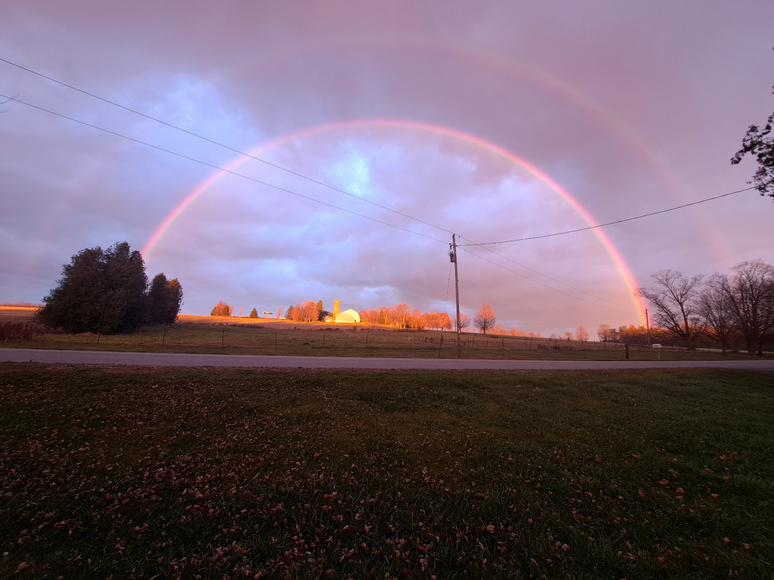
Photo by Randy Dewey
Scripture – 1 Samuel 1:4-20 NRSVUE
https://www.biblegateway.com/passage/?search=1%20Samuel%201%3A4-20&version=NRSVUE
⁴ On the day when Elkanah sacrificed, he would give portions to his wife Peninnah and to all her sons and daughters, ⁵ but to Hannah he gave a double portion because he loved her, though the Lord had closed her womb. ⁶ Her rival used to provoke her severely, to irritate her, because the Lord had closed her womb. ⁷ So it went on year by year; as often as she went up to the house of the Lord, she used to provoke her. Therefore Hannah wept and would not eat. ⁸ Her husband Elkanah said to her, “Hannah, why do you weep? Why do you not eat? Why is your heart sad? Am I not more to you than ten sons?”
⁹ After they had eaten and drunk at Shiloh, Hannah rose and presented herself before the Lord.] Now Eli the priest was sitting on the seat beside the doorpost of the temple of the Lord. ¹⁰ She was deeply distressed and prayed to the Lord and wept bitterly. ¹¹ She made this vow: “O Lord of hosts, if only you will look on the misery of your servant and remember me and not forget your servant but will give to your servant a male child, then I will set him before you as a nazirite until the day of his death. He shall drink neither wine nor intoxicants, and no razor shall touch his head.”
¹² As she continued praying before the Lord, Eli observed her mouth. ¹³ Hannah was praying silently; only her lips moved, but her voice was not heard; therefore Eli thought she was drunk. ¹⁴ So Eli said to her, “How long will you make a drunken spectacle of yourself? Put away your wine.” ¹⁵ But Hannah answered, “No, my lord, I am a woman deeply troubled; I have drunk neither wine nor strong drink, but I have been pouring out my soul before the Lord. ¹⁶ Do not regard your servant as a worthless woman, for I have been speaking out of my great anxiety and vexation all this time.” ¹⁷ Then Eli answered, “Go in peace; the God of Israel grant the petition you have made to him.” ¹⁸ And she said, “Let your servant find favor in your sight.” Then the woman went her way and ate and drank with her husband, and her countenance was sad no longer.
¹⁹ They rose early in the morning and worshiped before the Lord; then they went back to their house at Ramah. Elkanah knew his wife Hannah, and the Lord remembered her. ²⁰ In due time Hannah conceived and bore a son. She named him Samuel, for she said, “I have asked him of the Lord.”
From Rev Heather Leffler
Hannah was the beloved wife of Elkanah, yet her heart was broken. Elkanah’s first wife Peninnah had sons and daughters, but Hannah had none. In a time when a woman was defined by her role as mother being unable to give birth felt like a curse.
When the family traveled to Shiloh to worship, Hannah entered the temple by herself while the others finished their meal. She wept bitterly before God. She vowed that if only God would give her a son, she would dedicate him to God. In her distress, moving her lips while silently praying, Hannah appeared drunk to Eli the priest.
Instead of approaching her with curiosity or concern, Eli judged Hannah asking how long she would make a spectacle of herself. How often in the church have we judged people who … didn’t wear the right clothes, didn’t know when to stand up or sit, didn’t speak or act in the way we expected them to speak or act? How often did we judge children who … talked at the ‘wrong’ time, danced to the music, ran joyfully in the aisles?
Like Eli, it is so easy to judge others, especially when they say or do things that are different than we expect. Yet when he took the time to listen with compassion, Eli not only heard Hannah’s prayer, he heard God’s word for her. Hannah would have a son and he, Samuel, would serve God faithfully.
May we pause when someone surprises or confuses us with their behaviour to listen to their story. May we respond with compassion so that they might feel God’s presence as two or three of us gather and may we recognize God’s word for them and us.
Contemplation and Conversation
When have you misjudged someone?
Prayer
Loving God, we live in a world that is quick to judge and pushes people to the margins,
when they don’t live or act as we expect.
Teach us to listen with hearts filled with love and compassion,
so that together we can hear and respond to your word of love and hope. Amen.

Further Conversation … Would you like to talk more about today’s reflection? Email Heather at hleffler@rogers.com.

Our Rockwood Stone Family
If you missed today’s worship service, you can watch it here:

Stone United Church’s Foodgrains project helps the Canadian Foodgrains Bank to provide emergency food aid around the world and supports families in finding long-term solutions to feed themselves. One of the places they are currently active in is Lebanon. Learn more at www.foodgrainsbank.ca . The Canadian government partners with the CFGB matching donations 3-1. Join in this faithful response to the good things God has given us by sending a donation to Stone. Etransfers can be sent to stoneuc.treasurer@gmail.com. Cheques to Stone United Church, PO Box 57 Rockwood, ON N0B 2K0 or donate through Canada Helps https://www.canadahelps.org/en/dn/80455. Please designate your gift for Foodgrains.

United Church of Canada
Come, Lord Jesus! A Stewardship Round Table on Tuesday, November 19 from 12-1 pm.
Join your Stewardship Support Staff, Brenna Baker, for an informal conversation about how to encourage more generosity this Advent season. Move away from the panic of budgets and deficits, and into a posture of gratitude during this season of hope and joy. We’ll talk about:
Creating a welcoming space for newcomers and visitors
Celebrating all the amazing ministry you’ve done in the past year
How to make it easy for people to financially support your ministry
All the great ideas you have!
No registration needed. Zoom details are below. Contact Brenna Baker with any questions at bbaker@united-church.ca .
Join Zoom Meeting
https://united-church.zoom.us/j/84237625814
Meeting ID: 842 3762 5814

Centering Prayer: Introductory Workshop on Saturday, November 23, 2024 from 1:00-4:00 pm at Harcourt Memorial United Church 87 Dean Ave. Guelph.
Are you interested in learning more about a new way to pray?
Centering prayer is an ancient form of Christian prayer that moves beyond word, image and thought into silence. It has its roots in the wisdom sayings of Jesus and the writings of Christian contemplative masters such as Teresa of Avila, John of the Cross and Thomas Merton.
Presenter: The Rev. Kevin Steeper Registration: office@harcourtcommunity.ca
Registration deadline: November 22, 2024

August 5-12, 2025 Inclusive
IN PERSON Youth Forum at General Council 45 Gathering in Calgary
Accommodation, travel, food and supply costs will be covered for the in-person event
Youth Forum is an opportunity for young people to participate in the education, decision-making, and community of General Council 45 of The United Church of Canada. Its aim is to ensure that young people have a voice in the denomination-shaping issues and decisions for the next three years in the life of the church. Its an opportunity to speak to issues that matter to young people, to share ideas, and to connect with peers and other members and leaders of the General Council.
If you or someone you know wishes to apply to be a Youth Forum Delegate, please register with this form.
https://forms.office.com/r/6cqiZmFHV3
Contact Kathy Douglas, Faith Formation Minister with any questions at KDouglas@united-church.ca

A gift of belonging to a church is that the practice of gathering together for worship … to pray, sing, listen to scripture and share how God touches our lives – helps us grow in deeper relationship with God and each other. We are offering this practice of sharing beyond Sunday morning to deepen our connection. Each week you are offered a picture, a scripture and a question for contemplation, as well as a short reflection for you to contemplate, have conversation with people in your life and/or join an online conversation on our Rockwood Stone Facebook page.

