Contemplation and Conversation: Sunday, December 1, 2024
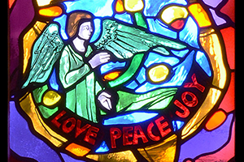
Scripture – Luke 1:26-38 NRSUE https://www.biblegateway.com/passage/?search=Luke%201%3A26-38&version=NRSVUE
²⁶ In the sixth month the angel Gabriel was sent by God to a town in Galilee called Nazareth, ²⁷ to a virgin engaged to a man whose name was Joseph, of the house of David.
The virgin’s name was Mary. ²⁸ And he came to her and said, “Greetings, favored one! The Lord is with you.”
²⁹ But she was much perplexed by his words and pondered what sort of greeting this might be.
³⁰ The angel said to her, “Do not be afraid, Mary, for you have found favor with God. ³¹ And now, you will conceive in your womb and bear a son, and you will name him Jesus. ³² He will be great and will be called the Son of the Most High, and the Lord God will give to him the throne of his ancestor David. ³³ He will reign over the house of Jacob forever, and of his kingdom there will be no end.”
³⁴ Mary said to the angel, “How can this be, since I am a virgin?”
³⁵ The angel said to her, “The Holy Spirit will come upon you, and the power of the Most High will overshadow you; therefore the child to be born will be holy; he will be called Son of God. ³⁶ And now, your relative Elizabeth in her old age has also conceived a son, and this is the sixth month for her who was said to be barren. ³⁷ For nothing will be impossible with God.”
³⁸ Then Mary said, “Here am I, the servant of the Lord; let it be with me according to your word.”
Then the angel departed from her.
From Tammy Smits
In my mind’s eye, angels are like God’s administrative assistants. They buzz around, helping people stay on the right track and doing all the odd jobs that need doing to make God’s master plan unfurl. Because they work mainly behind the scenes, they don’t get a lot of credit or recognition, although having a close working relationship directly with God would be a pretty awesome job perk.
Gabriel is specifically named as the angel who spoke to Mary (as well as both Daniel and Zechariah); an Executive Admin, perhaps, trusted to appear to people and deliver important messages that need clear communication. When Gabriel was delegated this particular assignment, I imagine he took the angel’s version of a shot of liquid courage before heading out. Announcing the upcoming conception of God’s son to a girl with no sexual experience, telling her what to name her child, informing her that his reign would be endless, and then adding on that her elderly cousin Elizabeth was also expecting was no small feat. This message was the first link in the chain of events that led to a whole new chapter of Christianity. Having Mary on-board was a crucial task.
However, with great responsibility comes great reward. What a delight it must have been for Gabriel when – after some initial confusion – Mary received the message, asked a few pertinent questions, and acknowledged the announcement with grace and acceptance (although she was wise enough to go visit Elizabeth for some independent validation).
We don’t all get direct communication from God’s Executive Admins when big changes come into our lives. I do believe God’s army of angels work tirelessly to provide support, whether it is the random strangers who happen along and give a hand exactly when we need it, the quiet moment of peace that descends when we are at our wits end, or the feelings of joy that bubble up sometimes when life finally goes our way. I like to think the angels celebrate when we succeed and thrive. Like Mary, we need to be open to these moments and recognize them as gifts from God.
Contemplation and Conversation
When have you received a message from an angel?
Prayer
Heavenly God, help us to be open to the messages
delivered by your angels in whatever form they take,
and to do your will with as much grace
as Mary showed when Gabriel appeared.
Especially in this holiday season,
help us to be your angels on earth,
putting aside our short sighted wants to lift up those
who are in greater need. Amen.

Further Conversation … Would you like to talk more about today’s reflection? Email Heather at hleffler@rogers.com.

Our Rockwood Stone Family
If you missed today’s worship service, you can watch it here: https://youtu.be/hp1YakdkGkQ .

Please keep members and friends of Rockwood and Stone in your thoughts and prayers as they remember loved ones who have died recently.
- The Darcie Family as they mourn the death of Lou’s daughter Kim.
- The May family as they mourn the death of Paul
- Jean and Gord Haws and the family and friends of Grace Nellis as they mourn her death.
- The McDougall family as they mourn the death of Eileen’s son-in-law Doug MacQueen.
- The family and friends of Harry Doyle as they mourn his death.
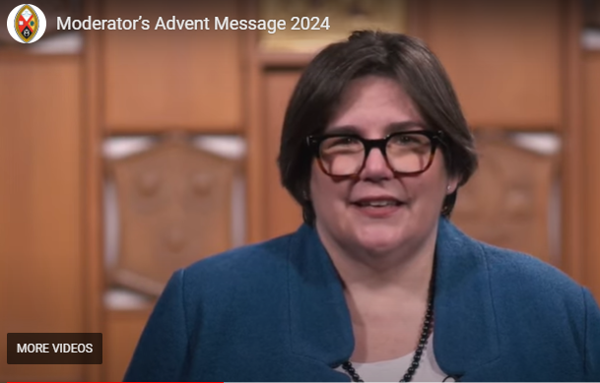
United Church of Canada
Transcript of Video Message
Season’s Greetings. I am the Right Rev. Dr. Carmen Lansdowne, Moderator of The United Church of Canada.
As we enter into Advent and approach Christmas, my thoughts turn to children, to the Christ child. He was born, perhaps not in luxury, but with loving parents and God’s grace. This love is what we hope for all those in our care—that they would be supported and lifted up to become who they are meant to be.
That’s why, in this Advent season, we are reaching out to you. We are sharing stories of how United Church members are supporting children and youth, wholeheartedly and with love. You are a part of this wonderful, loving community, and your support, both through prayer and your gifts, make this possible. I would encourage you to give a gift through Mission and Service this Advent season. Your support will mean so much to youth who are looking for love, acceptance, and understanding.
Thank you for your actions, your heartfelt prayers, and your willingness to help.
May God bless you and those around you this Advent season.

A gift of belonging to a church is that the practice of gathering together for worship … to pray, sing, listen to scripture and share how God touches our lives – helps us grow in deeper relationship with God and each other. We are offering this practice of sharing beyond Sunday morning to deepen our connection. Each week you are offered a picture, a scripture and a question for contemplation, as well as a short reflection for you to contemplate, have conversation with people in your life and/or join an online conversation on our Rockwood Stone Facebook page.

