Contemplation and Conversation: 3rd Sunday of Advent, December 15, 2024
Scripture – Luke 1:39-56 NRSVUE https://www.biblegateway.com/passage/?search=Luke%201%3A39-56%20&version=NRSVUE
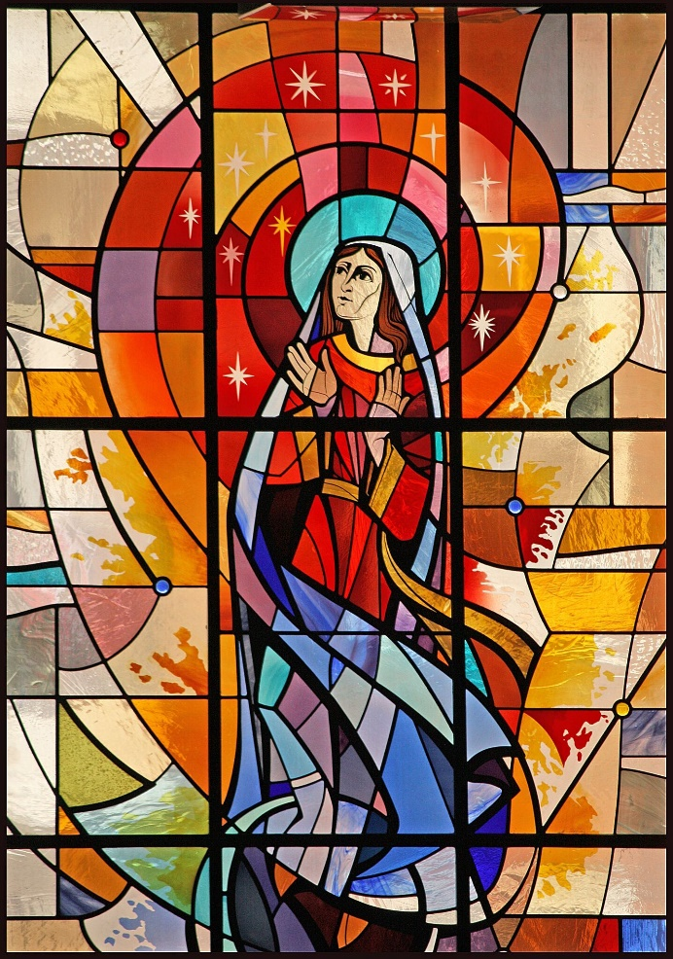
³⁹ In those days Mary set out and went with haste to a Judean town in the hill country, ⁴⁰ where she entered the house of Zechariah and greeted Elizabeth.
⁴¹ When Elizabeth heard Mary’s greeting, the child leaped in her womb. And Elizabeth was filled with the Holy Spirit ⁴² and exclaimed with a loud cry, “Blessed are you among women, and blessed is the fruit of your womb. ⁴³ And why has this happened to me, that the mother of my Lord comes to me? ⁴⁴ For as soon as I heard the sound of your greeting, the child in my womb leaped for joy. ⁴⁵ And blessed is she who believed that there would be a fulfillment of what was spoken to her by the Lord.”
⁴⁶ And Mary said,
“My soul magnifies the Lord,
⁴⁷ and my spirit rejoices in God my Savior,
⁴⁸ for he has looked with favor on the lowly state of his servant.
Surely from now on all generations will call me blessed,
⁴⁹ for the Mighty One has done great things for me,
and holy is his name;
⁵⁰ indeed, his mercy is for those who fear him
from generation to generation.
⁵¹ He has shown strength with his arm;
he has scattered the proud in the imagination of their hearts.
⁵² He has brought down the powerful from their thrones
and lifted up the lowly;
⁵³ he has filled the hungry with good things
and sent the rich away empty.
⁵⁴ He has come to the aid of his child Israel,
in remembrance of his mercy,
⁵⁵ according to the promise he made to our ancestors,
to Abraham and to his descendants forever.”
⁵⁶ And Mary remained with her about three months and then returned to her home.
From Barb Eley
This story raises so many questions. Any woman who has travelled during her pregnancy can tell you that it can be challenging. Why did Mary decide to journey to visit Elizabeth? Did she walk? Ride a donkey? How far was it? Did she go alone? What was the weather like?
Mary had just been told that she, a young, unmarried woman, was pregnant by the Holy Spirit. Who could she turn to for support in this astonishing situation? She had heard that her much older cousin had also miraculously conceived. Here was someone she could trust to understand her excitement and nervousness.
Mary was right. Elizabeth greeted her with blessings and rejoicing, leading to Mary’s own wonderful Song of Praise. Here are two very different women, one who had been looked down upon for infertility and one who could be shunned as an unwed mother, connecting through the power and the joy of the Holy Spirit.
The Holy Spirit brings the miraculous into our lives in a multitude of ways, and as we open our hearts, leads us to the people who will support us and keep us safe.
In loving memory of my mother, and all our mothers.
Contemplation and Conversation
When have you felt the Holy Spirit working in your life?
Was it surprising to you?
What people became an important part of the experience?
How have you changed because of this?
Prayer
Holy Spirit, help us to open our hearts to you.
Let us see where you are working in our lives
and follow where you lead.
Thank-you for all the people we encounter
who lift us up in your love. Amen.

Further Conversation … Would you like to talk more about today’s reflection? Email Heather at hleffler@rogers.com.

Our Rockwood Stone Family
If you missed today’s worship service, you can watch it here: https://youtu.be/fm0m6Ax78oI

United Church of Canada
From Advent Unwrapped…

Joy: I remember being at a church that expected an unnatural silence from my then-toddler. He pulled on my sleeve and asked me for a candy. I told him that I didn't have any. He didn't accept this answer. Finally, I said, “Look it, I can't give you what I do not have. Please stop asking.” My son’s response: “You don’t know because you didn’t look.” He was talking about my purse, but in that moment, it felt like he was talking about my heart. He was right; I didn’t look. So, I gave my purse a superficial glance to end this conversation that was already drawing too much attention (literally and figuratively). And to my surprise, in the bottom of my purse was a stale candy from a long-forgotten Easter egg hunt. My son giggled triumphantly while gladly enjoying the candy, and even the grumpy folks who were annoyed at our conversation smiled at my son’s glee. Such a small reminder of how moments of joy are often surprising moments of sweetness that we didn’t know were possible; a little bit of sweet that may help to make the bitterness more bearable. And now, on those harder days, I often hear my son reminding me to search for the sweetness. I won’t know unless I look, right? Where can we search for joy this Advent?
I know that happiness is not the same thing as joy, but moments of happiness can surely remind us of the deep joy that awaits us with Christ, a small foretaste.
This Week in Prayer
We are invited to join the Council of Churches in Zambia (CCZ) in prayer this week (Advent Unwrapped 2024: Advent Prayers of the World in the Worship Ideas section). The CCZ is an ecumenical body established in 1914 that aims to be “a prophetic voice with a transformative impact on church and society”. Together we give thanks for: peace, contributions to liberations struggles that have led to independence in neighboring countries, abundant natural resources, the hospitality and generosity of people, rich culture. And together we pray for: an end to acute poverty, sustained peace and unity, transformational leadership, economic independence, against all forms of injustice (such as sexual and gender based violence) and the shrinking of democratic, civic, media and religious spaces.

A gift of belonging to a church is that the practice of gathering together for worship … to pray, sing, listen to scripture and share how God touches our lives – helps us grow in deeper relationship with God and each other. We are offering this practice of sharing beyond Sunday morning to deepen our connection. Each week you are offered a picture, a scripture and a question for contemplation, as well as a short reflection for you to contemplate, have conversation with people in your life and/or join an online conversation on our Rockwood Stone Facebook page.
If you would like to write a reflection or have a picture to share, please send contact Heather Leffler hleffler@rogers.com.

