Contemplation and Conversation: 4th Sunday of Advent, December 22, 2024
Scripture – Luke 2:8-15 NRSVUE https://www.biblegateway.com/passage/?search=Luke%202%3A8-15&version=NRSVUE
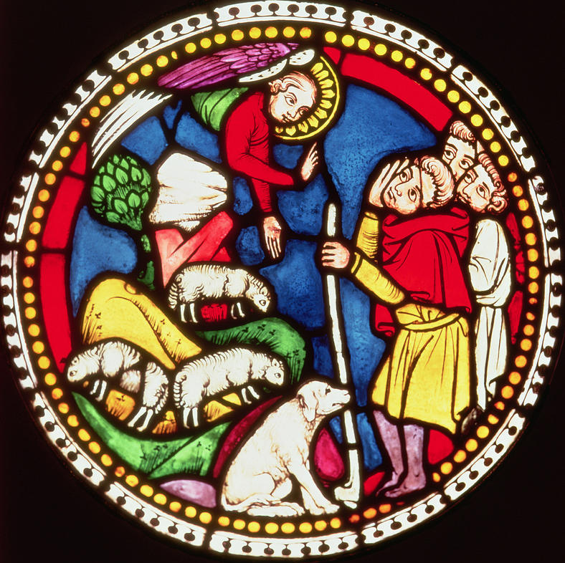
⁸ Now in that same region there were shepherds living in the fields, keeping watch over their flock by night. ⁹ Then an angel of the Lord stood before them, and the glory of the Lord shone around them, and they were terrified.
¹⁰ But the angel said to them, “Do not be afraid, for see, I am bringing you good news of great joy for all the people: ¹¹ to you is born this day in the city of David a Savior, who is the Messiah, the Lord. ¹² This will be a sign for you: you will find a child wrapped in bands of cloth and lying in a manger.”
¹³ And suddenly there was with the angel a multitude of the heavenly host, praising God and saying,
¹⁴ “Glory to God in the highest heaven,
and on earth peace among those whom he favors!”
¹⁵ When the angels had left them and gone into heaven, the shepherds said to one another, “Let us go now to Bethlehem and see this thing that has taken place, which the Lord has made known to us.”
From Brian Mack
It’s lambing season and I am out in the fields rather distant from Bethlehem guarding my sheep. I envy the farmers who have their fields of wheat near the town. They’re safe and sound in their warm beds. Huddled around a fire with two other companions, I can’t concentrate on the usual nightly banter. I’m wore out. I’ve been a shepherd for almost forty years. No one respects me. I occupy a low station in life.
Just when I thought I might be able to get some sleep, I notice a young ewe has come into the shadows near the fire. She is acting very nervous. All the signs of readying to lamb are there – an enlarged udder, a swollen vulva, a look that seems to say “what’s happening” that only another shepherd would understand. I have to stay awake. I have to be sure to mark her first-born male lamb so that it might be offered at a future time as a sacrifice at the temple according to Jewish custom.
As I struggle to my feet to take a closer look and ready myself to assist the birth if needed, I sense a presence unlike anything that I have ever encountered before. I try to comprehend the fact that there is an angel amongst us. I am filled with fear. I hear the angel proclaim words of the good news. I hear the singing of praises to God. I know that I must heed the angel’s call to go to Bethlehem and my heart overflows with anticipation.
As I enter the stable, a hovel really, I sense a radiance. In spite of my arthritic limbs, I instinctively kneel at the rough-hewn manger. Words fail me but I know I am in the presence of the promised Messiah. As I rise to leave so that Mary and Joseph and the baby might get some sleep, I offer words of praise and thanksgiving to my God – the God of the shepherds who went before me – the God of Jacob, Isaac, and Abraham. I am no longer weary. I am no longer an unknown. I know that my story has been bound up for all eternity with a tiny infant who will change the course of history. I have “come and adored Him.” Thanks be to God.
Contemplation and Conversation
When have you felt compelled like the shepherds
“to come and adore Him”?
Prayer
Holy God, we give you thanks that ordinary shepherds
were the first to be called into the presence of your Son.
May we be inspired by their story as we too seek the Christ child
in this season of peace, joy, hope, and love. Amen.

Further Conversation … Would you like to talk more about today’s reflection? Email Heather at hleffler@rogers.com.

Our Rockwood Stone Family
If you missed today’s worship service, you can watch it here: https://youtu.be/voU-0ffdy98

United Church of Canada
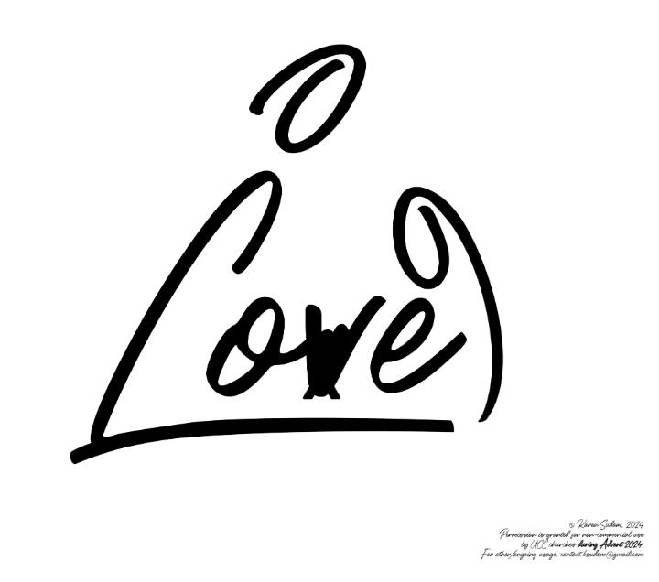
From Advent Unwrapped…
My paternal grandmother always made me sit with her while we ate diabetic candies. I remember bouncing around her bright, sun-filled nursing home room on summer afternoons, with a sweetie (hard candy) clanging in my mouth.
My grandma would tell me not to bite the candy, while patting the side of her bed, inviting me and my Dad, who always fussed about fixing the drapes and checking the thermostat, to "Ten' Tuddy," which might loosely translate to "be quiet and still." And so, my Dad and I would sit there, two antsy spirits lovingly tethered to a calm soul, waiting for the candy to dissolve.
I didn't realize how countercultural it was at the time. Waiting is often seen as foolishness, wasteful, and irresponsible when there is so much urgent need around us. A need to do, problem-solve, strategize, help...
And yet, just as the farmer must wait for the right time to harvest, I now know that so many amazing things come from times of waiting. Sitting with my grandma taught me that waiting doesn't need to be passive; in fact, it can sometimes be the most active expression of love. And the clearest declaration of our faith: we are willing to wait for things that are worth it. The sweetness of sitting beside my grandma was priceless.
In these last days of waiting, may we cling to the love around us, while listening to the ancient wisdom of our foremothers, who gently pat the side of the bed during moments of sweetness and invite us to be patient, and wait a while before we rush off to revolutionize the world (which we will).
For their wisdom and love, I say: Thanks be to God.
[Image credit: Love: notice Mary, Joseph and Jesus loving each other. Where do you encounter the grounding presence of God's love? (Eph 3:17) How does trusting "the love of Christ that surpasses knowledge" invite you into the fullness of God's love? (Eph 3:19). Permission has been granted for non-commercial use in The United Church of Canada worship services during Advent 2024. To use these resources after December 2024, please contact the artist at ksudom@gmail.com.]

A gift of belonging to a church is that the practice of gathering together for worship … to pray, sing, listen to scripture and share how God touches our lives – helps us grow in deeper relationship with God and each other. We are offering this practice of sharing beyond Sunday morning to deepen our connection. Each week you are offered a picture, a scripture and a question for contemplation, as well as a short reflection for you to contemplate, have conversation with people in your life and/or join an online conversation on our Rockwood Stone Facebook page.
If you would like to write a reflection or have a picture to share, please send contact Heather Leffler hleffler@rogers.com

