Contemplation and Conversation: 1st Sunday after Christmas, December 29, 2024
Scripture – Matthew 2:1-12 NRSUE https://www.biblegateway.com/passage/?search=Matthew%202%3A1-12&version=NRSVUE
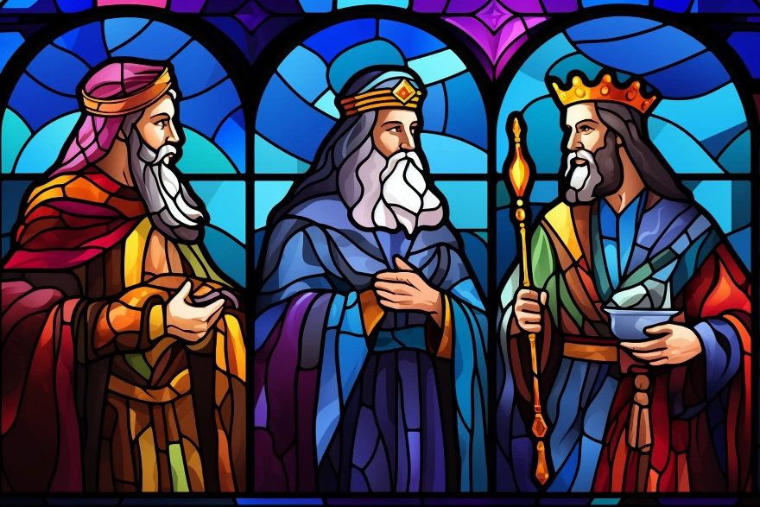
¹ In the time of King Herod, after Jesus was born in Bethlehem of Judea, magi from the east came to Jerusalem, ² asking, “Where is the child who has been born king of the Jews? For we observed his star in the east and have come to pay him homage.” ³ When King Herod heard this, he was frightened, and all Jerusalem with him, ⁴ and calling together all the chief priests and scribes of the people, he inquired of them where the Messiah was to be born. ⁵ They told him, “In Bethlehem of Judea, for so it has been written by the prophet:
⁶ ‘And you, Bethlehem, in the land of Judah,
are by no means least among the rulers of Judah,
for from you shall come a ruler
who is to shepherd my people Israel.’ ”
⁷ Then Herod secretly called for the magi and learned from them the exact time when the star had appeared. ⁸ Then he sent them to Bethlehem, saying, “Go and search diligently for the child, and when you have found him, bring me word so that I may also go and pay him homage.”
⁹ When they had heard the king, they set out, and there, ahead of them, went the star that they had seen in the east, until it stopped over the place where the child was. ¹⁰ When they saw that the star had stopped, they were overwhelmed with joy. ¹¹ On entering the house, they saw the child with Mary his mother, and they knelt down and paid him homage. Then, opening their treasure chests, they offered him gifts of gold, frankincense, and myrrh.
¹² And having been warned in a dream not to return to Herod, they left for their own country by another road.
From Barb Parker
Many of us have probably sung The First Nowell, and heard Matthew’s scripture of the Wisemen, more times than we can count; these words and music may also be among our favorites of the Christmas story, and from our earliest Nativity remembrances. (I get chills every time I hear the descant sung in the chorus.)
So what do we really know about The Magi, and their gifts? Is there anything new to learn? My internet "research" revealed these “facts”:
- This scripture reading from Matthew is the only reference to “the magi” in the Bible.
- The word “Magi” is Greek and means wisemen.
- There is not a specific mention of there being three wisemen in Mathew’s scripture. In Western Christianity it is generally assumed there were three, corresponding with each gift given to Jesus. In Eastern Christianity, they often number twelve.
- They were foreigners, from the east, but their identities are a mystery.
- They came to be known as kings, in conformation with the Old Testament prophecies that the Messiah would be worshipped by kings.
- Scholars think that Jesus was about two years old when the Wisemen arrived, based on the scripture wording that they came “into the house” and “saw the child”. This compares to the shepherds who saw a babe wrapped in swaddling clothes, laid in a manger.
- Their gifts – gold represented wealth and power, frankincense was a type of incense that only priests burned, and myrrh was an extravagant oil for anointing.
The wisemen have been the subject of many famous works of art, music, literature and even cinema, over the centuries. These sources may play a role in how many of our current Christian traditions visualize these men. We attach much symbolism to the wisemen and their gifts. They can give us much to think about; What do you think is fact, legend or remains a mystery?
In The Magi Monologue from our 2018 Epiphany Worship, the question was asked, “What makes a really good gift?” The reading goes on to suggest that the gifts given by the magi to Jesus, were the most expensive money could buy, so that they could honour and bless him.
Have you ever struggled with finding a gift for someone to show them how important they were to you? This question reminded me of the story The Gift of The Magi, read by Alan Maitland, which is often replayed on CBC the week before Christmas. It takes place on Christmas Eve day and tells of an impoverished couple named Jim and Della sacrificing their prized possessions to buy each other Christmas gifts. Della sells her long brown hair to buy a platinum fob chain to go with Jim’s pocket watch, only to learn that he had sold it to buy ornamental combs for her hair. Included are references to the biblical magi, and comparisons of the jewels of the Queen of Sheba, and treasurers of King Solomon, to the poverty of Jim and Della. The narrator ends the story by claiming that those who sacrifice the things they value for the people they love are as wise as the magi themselves.
Contemplation and Conversation
What was the most precious gift
you gave or received this Christmas?
Prayer
O God of the ancient star, and the shepherds and magi
who followed it with curiosity and wonder,
guide us with your light and help us to give of ourselves,
– to give what we can, in faith and in love. Amen.

Further Conversation … Would you like to talk more about today’s reflection? Email Heather at hleffler@rogers.com.

Our Rockwood Stone Family
If you missed today’s worship service, you can watch it here: https://youtu.be/N7gAdvq6ovU

United Church of Canada
Christmas Greetings | Joyeux Noël | Iotshennónnia ki Ratonniá:ne

The light shines in the night, and the night did not overcome it.
La lumière brille dans l’obscurité, et l’obscurité ne l’a pas arrêtée.
Watioswát’thene tsi ahsonthenhnékha, tánon ne ahsonthenhnékha iah teioshatstenshera’kén:nion.
[Text: John 1:5, paraphrased | Texte : Jean 1,5 (NFC) | Mohawk translation: Alma Ransom | Image credit: Seven Brighter © Lightstock ]

A gift of belonging to a church is that the practice of gathering together for worship … to pray, sing, listen to scripture and share how God touches our lives – helps us grow in deeper relationship with God and each other. We are offering this practice of sharing beyond Sunday morning to deepen our connection. Each week you are offered a picture, a scripture and a question for contemplation, as well as a short reflection for you to contemplate, have conversation with people in your life and/or join an online conversation on our Rockwood Stone Facebook page.
If you would like to write a reflection or have a picture to share, please send contact Heather Leffler hleffler@rogers.com .

