Contemplation and Conversation: 2nd Sunday after Christmas, December 29, 2024
Scripture – John 1:1-18 NRSUE https://www.biblegateway.com/passage/?search=John%201%3A1-18&version=NRSVUE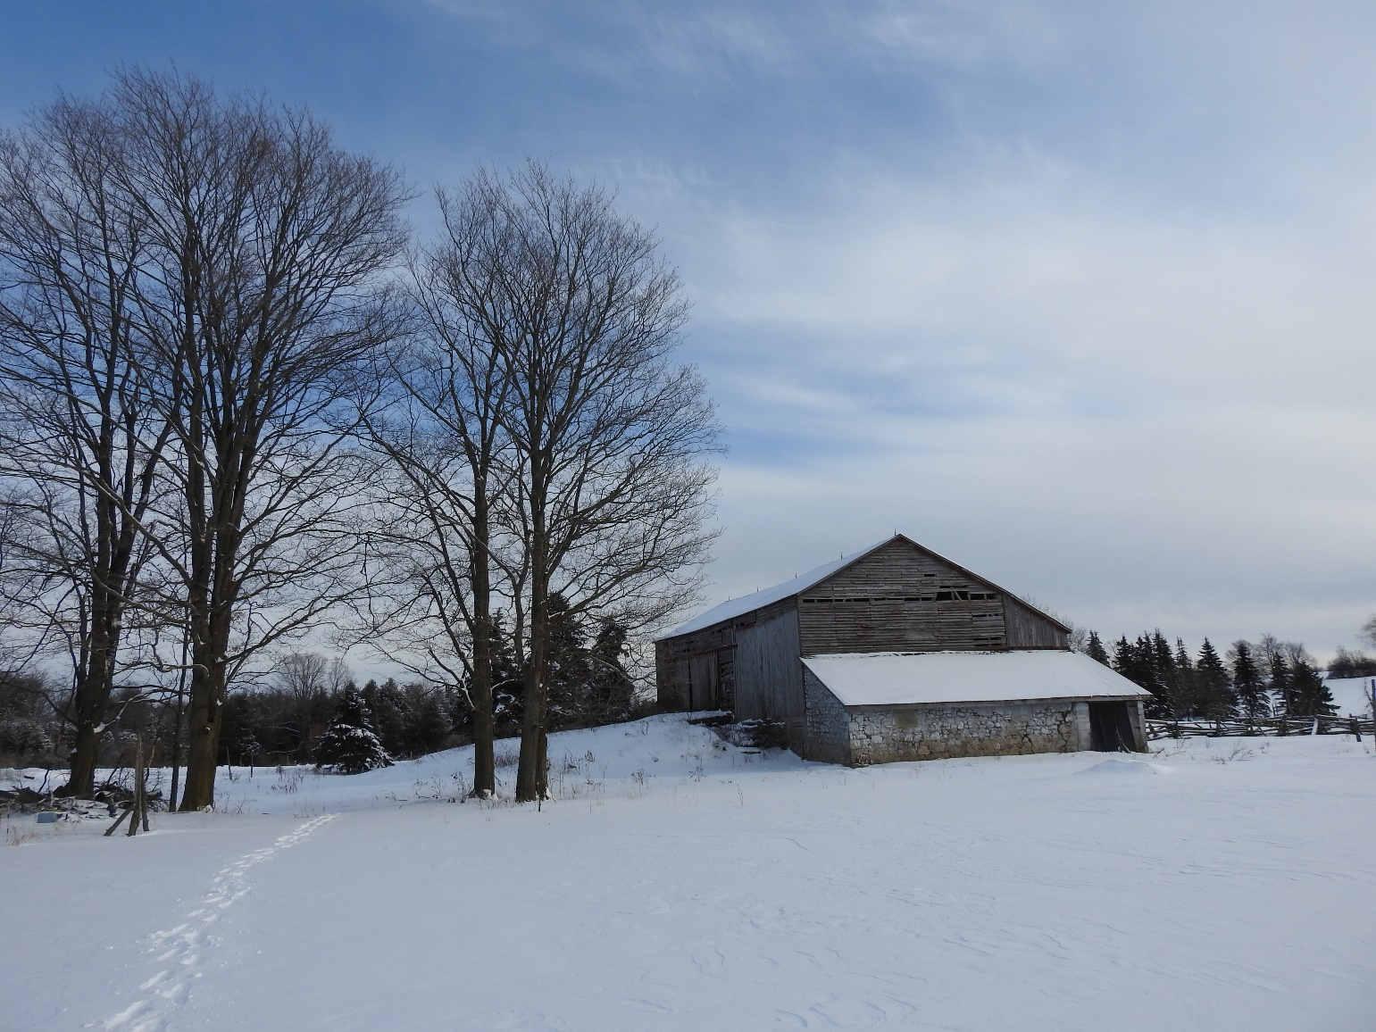
1 In the beginning was the Word, and the Word was with God, and the Word was God. ² He was in the beginning with God. ³ All things came into being through him, and without him not one thing came into being. What has come into being ⁴ in him was life, and the life was the light of all people. ⁵ The light shines in the darkness, and the darkness did not overtake it.
⁶ There was a man sent from God whose name was John. ⁷ He came as a witness to testify to the light, so that all might believe through him. ⁸ He himself was not the light, but he came to testify to the light. ⁹ The true light, which enlightens everyone, was coming into the world.
¹⁰ He was in the world, and the world came into being through him, yet the world did not know him. ¹¹ He came to what was his own, and his own people did not accept him. ¹² But to all who received him, who believed in his name, he gave power to become children of God, ¹³ who were born, not of blood or of the will of the flesh or of the will of man, but of God.
¹⁴ And the Word became flesh and lived among us, and we have seen his glory, the glory as of a father’s only son, full of grace and truth. ¹⁵ (John testified to him and cried out, “This was he of whom I said, ‘He who comes after me ranks ahead of me because he was before me.’ ”) ¹⁶ From his fullness we have all received, grace upon grace. ¹⁷ The law indeed was given through Moses; grace and truth came through Jesus Christ. ¹⁸ No one has ever seen God. It is the only Son, himself God, who is close to the Father’s heart, who has made him known.
From Brian Mack
The prologue to the gospel according to John presents Jesus as the eternal Word of God, who became a human and lived among us. On Christmas eve, when Rev. Leffer asked us to re-tell the story of Jesus’ birth, if we had followed John’s model, we could have started the narrative with “In the beginning….” for at the time of Creation, Christ was already in existence with God and was an active participant in bringing light and life to the world.
As the cosmic story unfolds, culminating with Christ’s arrival as a baby in Bethlehem, the good news changes everything for humankind. Suddenly God is not distant. God is not a vengeful God. God does not invoke fear. God is Emmanuel. As Henri Nouwen tells us, “As soon as we call God “God-with-us”, we enter into a new relationship of intimacy with him. By calling God Emmanuel, we recognize God’s commitment to live in solidarity with us, to share our joys and pains, to defend and protect us, and to suffer all of life with us. The God-with-us is a close God, a God whom we call our refuge, our stronghold, our wisdom, and even, more intimately, our helper, our shepherd, our love.” (Henri Nouwen, You Are The Beloved, p. 9) God is undeniably a God of Compassion full of grace and truth.
In the next few days, as you take down the Christmas tree, the decorations, and safely place the creche in storage until next year, take time to reflect on the journey we have been on for the past few weeks. Ponder the importance of the lowly stable that provided refuge for Mary and Joseph. Imagine the angels announcing Christ’s birth to the shepherds. Acknowledge the joy of Anna and Simeon as they viewed the baby and began to prophecy. Remember the wise men who followed the star for two full years. As you return to the busyness of everyday life, pause. Take a deep breath and contemplate the enormity of the words: “In the beginning was the Word, and the Word was with God, and the Word was God.” Pause again…..Take another deep breath and hold close to your heart the words “the Word became flesh and lived among us.” Thanks be to God.

Contemplation and Conversation
When has someone reached out to you with compassion?
Prayer
Holy Mystery, we give thanks that you came to live among us.
We acknowledge your impact upon our lives as a God of Compassion.
Help us to follow your Son’s example and reach out to all in love. Amen

Further Conversation … Would you like to talk more about today’s reflection? Email Heather at hleffler@rogers.com.

Our Rockwood Stone Family
If you missed today’s worship service, you can watch it here: https://youtu.be/N7gAdvq6ovU

United Church of Canada
Be sure to join us for this special online event with Moderator Carmen Lansdowne!
2025 marks the Centennial year of The United Church of Canada, and we’re kicking it off with a conversation with Moderator Carmen Lansdowne and the United Church's Growth team.
Join us on January 13, 2025 from 6:00 - 8:00 p.m. Eastern Time for a special New Year’s address and town hall exploring the theme of "visions, dreams, and growth as signs of hope."
Learn about the three streams of growth: "Renew, Create, Invite"
Meet the Growth team leadership and emerging church plant leads
Share your signs of hope and dreams for the church, and ask your questions in a Q&A
This webinar is an introduction to the United Church's exciting new church plants and growth initiatives, with a pastoral welcome to this Centennial year of looking outward-upward-inward!
Registration is now open on CHURCHx: https://churchx.ca/local/shop/product.php?id=246
This is a bilingual event.
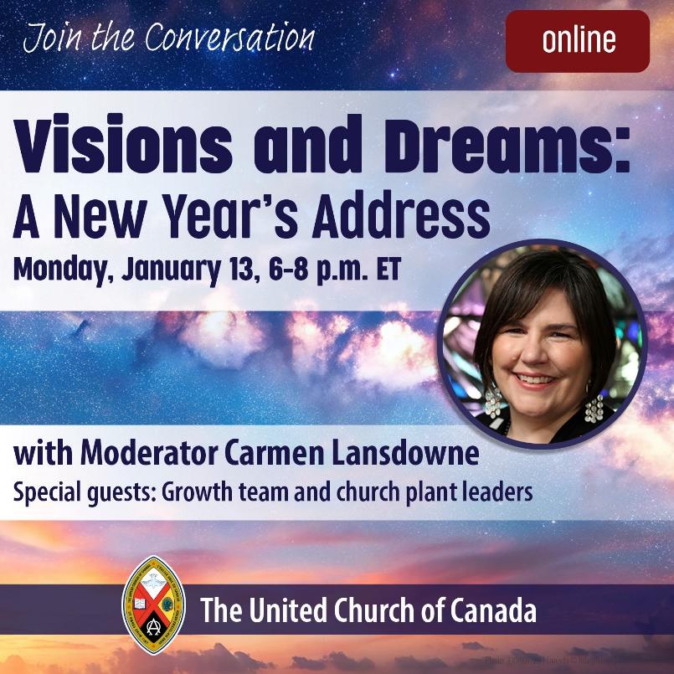
Let’s dream together, share our visions for The United Church of Canada, and step into the future with hope.

A gift of belonging to a church is that the practice of gathering together for worship … to pray, sing, listen to scripture and share how God touches our lives – helps us grow in deeper relationship with God and each other. We are offering this practice of sharing beyond Sunday morning to deepen our connection. Each week you are offered a picture, a scripture and a question for contemplation, as well as a short reflection for you to contemplate, have conversation with people in your life and/or join an online conversation on our Rockwood Stone Facebook page.
If you would like to write a reflection or have a picture to share, please send contact Heather Leffler hleffler@rogers.com .

