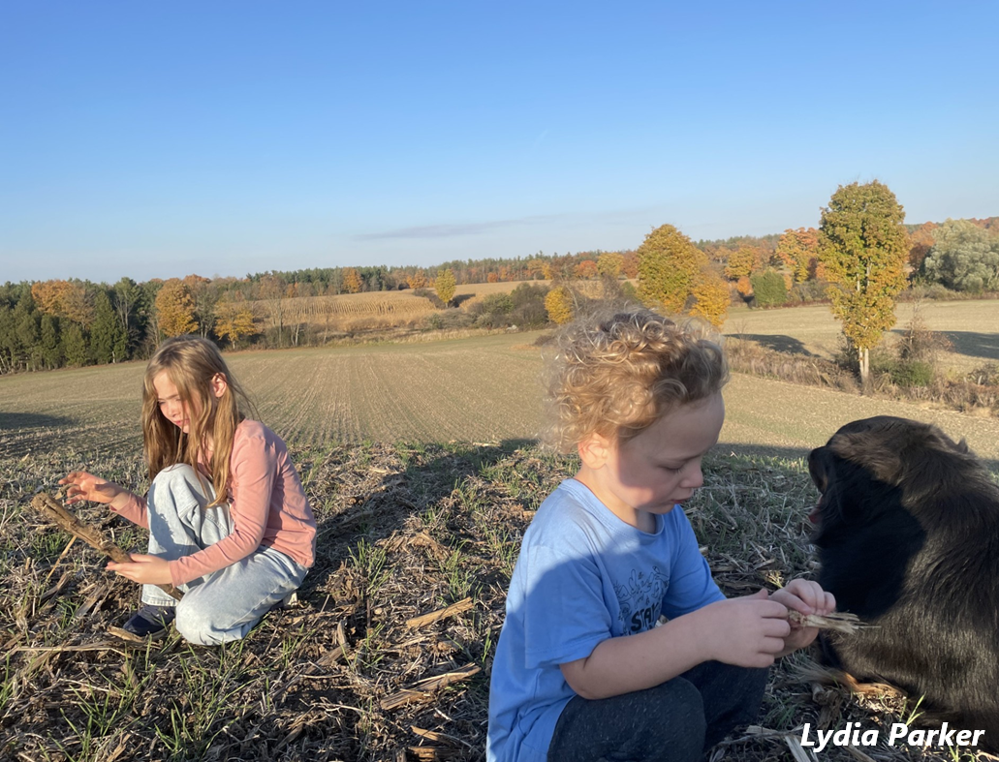
Contemplation and Conversation: Baptism of Jesus Sunday, January 12, 2025
Scripture – Psalm 29 NRSUE https://www.biblegateway.com/passage/?search=psalm%2029&version=NRSVUE
¹ Ascribe to the Lord, O heavenly beings,
ascribe to the Lord glory and strength.
² Ascribe to the Lord the glory of his name;
worship the Lord in holy splendor.
³ The voice of the Lord is over the waters;
the God of glory thunders,
the Lord, over mighty waters.
⁴ The voice of the Lord is powerful;
the voice of the Lord is full of majesty.
⁵ The voice of the Lord breaks the cedars;
the Lord breaks the cedars of Lebanon.
⁶ He makes Lebanon skip like a calf
and Sirion like a young wild ox.
⁷ The voice of the Lord flashes forth flames of fire.
⁸ The voice of the Lord shakes the wilderness;
the Lord shakes the wilderness of Kadesh.
⁹ The voice of the Lord causes the oaks to whirl
and strips the forest bare,
and in his temple all say, “Glory!”
¹⁰ The Lord sits enthroned over the flood;
the Lord sits enthroned as king forever.
¹¹ May the Lord give strength to his people!
May the Lord bless his people with peace!
From Brian Mack
As we walk in God’s Creation, we are reminded of the rhythms of life that had their origin when Holy Mystery created the heavens and the earth. Nature has much to teach us about what it means to be holy. As Henri Nouwen has written, “Once we become sensitive to the voices of nature, we may hear sounds from a world where humanity and nature both find their form. Once we become more aware of the voices of all that surrounds us, growing in respect and reverence for the God of Creation, we will also be able to truly care for all creatures, who are embedded in nature like a sapphire in a golden ring.” (Henri Nouwen, Discernment, p. 62)
Although I certainly didn’t realize it at the time, my feeling of closeness to God was being shaped as a youngster when I was able to freely wander and explore the land. My sense of awe and wonder at what God had created – like David reminds us in Psalm 29 with his story of the voice of God in the thunderstorm – was nurtured by experiences such as the following:
- Walking in a thunderstorm with my Dad with sparks flying off the tines of the fork that he carried
- Picking a giant puffball in a cow pasture and learning how to prepare it for eating by my Dad
- Being taught the names of plants and tending our garden under the direction of my Mom
- Observing the gentleness with which my parents cared for our farm animals and respected the flora and fauna of our farm
- Walking in the bush and observing deer drinking at an ever-flowing spring
- Laughing at the antics of young muskrats frolicking along the banks of our creek
- Marvelling at the intricacy of the claw marks of a porcupine sitting high in a tree sunning himself
- Sitting still on a rock and having Momma coyote pass within a metre of me with her pups in tow
Without a conscious effort, I learned to listen for the language of the water, the trees, the birds and plants. I learned how to discern the essence of God in Creation. I learned to be in touch with the Spirit. I grew and continue to grow in respect and reverence for the God of all Creation—the God who David assures us in Psalm 29—grants us the blessing of peace in our lives. Thanks be to God.
Contemplation and Conversation
When you are in nature, what might God be showing you about your place and purpose in Creation?
Prayer
Holy Mystery, we give you thanks that you can be found in all of your Creation.
Help us to understand what the world around us has to teach us
about our purpose and place in your kin-dom. Amen
Further Conversation … Would you like to talk more about today’s reflection? Email Heather at hleffler@rogers.com.

Our Rockwood Stone Family
If you missed today’s worship service, you can watch it here: https://youtu.be/E-hhZh8XfUw

United Church of Canada
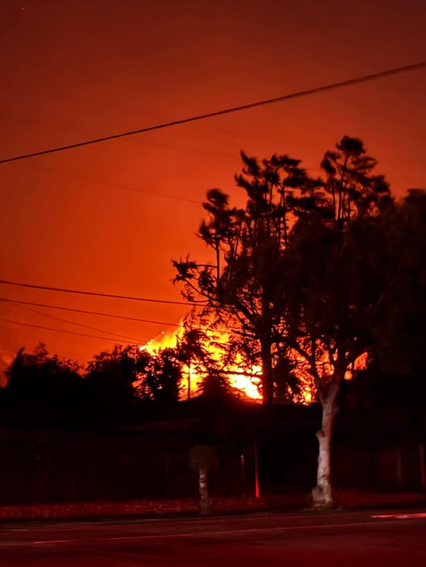
Ever-present God,
We pray for those affected by the ongoing wildfires in Southern California,
We pray for the people, livestock, wildlife, and lands impacted by these firestorms; for those who have lost everything, for those fleeing from danger, and for the firefighters, farmers, and other first responders who are faced with immense challenges.
When we are forced to fight the powers of climate in crisis for survival,
when the destructive winds rip away security and shelter, and
when the raging fires devastate homelands;
We come to you in prayer,
heartbroken and afraid,
and you remind us that we are not alone.
You comfort those who are suffering,
gathering close those most afflicted.
You mourn the suffering and loss caused by these infernos:
the catastrophic damage in Los Angeles and the surrounding areas being threated,
and the wake of destruction left in Southern California.
You stir those who are able to offer humanitarian aid,
so that we, your people, can move onward together.
And you teach us that, when the storms of life rage,
Whether we are facing fires or storm,
We are never alone—because you and your children
Will always be with us, comforting the mourning and mobilizing the helpers.
Amen.
[Photo credit: Joe Roos]

A gift of belonging to a church is that the practice of gathering together for worship … to pray, sing, listen to scripture and share how God touches our lives – helps us grow in deeper relationship with God and each other. We are offering this practice of sharing beyond Sunday morning to deepen our connection. Each week you are offered a picture, a scripture and a question for contemplation, as well as a short reflection for you to contemplate, have conversation with people in your life and/or join an online conversation on our Rockwood Stone Facebook page.
If you would like to write a reflection or have a picture to share, please send contact Heather Leffler hleffler@rogers.com .

