Contemplation and Conversation: Sunday, February x, 2025
Scripture – Jeremiah 1:4-10 NRSVUE
⁴ Now the word of the Lord came to me saying,
⁵ “Before I formed you in the womb I knew you,
and before you were born I consecrated you;
I appointed you a prophet to the nations.”
⁶ Then I said, “Ah, Lord God! Truly I do not know how to speak, for I am only a boy.”
⁷ But the Lord said to me,
“Do not say, ‘I am only a boy,’
for you shall go to all to whom I send you,
and you shall speak whatever I command you.
⁸ Do not be afraid of them,
for I am with you to deliver you, says the Lord.”
⁹ Then the Lord put out his hand and touched my mouth, and the Lord said to me,
“Now I have put my words in your mouth.
¹⁰ See, today I appoint you over nations and over kingdoms,
to pluck up and to pull down,
to destroy and to overthrow,
to build and to plant.”
From Rev. Heather Leffler
Psalm 139 has become one of my favourite Psalm. The assurance that God knows us from the moment of our conception and cares for us throughout our lives to our life beyond death is deeply comforting.
We don’t know how old Jeremiah was when God first spoke to him, but he saw himself as too young for the task. Many of us, regardless of age, would feel unprepared to speak God’s truth to power. Yet, God assured Jeremiah that he would not be alone—God would give him the words he needed.
Jesus offers us the same reassurance. His Spirit is with us, guiding, comforting, and protecting. What he asks of us is to listen—to be attentive to the Spirit’s voice—and to reach out in love. This love extends to those closest to us—our family, friends, and colleagues—as well as to our neighbors, strangers, and even those we consider enemies.
This call to love feels especially urgent when powerful voices seek to divide us. In such times, may we trust in God’s presence, listen to the Spirit, and choose love.
Contemplation and Conversation
When have you felt the Spirit prompting you to reach out in love to someone?
Prayer
Holy One, help us hear your Spirit’s call
and respond by speaking your word of love
in the face of those who seek to divide us. Amen.

Further Conversation … Would you like to talk more about today’s reflection? Email Heather at hleffler@rogers.com.

Our Rockwood Stone Family
If you missed today’s worship service, visit our Rockwood Stone YouTube page.

United Church of Canada
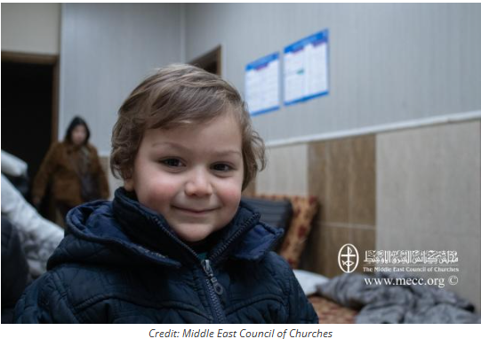
After the initial response, and after headlines fade away,
the emergency and urgency remain.
Published On: January 14, 2025
When we hear of a global emergency, our minds often jump to “How can we help?” Your gifts to Mission and Service enable partners to immediately get to work providing crucial basic needs: food, water, shelter, and medication. But after the initial response, and after headlines fade away, the emergency and urgency remain.
After the immediate shock fades, people living in the wake of a disaster can have difficulty imagining what life will look like down the road. In these times, hope is an essential, powerful force that gives us the motivation to move forward and inspires us to keep going.
Two years after the February 2023 earthquakes, people in Syria are still experiencing the devastating aftermath, exacerbated by civil war and other natural disasters. And Mission and Service partner the Middle East Council of Churches (MECC) continues to be hard at work providing hope. From retrofitting buildings and providing medical equipment to education and trauma healing, MECC is dedicated to sustainable relief. In Aleppo, MECC rehabilitated four schools before the academic year began in September 2023, providing children with a safe place to learn.
Thank you for supporting the work of our Mission and Service partners. Your generosity is a beacon of hope during challenging times.

A gift of belonging to a church is that the practice of gathering together for worship … to pray, sing, listen to scripture and share how God touches our lives – helps us grow in deeper relationship with God and each other. We are offering this practice of sharing beyond Sunday morning to deepen our connection. Each week you are offered a picture, a scripture and a question for contemplation, as well as a short reflection for you to contemplate, have conversation with people in your life and/or join an online conversation on our Rockwood Stone Facebook page.

