Contemplation and Conversation: 6th Sunday after Epiphany, February 16, 2025
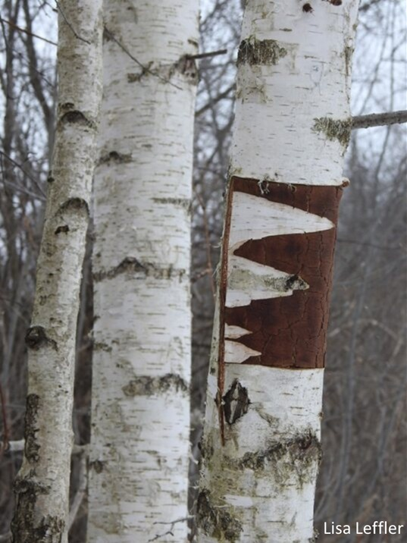
Scripture – Psalm 1 NRSVUE.
¹ Happy are those
who do not follow the advice of the wicked
or take the path that sinners tread
or sit in the seat of scoffers,
² but their delight is in the law of the Lord,
and on his law they meditate day and night.
³ They are like trees
planted by streams of water,
which yield their fruit in its season,
and their leaves do not wither.
In all that they do, they prosper.
⁴ The wicked are not so
but are like chaff that the wind drives away.
⁵ Therefore the wicked will not stand in the judgment
nor sinners in the congregation of the righteous,
⁶ for the Lord watches over the way of the righteous,
but the way of the wicked will perish.
From Rev. Heather Leffler
Psalm 1 invites us to choose a different path—to meditate on the law of the Lord day and night – rejecting the counsel of the wicked and the path of sinners. But how do we discern the right path?
It isn’t always easy to determine the way of the righteous. Throughout history – in both church and synagogue—many taught that wealth signified God's blessing. This belief can tempt us to prioritize our own families, friends, and church communities by preserving wealth and power for ourselves and those like us. When we invoke scripture and tradition to claim God’s favor, we risk isolating ourselves and living in constant fear of loss.
Jesus, however, turned this idea upside down. For Him, sin was not just breaking the Ten Commandments or succumbing to the seven deadly sins – it was turning our backs on community and our shared humanity. In Luke 6:17-26, the Beatitudes remind us that relying on wealth, fine food, personal happiness, and social status can place us outside God’s will. Instead, it is in building inclusive communities that we truly experience the kingdom.
I’m drawn to the image of the tree, ever in leaf and bearing fruit in its season. It reminds me that even when we faithfully follow Jesus’ path, the fruits of our labour may not be immediately visible. Yet we are called to care for God’s people and the earth, trusting that in God’s perfect timing, our actions will indeed bear fruit.
Contemplation and Conversation
When has helping someone in need been a blessing for you?
Prayer
Holy Mystery, you are indeed Wholly Love.
Thank you for the gift of your Son and the path he sets out for us.
Help us walk in your way and bear the fruits of love. Amen.

Further Conversation … Would you like to talk more about today’s reflection? Email Heather at hleffler@rogers.com.

Our Rockwood Stone Family
If you missed today’s worship service, visit our Rockwood Stone YouTube page.
This morning Heather shared a video of Archbishop Desmond Tutu speaking about Ubuntu which invites us to recognize our common humanity.
You may also be interested in the United Church Foundation’s video about the translation of the Bible into the Mohawk language we watched.

United Church of Canada
1921-1929
1921
- Canadian School of Missions begins (later the Ecumenical Forum) with the purpose to train people for overseas missions (Anglican, Methodist, Presbyterian, and later, Baptist).
1923
- At St. Paul's in Thunder Bay, ON, the General Council of the Presbyterian Church voted to join the Methodists and Congregationalists to form The United Church of Canada.
1925
- On June 10, in the Mutual St. Arena in Toronto, The United Church of Canada is formed by a union of Presbyterian, Methodist, Congregational, and the General Council of the Local Union Churches.
1925-26
- 1st General Council, Toronto, Ontario, Moderator: The Right Rev. George C. Pidgeon.
1926-28
- 2nd General Council, Montreal, Quebec, Moderator: The Right Rev. James Endicott.
1925-29
- Congregations, colleges, and offices of the uniting churches merge.
1928-30
- 3rd General Council, Winnipeg, Manitoba, Moderator: The Right Rev. William T. Gunn.
1929
- The Depression begins.

A gift of belonging to a church is that the practice of gathering together for worship … to pray, sing, listen to scripture and share how God touches our lives – helps us grow in deeper relationship with God and each other. We are offering this practice of sharing beyond Sunday morning to deepen our connection. Each week you are offered a picture, a scripture and a question for contemplation, as well as a short reflection for you to contemplate, have conversation with people in your life and/or join an online conversation on our Rockwood Stone Facebook page.

