Contemplation and Conversation: Transfiguration Sunday, March 2, 2025
Scripture – Exodus 34: 29-35 NRSVUE
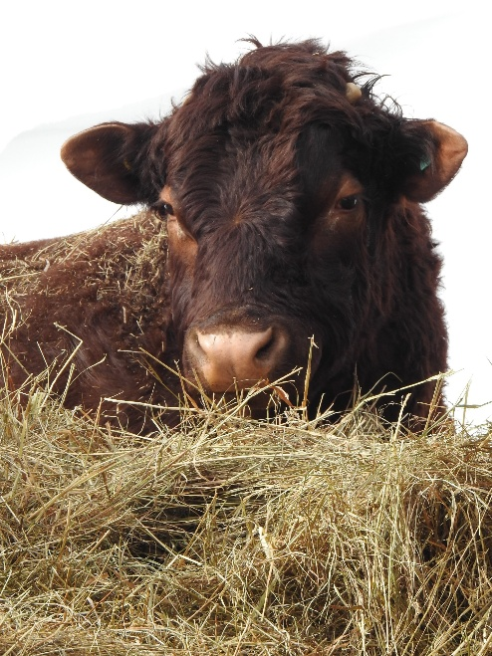
²⁹ Moses came down from Mount Sinai. As he came down from the mountain with the two tablets of the covenant in his hand, Moses did not know that the skin of his face shone because he had been talking with God. ³⁰ When Aaron and all the Israelites saw Moses, the skin of his face was shining, and they were afraid to come near him. ³¹ But Moses called to them, and Aaron and all the leaders of the congregation returned to him, and Moses spoke with them. ³² Afterward all the Israelites came near, and he gave them in commandment all that the Lord had spoken with him on Mount Sinai. ³³ When Moses had finished speaking with them, he put a veil on his face, ³⁴ but whenever Moses went in before the Lord to speak with him, he would take the veil off until he came out, and when he came out and told the Israelites what he had been commanded, ³⁵ the Israelites would see the face of Moses, that the skin of his face was shining, and Moses would put the veil on his face again until he went in to speak with him.
From Brian Mack
Imagine Moses experiencing God up close and personal for forty days and forty nights. As the prophet writes down the laws given to him by God, he did not eat or drink water for the entire time. His sole task was to record the Ten Commandments representing a new Covenant with the Holy One. In his humbleness, when he descends from the mountain, he is unaware that the skin on his face shone because of his being in the presence of the Creator.
The late Catholic theologian, Henri Nouwen, in his book entitled Discernment (p. 27), teaches us much about one way amongst many to enter into the presence of God. Like us, Nouwen often despaired as to whether he was hearing and experiencing God. For him, he found it helpful to pray slowly and out loud the uplifting words of Saint Teresa: “God alone is enough.” For Nouwen, he believed that praying these words helped him enter into God’s presence—a place of peace and a place of certainty that God is always with us and loves us.
In our communities of faith, we are exposed to many practices that help us to look for the essence of the Holy One in our everyday lives. For some, it may be to meditate quietly on a passage of scripture. For others, it may be to listen carefully to the words of a prayer or a favourite hymn. Others may feel the presence of God when they take Communion. Still others acknowledge the tug of the Spirit when they serve others. Sometimes we are surprised when we have an inkling of God while reading a book, watching a movie, walking in nature, or sharing an experience with a friend. By being open to God in everything we do, like Moses, we can experience the joy of being in the company of Holy Mystery who is Wholly love. Thanks be to God.
Contemplation and Conversation
How do you experience communion with the Spirit of God?
Prayer
Holy God, we give you thanks for the times when we have discerned your presence.
Help us to be even more open to the many signs in our lives that point us to
your wisdom, your guidance, and your love.
Amen

Further Conversation … Would you like to talk more about today’s reflection? Email Heather at hleffler@rogers.com.

Our Rockwood Stone Family
If you missed today’s worship service, you can watch it here: https://youtu.be/hOHViPeIekU
Please keep Edie and Jack Ward and the Turner family in your thoughts and prayers as they mourn the death of Lucille.

Sarah Eileen Leffler 1985 – 2025
Beloved daughter of Heather and John, and sister of Helen (Smith) and Lisa, Sarah was a much-loved aunt to John, William, and Henry Smith and their father, Robert; a dear cousin to Max and Emma Quickfall, Kelly Leffler and Dan Rooke; and a treasured niece of Rick Quickfall, Heather Godwin, and Rick and Sandie Leffler. She is remembered with love by many great-aunts, uncles, cousins, and friends. Sarah died at home on Tuesday, February 25, 2025 from a blood clot in her lung. Her family takes comfort in knowing she is reunited with her grandparents, Herb and Barb Quickfall, May and Jack Leffler, and her Uncle Phil Quickfall.
Sarah’s life, though not long enough, encompassed both gifts and challenges. In Grade 10, as part of the Community Environmental Leadership Program (CELP) at Norwell DSS, she designed and helped build a labyrinth for Rotary Park in Clifford. With the high school art program, she traveled to Italy, and she shared a special trip with her grandparents to visit dear family friends in Austria. Sarah’s time caring for her cousin’s daughter in the Bahamas turned into an adventure when they had to fly to Florida to dodge a hurricane.
Sarah’s deep faith and commitment to community shaped her life. She attended her first United Church General Council in Fergus at eight years old and later served as a commissioner to Councils in Wolfville, Thunder Bay, and Corner Brook. She was active in congregations in Bridgeport, Clifford, and Rockwood, and she took on leadership roles, including serving as Chairperson of Waterloo Presbytery. Sarah had been part of the Bridgeport Lions Club with her grandfathers and recently began helping with 9th Waterloo Beavers to be with her youngest nephew.
The heart of Sarah’s life was caring for children—her nephews, cousins, and the children of dear friends. She poured love into every moment with them, even while facing severe allergies, physical illness, and mental health struggles. No matter how she was feeling, she found joy in traditions and celebrations. She carved intricate pumpkins for Halloween, decorated enthusiastically for Christmas and other holidays, and was known for her delicious chocolate cake, chowders, and moussaka. She enjoyed helping make homemade apple sauce, dill pickles, and sauerkraut, and this year she created a very delicious hot sauce. Sarah delighted in finding matching pajamas for the kids, throwing epic Halloween parties at the farm, curating family photos for the Boettger calendar, and engaging in lively political debates.
Sarah saw herself as the keeper of family stories. She will be deeply missed by all whose lives she touched.
Visitation will be held at Parkminster United Church, 275 Erb St. E. Waterloo on Saturday, March 8, 2025 from 12 noon to 1:30 p.m.
The funeral service will take place at Parkminster United Church on Saturday, March 8, 2025 at 1:30 p.m., with Rev. Gord Dunbar officiating. A reception will immediately follow in the church hall.
The family would be grateful if those attending the visitation and funeral would refrain from scented products due to allergies.
A livestream and recording of the service will made available on Sarah’s tribute page at www.erbgood.com.
Cremation will have taken place and a private family interment will be held at a later date.
In lieu of flowers, condolences for the family and donations to Rockwood United Church, Mission and Service of The United Church of Canada, 9th Waterloo Scouting or a charity that is close to your heart would be appreciated and may be arranged through the Erb & Good Family Funeral Home, 171 King Street S. Waterloo at www.erbgood.com.

United Church of Canada
1940s
1940-42
- 9th General Council, Winnipeg, Manitoba, Moderator: The Right Rev. Aubrey S. Tuttle.
1940
- A Statement of Faith is published. By 1950, 75,000 copies are sold.
- Church retires Depression debt with war loan. "A loan to your country and a gift to your church."
1942-44
- 10th General Council, Belleville, Ontario, Moderator: The Right Rev. John R.P. Sclater.
1942
- United Church resists pressure to support conscription.
1943
- Anglicans in Canada mark their jubilee by inviting other denominations to union conversations. The United Church responds with willingness.
1944-46
- 11th General Council, London, Ontario, Moderator: The Right Rev. Jesse H. Arnup.
- A commission is appointed on the Christian Marriage and Christian Home.
1944
- The Catechism is published.
- United Church Publishing House renews agreement with Toronto Allied Printing Trades Council, allowing all eligible staff to become members of their respective unions.
- The Canadian Council of Churches is formed with the United Church a member.
1946-48
- 12th General Council, Montreal, Quebec, Moderator: The Right Rev. Thomas W. Jones. A commission is appointed on Canadian Culture.
1946
- A joint proposal from United and Anglican churches on mutual ministry is issued.
1948-50
- 13th General Council, Vancouver, British Columbia, Moderator: The Right Rev. Willard E. Brewing.
1948
- World Council of Churches is formed with the United Church a member.
- Church residential schools begin to close.

A gift of belonging to a church is that the practice of gathering together for worship … to pray, sing, listen to scripture and share how God touches our lives – helps us grow in deeper relationship with God and each other. We are offering this practice of sharing beyond Sunday morning to deepen our connection. Each week you are offered a picture, a scripture and a question for contemplation, as well as a short reflection for you to contemplate, have conversation with people in your life and/or join an online conversation on our Rockwood Stone Facebook page.

