Contemplation and Conversation: 1st Sunday of Lent, March 9, 2025
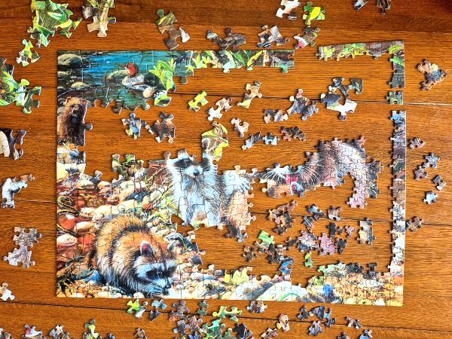
Scripture – 1 Corinthians 12:12-31 NRSVUE
¹² For just as the body is one and has many members, and all the members of the body, though many, are one body, so it is with Christ. ¹³ For in the one Spirit we were all baptized into one body—Jews or Greeks, slaves or free—and we were all made to drink of one Spirit.
¹⁴ Indeed, the body does not consist of one member but of many. ¹⁵ If the foot would say, “Because I am not a hand, I do not belong to the body,” that would not make it any less a part of the body. ¹⁶ And if the ear would say, “Because I am not an eye, I do not belong to the body,” that would not make it any less a part of the body. ¹⁷ If the whole body were an eye, where would the hearing be? If the whole body were hearing, where would the sense of smell be? ¹⁸ But as it is, God arranged the members in the body, each one of them, as he chose. ¹⁹ If all were a single member, where would the body be? ²⁰ As it is, there are many members yet one body. ²¹ The eye cannot say to the hand, “I have no need of you,” nor again the head to the feet, “I have no need of you.” ²² On the contrary, the members of the body that seem to be weaker are indispensable, ²³ and those members of the body that we think less honorable we clothe with greater honor, and our less respectable members are treated with greater respect, ²⁴ whereas our more respectable members do not need this. But God has so arranged the body, giving the greater honor to the inferior member, ²⁵ that there may be no dissension within the body, but the members may have the same care for one another. ²⁶ If one member suffers, all suffer together with it; if one member is honored, all rejoice together with it.
²⁷ Now you are the body of Christ and individually members of it. ²⁸ And God has appointed in the church first apostles, second prophets, third teachers, then deeds of power, then gifts of healing, forms of assistance, forms of leadership, various kinds of tongues. ²⁹ Are all apostles? Are all prophets? Are all teachers? Do all work powerful deeds? ³⁰ Do all possess gifts of healing? Do all speak in tongues? Do all interpret? ³¹ But strive for the greater gifts. And I will show you a still more excellent way.
From Brian Mack
On a recent visit to the Marden Public Library, I noticed that there were jigsaw puzzle pieces scattered on several tables. There were puzzles for toddlers, children, teens, and adults in various stages of completion. Seeing those puzzles brought back childhood memories of a time when puzzles were a popular form of recreation to amuse folks during long winter nights. Each person contributed to the finishing of the puzzle as they were able. Collective patience and perseverance, led to the completion of a beautiful scene and a tremendous sense of accomplishment. What a wonderful way to build community.
In the church at Corinth, the people were having trouble working together. Paul acknowledges that the church was blessed with people who possessed a wide variety of gifts. Unfortunately, the early church was filled with tension as to how these gifts should be used. There were quarrels over doctrine. There were divisions concerning church leadership. Jealousy and pettiness were in evidence as the contributions of some people were undervalued while others were overvalued.
Each of the pieces in a jigsaw puzzle are unique in their placement and function. All the pieces play a unique role in the completion of the scene depicted. If one piece is missing, the entire picture is ruined. Likewise, in the analogy used by Paul to portray the church as one body, each of the pieces of the body play a vital role. If a church is to avoid degenerating into a collection of individuals each pulling in a different direction, the diversity of gifts in a faith community must be recognized and harnessed. When one part of the body is missing or undervalued, the church is diminished. Our Rockwood-Stone affirming vision statement clearly acknowledges our approach: “We are committed to creating a space where the unique gifts and skills of each person are valued, lifted up, and shared in service of God, our communities, and the world.” Thanks be to God.
Contemplation and Conversation
What gifts have you been given to use in the service of God?
Prayer
Holy God, we thank you for each of the gifts granted to us by the Spirit.
May we use them wisely in our faith communities and in the wider world. Amen

Further Conversation … Would you like to talk more about today’s reflection? Email Heather at hleffler@rogers.com.

Our Rockwood Stone Family
If you missed today’s worship service, you can watch it here: https://youtu.be/9HgF5-7SlsQ

United Church of Canada
1950s
1950-52
- 14th General Council, Toronto, Ontario, Moderator: The Right Rev. Clarence M. Nicholson.
1950
- Reaffirmation of the 10th Anniversary Declaration on the 25th anniversary of church union.
1952-54
- 15th General Council, Hamilton, Ontario, Moderator: The Right Rev. Alexander A. Scott.
- General Council supports medicare and makes a de facto recognition of People's Republic of China.
- The decision is made to begin a New Curriculum.
- The Central Archives of the United Church are formally established, housed at Victoria University, Toronto.
1954-55
- 16th General Council, Sackville, New Brunswick, Moderator: The Right Rev. George Dorey.
1955-65
- Development of New Curriculum by the board of Christian Education (David Forsyth, Alvin Cooper, Frank Fidler) and the Board of Publication (Peter Gordon White, Wilbur K. Howard).
1956-58
- 17th General Council, Windsor, Ontario, Moderator: The Right Rev. James S. Thomson.
1958-60
- 18th General Council, Ottawa, Ontario, Moderator: The Right Rev. Angus J. MacQueen.
- United Church queries the Anglican Church on its wish to continue or withdraw its 1943 invitation; decision to continue.
1959
- General Council Executive approves the New Curriculum theological and educational presuppositions in November.

A gift of belonging to a church is that the practice of gathering together for worship … to pray, sing, listen to scripture and share how God touches our lives – helps us grow in deeper relationship with God and each other. We are offering this practice of sharing beyond Sunday morning to deepen our connection. Each week you are offered a picture, a scripture and a question for contemplation, as well as a short reflection for you to contemplate, have conversation with people in your life and/or join an online conversation on our Rockwood Stone Facebook page.

