Contemplation and Conversation
Creation Time 1 Sunday, September 13, 2020
Scripture: Matthew 18:21-35 https://www.biblegateway.com/passage/?search=Matthew%2018%3A21-35&version=NRSV
Contemplation and Conversation: Is there a place in your life where forgiveness could bring healing?
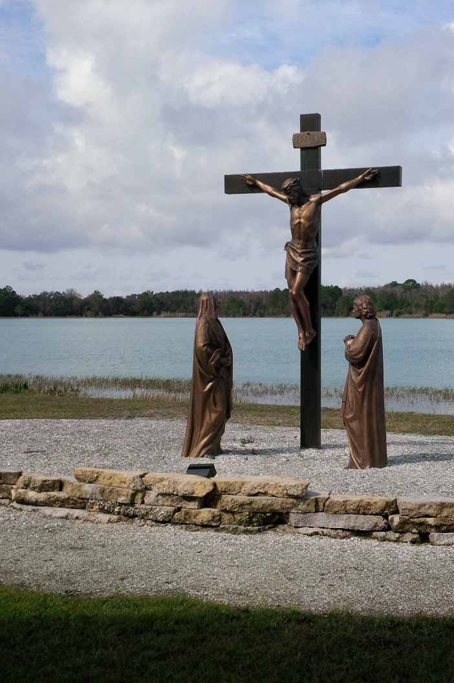
From Rev. Heather Leffler:
77 times – did Jesus really mean that we need to forgive each other 77 times? Most translations of this passage don’t just say 77 times, they say 70 times 7 or 490 times. Biblical scholars agree the number isn’t just huge – it means infinity. No matter what someone says or does that causes me to hurt, Jesus is asking me to forgive until we can be reconciled and love one another. How can that be when even the parable he shared seems to point to God punishing people who don’t forgive others?
When I look to the cross and remember Jesus asking God to forgive the people who crucified him, I know that he is asking me to forgive others and myself so that we can find healing. Drawing lines and saying after this many times I can’t forgive you is like “Survivor” and in the end leaves us alone. There are times when the offense continues, and people need to separate themselves from the offender to be safe, but what Jesus longs for us is to find ways to move past our differences to be in loving relationships. He is not saying God’s forgiveness is conditional when he asks us to pray, “forgive us our trespasses as we forgive each other”. He is telling us that to know the fullness of God’s love and forgiveness in our lives, we cannot hold on to things that separate us from each other.
Whether you are at home trying to help slow the spread of the virus,
working to help care for those who are impacted most by COVID-19
or working to keep some normalcy in this time,
may you know God’s deep and abiding love in your life.
Know you are a valued part of our Rockwood and Stone United Church families.

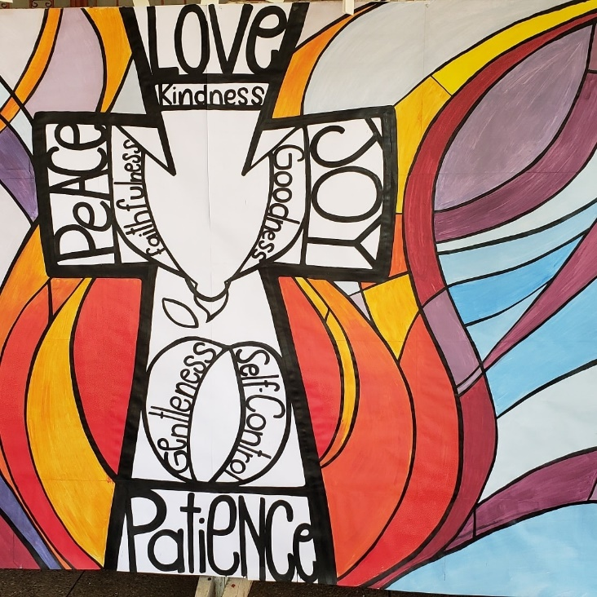
United Church of Canada
Posted by Moderator Richard Bott on Facebook, on September 5 at 4:51 pm
God of all places,
God of all times,
God of the certain and
God of the paradox -
help us to know that you are with us
as we wander this circuitous path.
Some of us will move through the doors
to physical places of sanctuary, tomorrow;
to join with others in our
community of faith, in prayer and praise,
in song and celebration.
Others of us will gather in virtual spaces,
where our hearts reach out to one another,
as we worship together, apart.
However we come together tomorrow,
it will be different.
Perhaps because of the changes
required for safety;
perhaps because of the changes
needed for this medium;
things will be... different.
Help us to see those changes as opportunity,
as possibility,
as wonder!
Help us to touch lightly on each other's grief,
each other's frustrations,
not knowing what will be missed,
one from another.
And, help us, O God,
to be people who take each other's safety seriously,
who act wisely and compassionately,
guided by your Spirit.
Where hands are washed,
and smiles are seen in peoples whole being;
where masks are worn,
and we sing with our hearts;
where physical distancing is practiced,
but, socially, we are never apart...
and remind us, please,
that where two or more are gathered in your Name,
you are –
bless us, we pray;
bless our communities, we pray;
bless your world, we pray.
Alleluia, loving God!
Alleluia, AMEN!
A gift of belonging to a church is that the practice of gathering together for worship … to pray, sing, listen to scripture and share how God touches our lives – helps us grow in deeper relationship to God and each other. With COVID-19 keeping us at home and physically distant from our Stone or Rockwood families, we are missing each other. We are offering this practice of sharing beyond Sunday morning to deepen our connection. Each week you will be offered a picture, a scripture and a question for contemplation, as well as a short reflection for you to contemplate, have conversation with people in your life and/or join an online conversation on our Rockwood Stone Facebook page.

