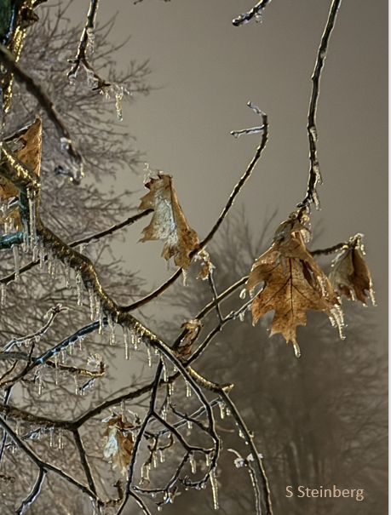
Contemplation and Conversation: 5th Sunday of Lent, April 6, 2025
Scripture – Psalm 126 NRSVUE
¹ When the Lord restored the fortunes of Zion,
we were like those who dream.
² Then our mouth was filled with laughter
and our tongue with shouts of joy;
then it was said among the nations,
“The Lord has done great things for them.”
³ The Lord has done great things for us,
and we rejoiced.
⁴ Restore our fortunes, O Lord,
like the watercourses in the Negeb.
⁵ May those who sow in tears
reap with shouts of joy.
⁶ Those who go out weeping,
bearing the seed for sowing,
shall come home with shouts of joy,
carrying their sheaves.
Let us worship the Holy One who is with us
in our sorrows and joys, in our tears and laughter.

From Rev. Heather Leffler
The Psalms are sacred songs and poems that give voice to the full range of human experience. In them, the people of Israel cry out to God in sorrow, sing with joy, give thanks, and question the suffering they endure. Addressed to God, these prayers remind us that God was with the people of Israel in every circumstance of life—and that God is with us too.
Psalm 126 is a song of memory and hope. It invites us to remember times when we experienced joy, when our mouths were filled with laughter and our hearts overflowed with gratitude. These memories sustain us in difficult seasons—when grief, anger, fear, or confusion threaten to cloud our view. In those moments, we are invited to bring our tears and troubles to God, trusting that the Spirit is still at work, sowing seeds of hope even in the hardest ground.
In times of uncertainty, when we wonder what the future holds, Psalm 126 reminds us that restoration is possible. Just as the people of Israel saw joy return after seasons of sorrow, we too can watch for signs of God’s renewing presence—in our own lives, in our communities, and in the world around us.
For me, one of the great gifts of being part of a church family is that we do not face these seasons alone. Together, we share our sorrows and joys, our tears and laughter. In this community, we offer each other comfort and strength, and together we learn to recognize the signs of God’s faithfulness and love.
Contemplation and Conversation
When in your life have you seen joy return after sorrow?
What signs of hope can you notice in your life or in the world today?
Prayer
God of Sorrow and Joy, thank you for the assurance that you are always with us.
When we are overwhelmed by grief or uncertainty, remind us of the joy we have known
and open our eyes to the signs of hope around us. Amen.

Further Conversation … Would you like to talk more about today’s reflection? Email Heather at hleffler@rogers.com.

Our Rockwood Stone Family
If you missed today’s worship service, you can watch it here: https://youtu.be/Nb0D9Mz29PA

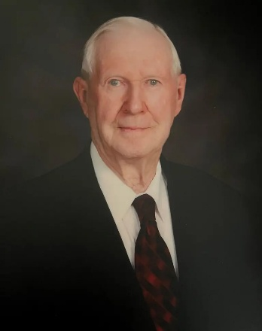
Ken M. Oakes
Sadly, we announce the peaceful passing of Ken Oakes on April 5th 2025, at the age of 98 and ¾.
Predeceased by his sister, Dorothy Comfort, and survived by his three nieces, Bev Comfort (Jim Craig), Sharon Fletcher, and Linda Myers (Bob).
At the age of 15, Ken was hired by Oustic Telephone Company. He worked his way up from digging holes for poles to repairing and installing some of the first phones in the county! He was also a farmer and hauled grain all over the province.
Ken, his friends, and family wish to thank the dedicated staff at Guelph General Hospital and Hospice Wellington, for the excellent care he received.
Visitation will be held at the WALL-CUSTANCE FUNERAL HOME & CHAPEL, 206 Norfolk St., Guelph, on Thursday, April 10 from 10:00 – 11:00am. Funeral service will begin at 11:00am in the funeral home chapel. Burial will be held at Memory Gardens.
In lieu of flowers, Ken requests donations be made to Hospice Wellington.
A tree will be planted in memory of Ken M. Oakes in the Wall-Custance Memorial Forest.

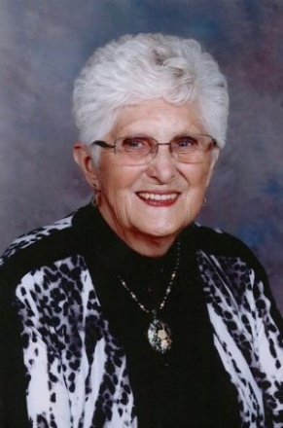
Duffield, Joyce Marilyn
It is with profound sadness that we announce the passing of our beloved mother, grandmother, great-grandmother, sister, and friend, Joyce Marilyn Duffield, who left us on April 2, 2025, in her 81st year. Born on August 23, 1944, Joyce was a woman whose selflessness, optimism, kindness, and generosity touched countless lives.
Predeceased by her best friend and soulmate, Wayne (April 2008). Joyce found her greatest joy in her family, whom she cherished above all else. She was a devoted mother to her sons and their wives: Steve and Colleen, John and Karen, and Mike and Stacey.
Her pride and joy were her grandchildren: Jake and Alexis, Julie, David, Dylan, and Charlotte, as well as her great-grandson Patrick. Joyce is survived by her loving sister Marion and George, and her brothers Norm and Bernice, Barrie and Kathy, Hugh and Leslie, and Brian and Wendy. She is also survived by her sisters-in-law Karen and Vera, and brother-in-law Murray and Marg. She was predeceased by her parents Bill and Doris Lindsay, her sister Shirley and Lloyd, and her brothers Bob and Jim. Joyce’s legacy lives on in the hearts of her many nieces, nephews, great-nieces and nephews, and great-great-nieces and nephews, all of whom she was so proud to call family.
She left an indelible mark on everyone she met, always finding the sunny side of life. Her love, laughter, and unwavering optimism will be dearly missed but never forgotten.
A celebration of Joyce’s life will be held at the WALL-CUSTANCE FUNERAL HOME & CHAPEL, 206 Norfolk St., Guelph on Monday, April 7, from 12:00 – 2:00pm. Service will begin at 2:00pm in the funeral home chapel. For those who are unable to attend but wish to watch the service remotely, you can access the YouTube link within Joyce’s obituary on the funeral home website. Arrangements entrusted to the WALL-CUSTANCE FUNERAL HOME & CHAPEL 519-822-0051 / www.wallcustance.com.
In lieu of flowers, donations can be made to Hospice Wellington, the Guelph Dialysis Unit and Stone United Church in her memory.
Her warmth and love will remain in our hearts forever.
A tree will be planted in memory of Joyce M. Duffield in the Wall-Custance Memorial Forest.

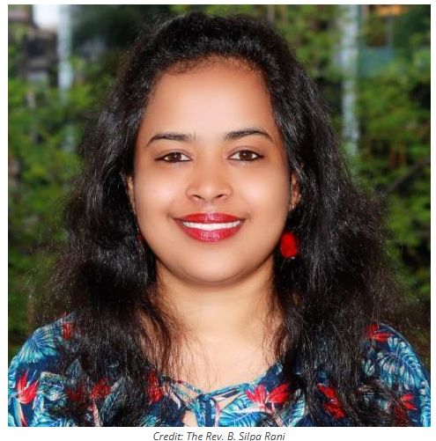
United Church of Canada – Working to empower women and change the world.
Published On: February 11, 2025
In India, social and cultural factors limit access to theological education for women in comparison to men. The Rev. B. Silpa Rani is actively encouraging women to pursue theological education and engage in leadership roles.
When Silpa started her first degree in Theology, she spent two years as the only woman in a class of 16. Now, years later, as she works on her doctoral dissertation, she has seen a gradual increase in the enrolment of women in theological programs. While this is encouraging, Silpa recognizes that there is still a long journey forward. While she seeks to empower modern women, she is also working to shed light on the experiences of women and minorities of the past.
Silpa was the recipient of a theological education scholarship, which paved her way to join the faculty at Bishop's College, Kolkata. She has been exploring the unique identity of the Qumran community within the context of the Dead Sea Scrolls. She is actively researching to identify the women, children, and minority groups of the society, drawing parallels between the Qumran context and contemporary Indian context.
Your Mission and Service gifts provide support to leaders like Silpa, who are actively working to empower women and change the world.

1980s
1980-82
- 28th General Council, Halifax, Nova Scotia, Moderator: The Right Rev. Lois M. Wilson.
- After reviewing the latest study on ministry, Project: Ministry, a General Council Sessional Committee concludes: "As a church we are still on our journey toward a more complete understanding of ministry."
1982-84
- 29th General Council, Montreal, Quebec, Moderator: The Right Rev. W. Clarke MacDonald.
1982
- In Lima, Peru, theologians associated with the World Council of Churches issue a joint document of considerable faith consensus, Baptism, Eucharist and Ministry, and find agreement to celebrate Lord's Supper together (the Lima Liturgy).
1984-86
- 30th General Council, Morden, Manitoba, Moderator: The Right Rev. Robert F. Smith.
1985
- Union talks between United Church and Disciples of Christ end.
1986-88
- 31st General Council, Sudbury, Ontario, Moderator: Dr. Anne M. Squire.
- General Council ends South African investments.
- General Council apologizes to Native congregations of the United Church for past denial of Native spirituality.
1988-90
- 32nd General Council, Victoria, British Columbia, Moderator: The Right Rev. Sang Chul Lee.
- The All Native Circle Conference is inaugurated.
- General Council declares that "all persons, regardless of sexual orientation, who profess their faith in Jesus Christ are welcome to be or become members of The United Church of Canada" and that "all members of the United Church are eligible to be considered for ordered ministry."

A gift of belonging to a church is that the practice of gathering together for worship … to pray, sing, listen to scripture and share how God touches our lives – helps us grow in deeper relationship with God and each other. We are offering this practice of sharing beyond Sunday morning to deepen our connection. Each week you are offered a picture, a scripture and a question for contemplation, as well as a short reflection for you to contemplate, have conversation with people in your life and/or join an online conversation on our Rockwood Stone Facebook page.

