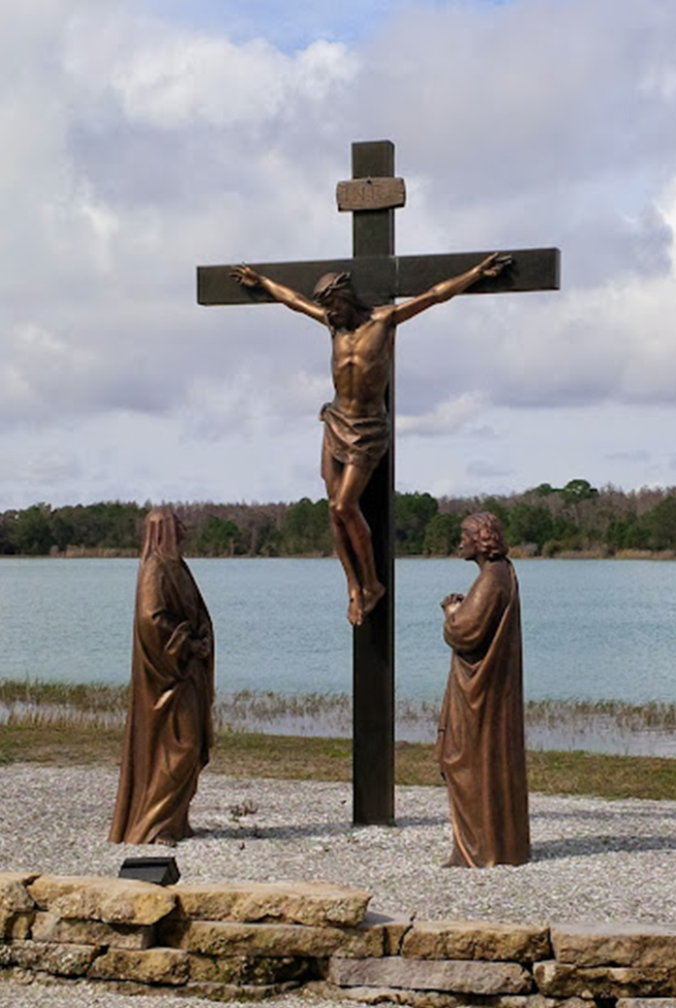
Contemplation and Conversation: Palm/Passion Sunday, April 13, 2025
Scripture – Philippians 2:5-11
⁵ Let the same mind be in you that was in Christ Jesus,
⁶ who, though he existed in the form of God,
did not regard equality with God
as something to be grasped,
⁷ but emptied himself,
taking the form of a slave,
assuming human likeness.
And being found in appearance as a human,
⁸ he humbled himself
and became obedient to the point of death—
even death on a cross.
⁹ Therefore God exalted him even more highly
and gave him the name
that is above every other name,
¹⁰ so that at the name given to Jesus
every knee should bend,
in heaven and on earth and under the earth,
¹¹ and every tongue should confess
that Jesus Christ is Lord,
to the glory of God the Father.
From Rev. Heather Leffler
As we enter into Holy Week, Paul’s words in Philippians 2:5-11 call us to adopt the same mind that was in Christ Jesus. Though he was in the form of God, Jesus did not cling to status or power. Instead, he emptied himself—choosing humility, vulnerability, and full solidarity with humanity.
Jesus didn’t just appear to be human; he became one of us. From birth to death, he shared in our human experience – in joy and in sorrow, in laughter and in tears, in pain and in beauty. He walked roads filled with hope and heartbreak.
Because he has walked where we walk, we can trust that he understands us completely. Whether we are grieving or grateful, struggling or rejoicing, Jesus meets us where we are. He is our companion in the darkest valleys and on the highest hills.
Jesus can be a friend who listens without judgment, a shepherd who guides us gently, a teacher who opens our hearts to wisdom, a healer who mends what is broken, a Saviour who redeems us in love.
Even when words fail us or when no one else seems to understand, Jesus remains—present, patient, and faithful.
Contemplation and Conversation
Who is Jesus for you today?
What do I need from him right now—and what might he be offering me?
Prayer
As we enter Holy Week, open our hearts to see you more clearly,
follow you more faithfully
and trust that you understand our spoken and unspoken prayers. Amen.

Further Conversation … Would you like to talk more about today’s reflection? Email Heather at hleffler@rogers.com.

Our Rockwood Stone Family
If you missed today’s worship service, you watch it here: https://youtu.be/rDS6E9wS87Q
Thank you to Julie Martin Jansen from Hospice Wellington for leading us through a time of self-care, learning how to recognize and prevent caregiver fatigue: https://youtu.be/vMTYYt4_Gk0

United Church of Canada
1990s
1990-92
- 33rd General Council, London Ontario, marks 65 years of the United Church. Moderator: The Right Rev. Walter H. Farquharson.
1992-94
- 34th General Council, Fredericton, New Brunswick elects The Right Rev. Stan McKay, a Native Canadian, as Moderator.
1994-97
- 35th General Council, Fergus, Ontario celebrates Church Fair Day; Moderator: Dr. Marion Best.
- The Healing Fund is established to help First Nations communities respond to the painful legacy of residential schools.
- In March 1995, the General Council Office moves from 85 St. Clair Ave. East, Toronto, to rented facilities at 3250 Bloor St. West.
- The Ethnic Ministries Council is officially inaugurated in June 1996.
- A new hymn book, Voices United, is published in 1996.
1997-1999
- 36th General Council in Camrose, Alberta, elects The Right Rev. Bill Phipps as Moderator.
- In October 1997, comments made by Bill Phipps in conversation with a newspaper editorial board spark a heated national debate over the divinity of Jesus.
- In October 1998, The United Church of Canada offers an apology to former students of United Church Indian Residential Schools.

A gift of belonging to a church is that the practice of gathering together for worship … to pray, sing, listen to scripture and share how God touches our lives – helps us grow in deeper relationship with God and each other. We are offering this practice of sharing beyond Sunday morning to deepen our connection. Each week you are offered a picture, a scripture and a question for contemplation, as well as a short reflection for you to contemplate, have conversation with people in your life and/or join an online conversation on our Rockwood Stone Facebook page.

