Contemplation and Conversation: 2nd Sunday of Easter, April 27, 2025
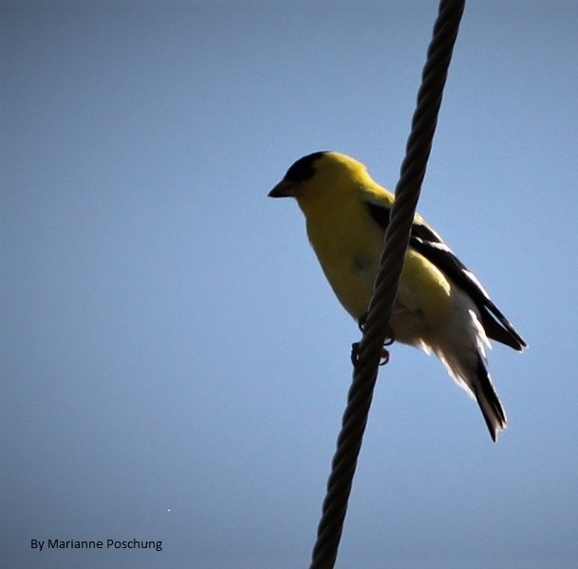
Scripture – Psalm 150 NRSVUE
¹ Praise the Lord!
Praise God in his sanctuary;
praise him in his mighty firmament!
² Praise him for his mighty deeds;
praise him according to his surpassing greatness!
³ Praise him with trumpet sound;
praise him with lute and harp!
⁴ Praise him with tambourine and dance;
praise him with strings and pipe!
⁵ Praise him with clanging cymbals;
praise him with loud clashing cymbals!
⁶ Let everything that breathes praise the Lord!
Praise the Lord!
From Rev. Heather Leffler
One of the great gifts of community is the ability to sing together. Whether songs of joy and praise, laments of sadness, or hymns that tell the stories of our faith, singing has the power to draw us closer to each other and to God. It lifts our spirits, offers comfort, and gives voice to feelings too deep for words.
I remember learning a wonderful phrase attributed to St. Augustine: "To sing is to pray twice." Singing is not only a form of worship; it brings many blessings to our physical and emotional health. A quick search reminds us that singing improves respiratory function, boosts the immune system, reduces stress, enhances cognitive abilities, and, when done together, builds a sense of connection and community.
Hearing our choirs on Palm Sunday and Easter, and the combined choir at Barrie Hill on Good Friday, touched me deeply. Singing with you each Sunday fills my heart with joy. After the isolation of the pandemic, I found it hard to sing at first, but slowly, song by song, my voice and spirit have returned. With the songs comes a deep gratitude for all the people I have sung with, and for the gift that we can continue to sing together.
It is no surprise that the most recent statement of faith from our church is called A Song of Faith. It ends with these beautiful words:
Grateful for God’s loving action,
we cannot keep from singing.
Creating and seeking relationship,
in awe and trust,
we witness to Holy Mystery who is Wholly Love.
Contemplation and Conversation
When has singing — whether alone or with others — helped you feel more connected to God, to yourself, or to the people around you?
Prayer
Holy Mystery, you are Wholly Love. Thank you for the gift of music and singing.
Thank you for the way songs bring us joy, comfort, and hope.
Help us to lift our voices to praise you,
in happy times and in hard times.
Let our songs remind us that we are never alone,
and that your love is always with us.
Amen.

Further Conversation … Would you like to talk more about today’s reflection? Email Heather at hleffler@rogers.com.

Our Rockwood Stone Family
If you missed today’s worship service, you can watch it here: https://youtu.be/SVE259EmVfU

Pope Francis, who has died aged 88, made his final public appearance on Easter Sunday at the Vatican's St Peter's Square.
After wishing the gathered crowd of more than 20,000 a happy Easter, he indicated that Archbishop Diego Ravelli, master of liturgical ceremonies, would read a message he had written.
Here is the full text of his final public address, as released by the Vatican.
"Christ is risen, alleluia!
Dear brothers and sisters, Happy Easter!
Today at last, the singing of the 'alleluia' is heard once more in the Church, passing from mouth to mouth, from heart to heart, and this makes the people of God throughout the world shed tears of joy.
From the empty tomb in Jerusalem, we hear unexpected good news: Jesus, who was crucified, 'is not here, he has risen' (Lk 24:5). Jesus is not in the tomb, he is alive!
Love has triumphed over hatred, light over darkness and truth over falsehood. Forgiveness has triumphed over revenge. Evil has not disappeared from history; it will remain until the end, but it no longer has the upper hand; it no longer has power over those who accept the grace of this day.
Sisters and brothers, especially those of you experiencing pain and sorrow, your silent cry has been heard and your tears have been counted; not one of them has been lost!
In the passion and death of Jesus, God has taken upon himself all the evil in this world and in his infinite mercy has defeated it. He has uprooted the diabolical pride that poisons the human heart and wreaks violence and corruption on every side. The Lamb of God is victorious! That is why, today, we can joyfully cry out: 'Christ, my hope, has risen!' (Easter Sequence).
The resurrection of Jesus is indeed the basis of our hope. For in the light of this event, hope is no longer an illusion. Thanks to Christ — crucified and risen from the dead — hope does not disappoint! Spes non confundit! (cf. Rom 5:5). That hope is not an evasion, but a challenge; it does not delude, but empowers us.
All those who put their hope in God place their feeble hands in his strong and mighty hand; they let themselves be raised up and set out on a journey. Together with the risen Jesus, they become pilgrims of hope, witnesses of the victory of love and of the disarmed power of Life.
Christ is risen! These words capture the whole meaning of our existence, for we were not made for death but for life. Easter is the celebration of life! God created us for life and wants the human family to rise again! In his eyes, every life is precious! The life of a child in the mother's womb, as well as the lives of the elderly and the sick, who in more and more countries are looked upon as people to be discarded.
What a great thirst for death, for killing, we witness each day in the many conflicts raging in different parts of our world! How much violence we see, often even within families, directed at women and children! How much contempt is stirred up at times towards the vulnerable, the marginalised, and migrants!
On this day, I would like all of us to hope anew and to revive our trust in others, including those who are different than ourselves, or who come from distant lands, bringing unfamiliar customs, ways of life and ideas! For all of us are children of God!
I would like us to renew our hope that peace is possible! From the Holy Sepulchre, the Church of the Resurrection, where this year Easter is being celebrated by Catholics and Orthodox on the same day, may the light of peace radiate throughout the Holy Land and the entire world.
I express my closeness to the sufferings of Christians in Palestine and Israel, and to all the Israeli people and the Palestinian people. The growing climate of anti-Semitism throughout the world is worrisome. Yet at the same time, I think of the people of Gaza, and its Christian community in particular, where the terrible conflict continues to cause death and destruction and to create a dramatic and deplorable humanitarian situation.
I appeal to the warring parties: call a ceasefire, release the hostages and come to the aid of a starving people that aspires to a future of peace!
Let us pray for the Christian communities in Lebanon and in Syria, presently experiencing a delicate transition in its history. They aspire to stability and to participation in the life of their respective nations. I urge the whole Church to keep the Christians of the beloved Middle East in its thoughts and prayers.
I also think in particular of the people of Yemen, who are experiencing one of the world's most serious and prolonged humanitarian crises because of war, and I invite all to find solutions through a constructive dialogue.
May the risen Christ grant Ukraine, devastated by war, his Easter gift of peace, and encourage all parties involved to pursue efforts aimed at achieving a just and lasting peace.
On this festive day, let us remember the South Caucasus and pray that a final peace agreement between Armenia and Azerbaijan will soon be signed and implemented, and lead to long-awaited reconciliation in the region.
May the light of Easter inspire efforts to promote harmony in the western Balkans and sustain political leaders in their efforts to allay tensions and crises, and, together with their partner countries in the region, to reject dangerous and destabilising actions.
May the risen Christ, our hope, grant peace and consolation to the African peoples who are victims of violence and conflict, especially in the Democratic Republic of the Congo, in Sudan and South Sudan. May he sustain those suffering from the tensions in the Sahel, the Horn of Africa and the Great Lakes region, as well as those Christians who in many places are not able freely to profess their faith.
There can be no peace without freedom of religion, freedom of thought, freedom of expression and respect for the views of others.
Nor is peace possible without true disarmament! The requirement that every people provide for its own defence must not turn into a race to rearmament.
The light of Easter impels us to break down the barriers that create division and are fraught with grave political and economic consequences. It impels us to care for one another, to increase our mutual solidarity, and to work for the integral development of each human person.
During this time, let us not fail to assist the people of Myanmar, plagued by long years of armed conflict, who, with courage and patience, are dealing with the aftermath of the devastating earthquake in Sagaing, which caused the death of thousands and great suffering for the many survivors, including orphans and the elderly. We pray for the victims and their loved ones, and we heartily thank all the generous volunteers carrying out the relief operations.
The announcement of a ceasefire by various actors in the country is a sign of hope for the whole of Myanmar.
I appeal to all those in positions of political responsibility in our world not to yield to the logic of fear which only leads to isolation from others, but rather to use the resources available to help the needy, to fight hunger and to encourage initiatives that promote development. These are the 'weapons' of peace: weapons that build the future, instead of sowing seeds of death!
May the principle of humanity never fail to be the hallmark of our daily actions. In the face of the cruelty of conflicts that involve defenceless civilians and attack schools, hospitals and humanitarian workers, we cannot allow ourselves to forget that it is not targets that are struck, but persons, each possessed of a soul and human dignity.
In this Jubilee year, may Easter also be a fitting occasion for the liberation of prisoners of war and political prisoners!
Dear brothers and sisters,
In the Lord's Paschal Mystery, death and life contended in a stupendous struggle, but the Lord now lives forever (cf. Easter Sequence). He fills us with the certainty that we too are called to share in the life that knows no end, when the clash of arms and the rumble of death will be heard no more. Let us entrust ourselves to him, for he alone can make all things new (cf. Rev. 21:5)!
Happy Easter to everyone!"

United Church of Canada
2010s
2010
- On January 17, 2010, Moderator Mardi Tindal issues an open letter to Canadians calling on them to consider climate change a crisis of conscience.
- The United Church launches an emergency appeal designated for earthquake relief and reconstruction in Haiti. More than $3 million is raised.
- Flour is collected from all 13 Conferences so congregations can celebrate communion on the church's 85th anniversary by sharing a common loaf.
- Moderator Mardi Tindal boards the train on the first leg of travelling to all 13 Conferences using as much “green friendly” transportation as possible.

A gift of belonging to a church is that the practice of gathering together for worship … to pray, sing, listen to scripture and share how God touches our lives – helps us grow in deeper relationship with God and each other. We are offering this practice of sharing beyond Sunday morning to deepen our connection. Each week you are offered a picture, a scripture and a question for contemplation, as well as a short reflection for you to contemplate, have conversation with people in your life and/or join an online conversation on our Rockwood Stone Facebook page.

