Contemplation and Conversation
5th Sunday of Easter, May 18, 2025
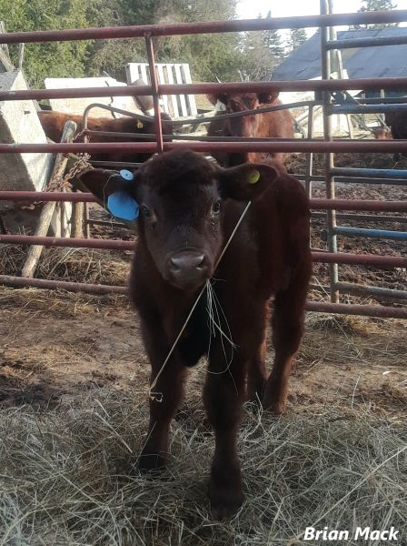
Scripture – Psalm 148 NRSVUE

¹ Praise the Lord!
Praise the Lord from the heavens;
praise him in the heights!
² Praise him, all his angels;
praise him, all his host!
³ Praise him, sun and moon;
praise him, all you shining stars!
⁴ Praise him, you highest heavens
and you waters above the heavens!
⁵ Let them praise the name of the Lord,
for he commanded and they were created.
⁶ He established them forever and ever;
he fixed their bounds, which cannot be passed.
⁷ Praise the Lord from the earth,
you sea monsters and all deeps,
⁸ fire and hail, snow and frost,
stormy wind fulfilling his command!
⁹ Mountains and all hills,
fruit trees and all cedars!
¹⁰ Wild animals and all cattle,
creeping things and flying birds!
¹¹ Kings of the earth and all peoples,
princes and all rulers of the earth!
¹² Young men and women alike,
old and young together!
¹³ Let them praise the name of the Lord,
for his name alone is exalted;
his glory is above earth and heaven.
¹⁴ He has raised up a horn for his people,
praise for all his faithful,
for the people of Israel who are close to him.
Praise the Lord!
From Brian Mack
In contemporary worship, Psalm 148 is easily adapted for use as a call to worship or as a responsive reading. It also serves as a personal call to praise God on a daily basis. Doing so allows us to strengthen our relationship with the Holy One as we more fully appreciate nature, relationships, and the many blessings in life.
When I started reading and re-reading this psalm in preparation for writing this commentary, I was sitting outside. It was just after supper on a warm, spring evening. I was surrounded by the sights, smells, and sounds of God’s creation. White billowy clouds were set against a beautiful blue sky. While a fox barked in the distance, I could hear the closer sounds of cattle chomping on their hay. Starlings darted in an out of their nesting places as did the newly arrived swallows. In the rustling grass, mice scurried back and forth close to my feet. Following a beautiful sunset, evening shadows began to appear as the stars and the moon emerged. Several rabbits cautiously crept from their topsy turvy warren. Frogs could be heard chirping from both a neighboring farm and from my creek that runs just below the house. A mother raccoon cautiously came into view and turned over a stone looking for a morsel of sustenance. Smells of new life were all around me, as the fragrance of fresh grass and emerging lilacs, became evident in the stillness of the night. Tall cedars and a solitary maple tree swayed gently in the wind further reminding me of God’s presence.
As the splendor of my surroundings engulfed me, I saw through a new lens that everything from the stars to the smallest of creatures reflects God’s glory. All of creation is called to exalt Holy Mystery who is Wholly Love. Thanks be to God.
Contemplation and Conversation
When has an experience with nature led you to a sense of awe, gratitude, or spiritual reflection?
Prayer
Holy One, we give thanks for your Creation.
May our experiences in nature help us to grow in our relationship with you. Amen
Further Conversation … Would you like to talk more about today’s reflection? Email Heather at hleffler@rogers.com.

Our Rockwood Stone Family
If you missed today’s worship service, you can watch it here: https://youtu.be/jbMnzKN-I0Q

United Church of Canada
2013
- The United Church marks the 25th anniversary of The United Church of Canada’s landmark 1988 decision declaring that sexual orientation should not be a barrier to becoming a United Church minister.
- United Church launches the Unsettling Goods: Choose Peace in Palestine and Israel campaign.
- United Church says a National Inquiry into missing and murdered Aboriginal women and girls is needed.
- The United Church of Canada’s Toronto-based Archives moves from the General Council Office to the Toronto Christian Resource Centre at 40 Oak Street, Toronto.
2014
- Moderator Gary Paterson joins other Canadian faith leaders to express deep concern about what is happening to religious minorities in the city of Mosul, Iraq.
- The United Church of Canada joins 348 global institutional investors in signing an investor statement on climate change ahead of the United Nations’ Climate Summit.
- United Church expresses deep concern over provisions in the Conservative government’s Bill C-43 that could lead to newly arrived refugees being deprived of social assistance.
- United Church calls for its members to sign a pledge for medicare.
2015
- The 42nd General Council meets in Corner Brook, Newfoundland and Labrador and elects Rev. Jordan Cantwell as Moderator.
- The 42nd General Council voted to sell the church’s investment holdings in the 200 largest fossil fuel companies.
- Representatives of The United Church of Canada and the United Church of Christ (USA) gathered in Niagara Falls, Ontario, to sign a historic Full Communion Agreement.

A gift of belonging to a church is that the practice of gathering together for worship … to pray, sing, listen to scripture and share how God touches our lives – helps us grow in deeper relationship with God and each other. We are offering this practice of sharing beyond Sunday morning to deepen our connection. Each week you are offered a picture, a scripture and a question for contemplation, as well as a short reflection for you to contemplate, have conversation with people in your life and/or join an online conversation on our Rockwood Stone Facebook page.

