Contemplation and Conversation: Sunday after Pentecost, June 8, 2025
Scripture – Acts 2:1-21 NRSVUE
¹ When the day of Pentecost had come, they were all together in one place. ² And suddenly from heaven there came a sound like the rush of a violent wind, and it filled the entire house where they were sitting. ³ Divided tongues, as of fire, appeared among them, and a tongue rested on each of them. ⁴ All of them were filled with the Holy Spirit and began to speak in other languages, as the Spirit gave them ability.
⁵ Now there were devout Jews from every people under heaven living in Jerusalem. ⁶ And at this sound the crowd gathered and was bewildered, because each one heard them speaking in the native language of each. ⁷ Amazed and astonished, they asked, “Are not all these who are speaking Galileans? ⁸ And how is it that we hear, each of us, in our own native language? ⁹ Parthians, Medes, Elamites, and residents of Mesopotamia, Judea and Cappadocia, Pontus and Asia, ¹⁰ Phrygia and Pamphylia, Egypt and the parts of Libya belonging to Cyrene, and visitors from Rome, both Jews and proselytes, ¹¹ Cretans and Arabs—in our own languages we hear them speaking about God’s deeds of power.” ¹² All were amazed and perplexed, saying to one another, “What does this mean?” ¹³ But others sneered and said, “They are filled with new wine.”
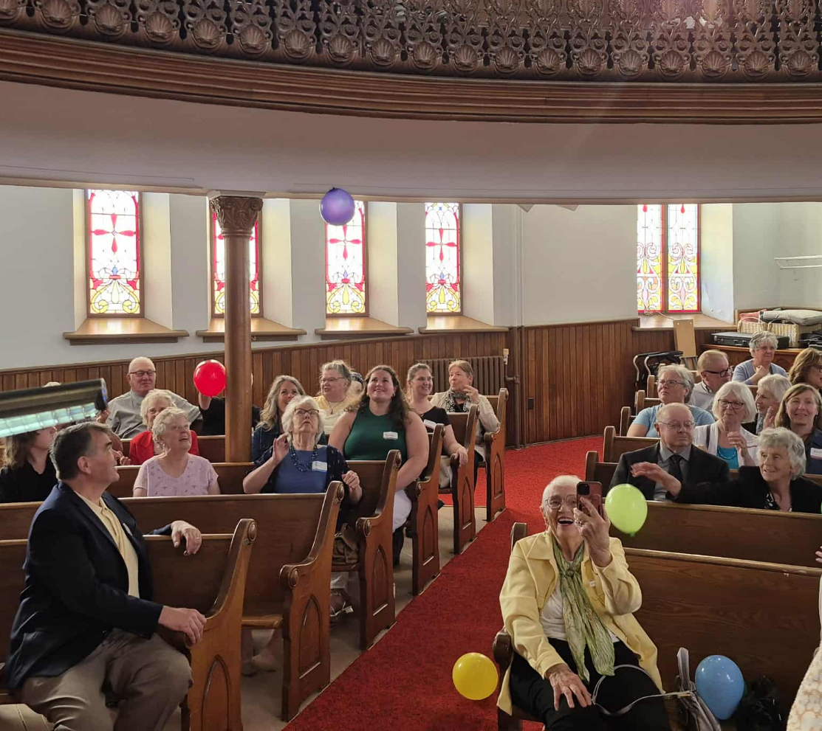
¹⁴ But Peter, standing with the eleven, raised his voice and addressed them, “Fellow Jews and all who live in Jerusalem, let this be known to you, and listen to what I say. ¹⁵ Indeed, these are not drunk, as you suppose, for it is only nine o’clock in the morning. ¹⁶ No, this is what was spoken through the prophet Joel:
¹⁷ ‘In the last days it will be, God declares,
that I will pour out my Spirit upon all flesh,
and your sons and your daughters shall prophesy,
and your young men shall see visions,
and your old men shall dream dreams.
¹⁸ Even upon my slaves, both men and women,
in those days I will pour out my Spirit,
and they shall prophesy.
¹⁹ And I will show portents in the heaven above
and signs on the earth below,
blood, and fire, and smoky mist.
²⁰ The sun shall be turned to darkness
and the moon to blood,
before the coming of the Lord’s great and glorious day.
²¹ Then everyone who calls on the name of the Lord shall be saved.’
From Rev. Heather Leffler
What a day! Fifty days after Jesus’ resurrection, on the day of Pentecost, the disciples were gathered in one place. Suddenly, the house was engulfed by the sound of a violent, rushing wind. Tongues of fire rested on each of them, and they began to speak in different languages—so that everyone present could understand the Good News in their own tongue.
There was incredible energy as Peter stood and boldly quoted the prophet Joel, proclaiming that God’s Spirit would be poured out on all people—young and old, women and men, rich and poor. Knowing the Holy Spirit was with them the disciples were ready to go into the world and share the Good News.
Pentecost is often called the birthday of the church—the moment when the Word began to be spoken in new ways to God’s people and to the Gentiles alike. It was the birth of a church that would preach and teach, that would stand up for people of every race, ability, gender, and sexual orientation. A church that would split, stumble, make mistakes—and apologize, heal, and begin again. Always, it is the church loved into being by Jesus—the Word made flesh—called to bring healing and hope to each generation and to every corner of creation.
Thank you to everyone who joined in the joyful celebration of the 100th Anniversary of The United Church of Canada at Melville United Church in Fergus this Pentecost Sunday. Just as the Spirit filled the disciples with new energy and courage, our worship was filled with that same Spirit—flowing through our singing, laughter, applause, and the joyful chaos of balloons and children’s hands signing We Are the Church.
I am the church. You are the church. We are the church together. In this anniversary year, may we be inspired by the courage of the disciples to go into a world that does not know Jesus as we do, and to share the Good News—so others may be part of a church that *celebrates God’s presence, lives with respect in Creation, loves and serves others, seeks justice, resists evil, and proclaims Jesus, crucified and risen, our judge and our hope.
*from a New Creed
Contemplation and Conversation
Where is the Spirit pushing you to speak, act, or witness in a new way—
so that others might hear and experience God’s love in a language they understand?
Prayer
Holy Mystery, you are Wholly Love. As we celebrate the 100th Anniversary of our church,
*we offer worship as an outpouring of gratitude and awe,
and as a practice of opening ourselves to your still,
small voice of comfort and your rushing whirlwind of challenge.
Through word, music, art, and sacrament, in community and in solitude,
God change our lives, our relationships, and our world. Amen.
*from a Song of Faith

Further Conversation … Would you like to talk more about today’s reflection? Email Heather at hleffler@rogers.com.

Our Rockwood Stone Family
If you missed today’s worship service of our 100th Anniversary Celebration at Melville United here: https://www.youtube.com/live/dF18-ySh4R0?si=Bhq_WgnhoWgo6uSd
Join the National Centennial Service at 5:30 pm (or watch it later) here: https://www.youtube.com/live/bh4sW1kdpWo?si=jtsh1bzhG81gAX6h

United Church of Canada
2018
- The church and Affirm United launch Iridesce: The Living Apology Project to help the church discern if and how it might live into a possible apology to the church’s LGBTQ and Two-Spirit people.
- The United Church of Canada and the United Church of Christ USA commit to the United Nations International Decade for People of African Descent, which runs 2015–2024.
- Moderator Jordan Cantwell joins ecumenical leaders in urging the Government of Canada to pass legislation ensuring that the laws of Canada are in harmony with the UN Declaration on the Rights of Indigenous Peoples.
- The 43rd General Council meets in Oshawa, Ontario, and elects the Right Rev. Dr. Richard Bott as Moderator.
- The 43rd General Council enacts seven remits, including one that establishes a new three-council model that creates 16 new regional councils to replace Conferences and presbyteries.
- Conference offices and presbyteries close on December 31, 2018.
2019
- A major restructuring of the church is implemented, including a new funding model that includes pastoral charge assessments, a new Office of Vocation, and a new Candidacy Pathway.
- The House of Commons unanimously passes amendments to The United Church of Canada Act on April 2.
- The church confirms that people entering ministry must be in essential agreement with the Statement of Doctrine.
- The church continues its commitment to seeking reconciliation and a peaceful resolution of the crisis on the Korean peninsula and opposes UN sanctions on North Korea.
- The Christian Church (Disciples of Christ) and The United Church of Canada enter into a Full Communion Agreement.
- In August, Indigenous members establish a National Indigenous Organization—consisting of a National Indigenous Council and a National Elders Council—as a step toward a self-determining Indigenous Church within The United Church of Canada.
- A United Church delegation attends the UN Climate Negotiations (COP25) in Madrid in December.
2020s
2020
- The COVID-19 pandemic forces the closure of the General and regional council offices and churches across Canada.
- Communities of faith, camps, and community ministries find amazing ways of reaching people despite physical distancing.
- Following the horrific death of George Floyd in Minneapolis and widespread Black Lives Matter protests, the proposal “Towards an Anti-Racist Denomination” is referred to the General Council Executive to begin initiatives to rid the church of bias and racism.
- In October, General Council 43 commissioners vote to become an anti-racist church. An Anti-Racist and Equity Officer staff position is created in the General Council Office.
- GC43 commissioners vote to postpone General Council 44 from July 2021 to July 2022 because of concerns around COVID-19. The Moderator and Executive agree to stay on for an additional year.
- The Rev. Michael Blair is appointed General Secretary after Nora Sanders retires.
- United Property Resource Corporation is launched to meet the need for professional real estate development and management expertise for communities of faith and non-profits across Canada.
- The church advocates for a guaranteed livable income in Canada, a need that becomes even more apparent during the COVID-19 pandemic.
- The United Church apologizes for its role in separating mothers and their babies in maternity homes it operated from the end of World War II to 1980.
2021
- The church launches a campaign to support communities in the Global South struggling with the effects of the COVID pandemic and to buy vaccines for those communities.
- In May, the remains of 215 children are found in unmarked graves on the grounds of the former Kamloops Residential School in BC, the first in a number of horrific discoveries. To honour the children who did not return home from its 15 residential schools, the United Church creates the Bringing the Children Home initiative.
- United Church Publishing House announces the website launch for Then Let Us Sing!, an online music portal that will make all of the United Church’s hymn resources available in one digital location and under one copyright licence.
- A United Church delegation attends the UN Climate Negotiations (COP26) virtually, and the church signs on to a new Canadian Investor Statement on Climate Change as a member of the Responsible Investment Association, pledging to manage their assets in promoting a transition to a low-carbon economy.
- In October, General Council 43 adopts the Call and Vision, which reflects what the church aspires to be over a 5- to 10-year span.
- The church also adopts the 2022‒2025 Strategic Plan of the General Council Office.
2022
- General Council 44, the first virtual meeting of the council in the church’s history, is held via several sessions between February and August.
- With a large percentage of Canadians vaccinated against COVID-19, communities of faith and United Church offices gradually open to in-person gatherings.
- GatheringWorship.ca, an extension of Gathering magazine’s almost 50-year presence, is launched.
- The United Church condemns Russia’s invasion of Ukraine and launches a major appeal to support Ukrainian refugees.
- The Very Rev. Bill Phipps, 36th Moderator, 1997‒2000, dies in March.
- Alberta Billy, the We Wai Kai Elder who demanded that The United Church of Canada apologize for its role in colonization and the loss of Indigenous languages, culture, and spirituality, dies in June.
- The Right Rev. Dr. Carmen Lansdowne is elected the 44th Moderator.
2023
- The Intercultural and Intentionally Anti-Racist statement is added to the Declarations section of The Manual.
- General Council 44 renounces all claims to former United Church of Canada mission properties in the Democratic People’s Republic of Korea (North Korea) in solidarity with The Presbyterian Church in the Republic of Korea.

A gift of belonging to a church is that the practice of gathering together for worship … to pray, sing, listen to scripture and share how God touches our lives – helps us grow in deeper relationship with God and each other. We are offering this practice of sharing beyond Sunday morning to deepen our connection. Each week you are offered a picture, a scripture and a question for contemplation, as well as a short reflection for you to contemplate, have conversation with people in your life and/or join an online conversation on our Rockwood Stone Facebook page.

