Contemplation and Conversation
2nd Sunday after Pentecost, June 22, 2025

Scripture – Luke 8:26-39 NRSVUE
²⁶ Then they arrived at the region of the Gerasenes, which is opposite Galilee. ²⁷ As he stepped out on shore, a man from the city who had demons met him. For a long time he had not worn any clothes, and he did not live in a house but in the tombs. ²⁸ When he saw Jesus, he cried out and fell down before him, shouting, “What have you to do with me, Jesus, Son of the Most High God? I beg you, do not torment me,” ²⁹ for Jesus had commanded the unclean spirit to come out of the man. (For many times it had seized him; he was kept under guard and bound with chains and shackles, but he would break the bonds and be driven by the demon into the wilds.) ³⁰ Jesus then asked him, “What is your name?” He said, “Legion,” for many demons had entered him. ³¹ They begged him not to order them to go back into the abyss.
³² Now there on the hillside a large herd of swine was feeding, and the demons begged Jesus to let them enter these. So he gave them permission. ³³ Then the demons came out of the man and entered the swine, and the herd stampeded down the steep bank into the lake and was drowned.
³⁴ When the swineherds saw what had happened, they ran off and told it in the city and in the country. ³⁵ Then people came out to see what had happened, and when they came to Jesus, they found the man from whom the demons had gone sitting at the feet of Jesus, clothed and in his right mind. And they became frightened. ³⁶ Those who had seen it told them how the one who had been possessed by demons had been healed. ³⁷ Then the whole throng of people of the surrounding region of the Gerasenes asked Jesus to leave them, for they were seized with great fear. So he got into the boat and returned. ³⁸ The man from whom the demons had gone out begged that he might be with him, but Jesus sent him away, saying, ³⁹ “Return to your home, and declare how much God has done for you.” So he went away, proclaiming throughout the city how much Jesus had done for him.
From Brian Mack
The story of the demon possessed individual, as recorded by Luke, needs to be considered in context. It is part of a larger narrative in which the disciples also encounter a severe storm, a woman who continually haemorrhages, and the corpse of a young girl. In each scenario, Jesus is present to the disciples.
Imagine the consternation of the disciples when they encountered the strange man on the eastern shore of the Sea of Galilee. Luke provides a vivid description of an individual who was
- Naked and could not bear to have clothing touch his skin
- Unhoused and living amongst the tombs associated with the dead
- Often bound with chains and kept under guard only to periodically find the strength to throw off his restraints and escape to the desert
- Called Legion for the unimaginable number of demons that possessed his body (a Roman legion consisted of 3000-6000 men)
- Inhabited by unclean spirits who openly resisted the command of Jesus to “come out” for fear of being cast into the abyss
Although we do not generally use the phrase “demon possessed” today, it is not hard to look around and see people who are likewise suffering from the relentless torment of despair in mind, body, and spirit. This suffering is not peculiar to just an individual. In the world of 2025, we are collectively conflicted by economic turmoil, political strife, and a sense of foreboding that we are hurtling toward self destruction. In the midst of trouble, we can bury our heads in the sand, cry “woe us me”, or even give up and be active participants in perpetuating the evils of the world.
As believers in a higher power, however, we can choose a different path – to prayerfully reflect on the lessons that Christ was teaching the disciples through exposing them to difficult situations. Jesus was present to his followers and through his example gave them hope. Through faith, Christ is present with us today and offers us that same comfort and hope. As Christians, our task is to heed the command given by Jesus to the man who was rescued from his torment: “Return to your house and describe what great things God has done for you.” Thanks be to God.
Contemplation and Conversation
What resonates most with you from this story of the transformation
of a demon possessed individual?
Prayer
Holy God, we give you thanks for the stories of Jesus and the disciples as recorded by Luke.
May we read these stories involving times of trouble with new insight.
Grant us the peace and understanding that comes with the knowledge
that Jesus is ever present to us. Amen.

Further Conversation … Would you like to talk more about today’s reflection? Email Heather at hleffler@rogers.com.

Our Rockwood Stone Family
If you missed today’s worship service, visit our Rockwood Stone YouTube page.

United Church of Canada
100 Years of Spirit and Song
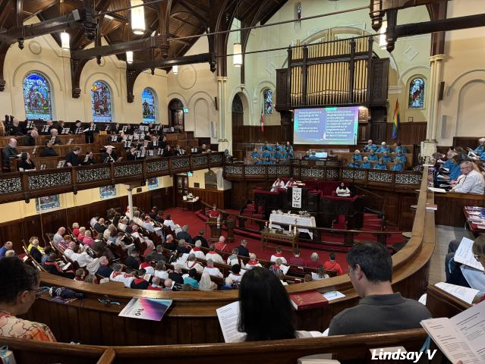
Published On: June 17, 2025

On Sunday, June 8th, Gower Street United Church in St. John’s, Newfoundland and Labrador, was alive with joyful celebration. The sanctuary buzzed with warm greetings, laughter, and the unmistakable hum of love and connection as people gathered to mark The United Church of Canada’s 100th anniversary. Many more joined the festivities via livestream(opens in a new tab), sharing in the spirit of the day from near and far.
It was a celebration of history, community, and hope. Guests admired the church’s beautiful historic architecture, an ideal setting for such a milestone. The choir, along with the Gower Community Band Bell Choir, filled the space with soul-stirring music that brought both tears and smiles. Liturgical dancers brought Pentecost flames to life, their movements echoing the Spirit’s energy and presence.
Moderator The Right Rev. Dr. Carmen Lansdowne and General Secretary Rev. Michael Blair presided at the service, and The Rev. Prof. Dr. Jerry Pillay, General Secretary of the World Council of Churches, offered a stirring message calling the church to remain rooted in deep spirituality, bold discipleship, and daring justice.
Thanks to your gifts to Mission and Service, vibrant ministries continue to thrive, offering not only worship and music, but hospitality, outreach, and a strong voice for love and justice in their communities.
Your support helps carry this legacy forward. Thank you for being part of the story. Here’s to the next hundred years, together.

A gift of belonging to a church is that the practice of gathering together for worship … to pray, sing, listen to scripture and share how God touches our lives – helps us grow in deeper relationship with God and each other. We are offering this practice of sharing beyond Sunday morning to deepen our connection. Each week you are offered a picture, a scripture and a question for contemplation, as well as a short reflection for you to contemplate, have conversation with people in your life and/or join an online conversation on our Rockwood Stone Facebook page.

