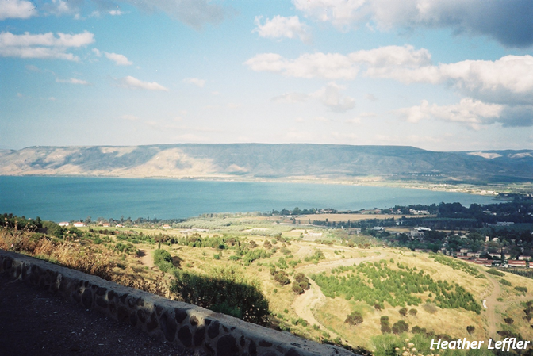
Contemplation and Conversation: 4th Sunday after Pentecost, July 6, 2025
Scripture – Psalm 66:1-9 NIV
¹ Shout for joy to God, all the earth!
² Sing the glory of his name;
make his praise glorious.
³ Say to God, “How awesome are your deeds!
So great is your power
that your enemies cringe before you.
⁴ All the earth bows down to you;
they sing praise to you,
they sing the praises of your name.”[
⁵ Come and see what God has done,
his awesome deeds for mankind!
⁶ He turned the sea into dry land,
they passed through the waters on foot—
come, let us rejoice in him.
⁷ He rules forever by his power,
his eyes watch the nations—
let not the rebellious rise up against him.
⁸ Praise our God, all peoples,
let the sound of his praise be heard;
⁹ he has preserved our lives
and kept our feet from slipping.
From Rosslyn Bentley
It might not be a surprise that I would choose to comment on a passage that reminds us to “Sing the glory of his name”: every week in choir I feel inspired to worship God through music. But exercising my lungs, letting my body vibrate with sound – these are simple tasks compared to those who needed Gods help to literally survive.
Escaping from Egypt, the Israelites looked like their journey was already at an end on the shores of the Red Sea. The idea of parting the waves and being able to walk across the seabed has always fascinated me: that is truly an incredible image. God of the Old Testament has this vastness and makes expressions of power that saved nations. How awe inspiring and incredible! Such expressions of power would be pretty hard to ignore and yet we know the Israelites go on to make many mistakes and missteps almost as if they have forgotten the mighty wielding of power to allow them to be lifted up. I can’t help but think how this sense of being the chosen people has come down to Israel of our modern era and yet the abuse of power we see today in Gaza.
The Psalm reminds us that God does have the power to do incredible things but its up to us to provide thanks and to be inspired to do the right things ourselves in response.

Contemplation and Conversation
How does God inspire you to give thanks? How might you witness your appreciation so that others might be moved to hear and experience God’s inspiration too?
Prayer
God of all creation, you guide our steps and hold us fast when the path is uncertain.
We offer you our thanks and praise, hearts open and lives willing to follow you.
Let your love move through us, reaching the world with hope. Amen

Further Conversation … Would you like to talk more about today’s reflection? Email Heather at hleffler@rogers.com.

Our Rockwood Stone Family
If you missed today’s worship service, you can watch it here: https://youtu.be/I-V6nlnbYAs

United Church of Canada
100 Words of Hope: Resilient by Grace
Something interesting happens as we age. We’ve gathered experiences that younger people have just started to accumulate. Experience softens the sharp edges of crisis. It prepares us for the unimaginable.
Our adaptation muscles are strong. We can say, with confidence, “this too shall pass.” It isn’t a lack of caring or abandonment; it’s a shortening of the shock and a faster ability to roll up the sleeves.
The church has seen 2,000 years of surprises. Let us situate ourselves in that wisdom and do the work that needs to be done. United in hope, with love and care for one another.
—Éric Hébert-Daly, Executive Minister for Eastern Ontario Outaouais, Nakonha:ka, East Central Ontario regional councils
Find more 100 Words of Hope reflections: https://united-church.ca/blogs/round-table
We encourage you to share your own "100 Words of Hope" (prayers, poems, or reflections): https://ow.ly/4lqn50VsQSP
#UCCan #DeepBoldDaring #100WordsofHope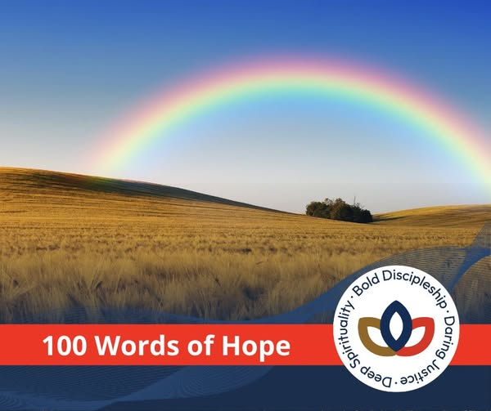

A gift of belonging to a church is that the practice of gathering together for worship … to pray, sing, listen to scripture and share how God touches our lives – helps us grow in deeper relationship with God and each other. We are offering this practice of sharing beyond Sunday morning to deepen our connection. Each week you are offered a picture, a scripture and a question for contemplation, as well as a short reflection for you to contemplate, have conversation with people in your life and/or join an online conversation on our Rockwood Stone Facebook page.

