Contemplation and Conversation: 4th Sunday after Pentecost, July 13, 2025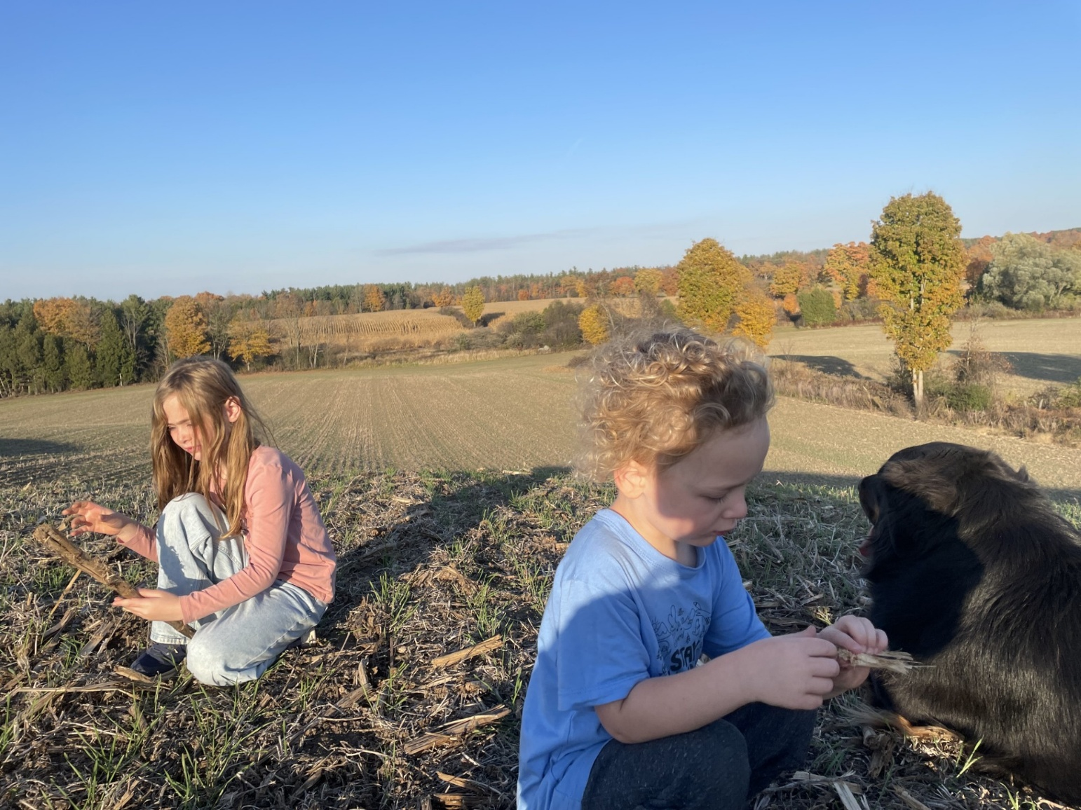
Scripture – Deuteronomy 30:9-14 NRVUEV
⁹ and the Lord your God will make you abundantly prosperous in all your undertakings, in the fruit of your body, in the fruit of your livestock, and in the fruit of your soil. For the Lord will again take delight in prospering you, just as he delighted in prospering your ancestors, ¹⁰ when you obey the Lord your God by observing his commandments and decrees that are written in this book of the law, because you turn to the Lord your God with all your heart and with all your soul.
¹¹ “Surely, this commandment that I am commanding you today is not too hard for you, nor is it too far away. ¹² It is not in heaven, that you should say, ‘Who will go up to heaven for us and get it for us so that we may hear it and observe it?’ ¹³ Neither is it beyond the sea, that you should say, ‘Who will cross to the other side of the sea for us and get it for us so that we may hear it and observe it?’ ¹⁴ No, the word is very near to you; it is in your mouth and in your heart for you to observe.
From Barb Parker
In Deuteronomy, Moses gives important instructions to the people of Israel to help prepare and encourage them, as they get ready to cross the Jordon and enter the land God promised them. It is not a chapter that I am very familiar with, especially if compared to the exciting events of Exodus (better described by Rosslyn last week as “awe inspiring and incredible”); I confess I have never stayed awake long enough to see the end of “The Ten Commandments” in the many times I have watched that movie, so I don’t know what emphasis, if any, that “media” puts on Moses’s final words of wisdom, and his blessings to the Tribes of Israel.
The scripture details the conditions of the covenant God made with his chosen people … a simple, attainable “quid pro quo”, if you will, on the abundant life blessings they would receive if they fully loved God, and obeyed God’s commandments and laws. Simple yes, but history and life show us many examples where this was/is much easier said than done.
God wants his people to succeed; Moses wanted his people to succeed. We, as parents and grandparents, want our children and grandchildren to succeed; to choose well in those decisions that will set the direction of their lives; also to choose to be “good”, and “do good” with their fellow human beings.
Reading and contemplating this passage also led me to think about the concept of “blessings”. Webster’s Dictionary descriptions for blessings, include the “bestowal of Divine, favour, grace” …a” gift of Nature”… a “solemn wish expressed by a human being for another”. It gives examples of both giving and asking a blessing.
Rev. Heather regularly extends us “Blessings” in her emails and cards. One of my favourite lines in the movie “Fiddler on the Roof” is where Motel the tailor asks the Rabbi, “Rabbi, is there a blessing for a sewing machine?” The Rabbi answered “There is a blessing for everything.” There is also the House Blessing George and Mary Bailey’s friends give in “It’s a Wonderful Life”, “Bread, that this house may never know hunger. Salt, that life may always have flavour. And wine, that joy and prosperity may reign forever.” We have many hymns which incorporate the word “blessing”. At Eden Mills UC we regularly held a Summer Service of Blessings of the Fields and Gardens, at our farm. Parents may be asked for their blessing on the proposed marriage of their children. I recall a special time when I asked our Minister to perform a House Blessing, when our son moved into the farm house he would then share with his grandparents, and later his future family. He became the 7th generation to live in the farmhouse and work the land, and his children are now the 8th. That legacy is indeed a blessing!
God’s promised blessing of prosperity, children, abundant livestock and a land of their own, would all have been very important to the Israelites, given their history as slaves, and their long journey to the Promised Land. Today, living in Canada is a “blessing” for most, providing many opportunities for the enjoyment of family, home, community and employment. How much, if any, do we recognize the importance of God to our life’s successes and challenges, and the blessings we enjoy?
Contemplation and Conversation
Do you “count your blessings”? Do you stop and thank God for your blessings?
Do you think God’s covenant with the Israelites applies to us in these times?
Prayer
God of the past, our present and our future. We thank you for the blessings of this day, the hope of tomorrow, and for your abiding love. Guide us to live a life that reflects your love and blessings. Amen

Further Conversation … Would you like to talk more about today’s reflection? Email Heather at hleffler@rogers.com.

Our Rockwood Stone Family
If you missed today’s worship service, you can watch it here: https://youtu.be/jCKBbh3ytdw
In Offering Praise we reflected on the song Forgiveness by Matthew West. To respect copyright it was removed from the worship video but you can watch it here: https://www.youtube.com/watch?v=oIbCpy0CQEo&t=157s

United Church of Canada
On Friday, August 8, The United Church of Canada will offer a somber and historic apology to Two Spirit and LGBTQIA+ communities. This service acknowledges the deep and lasting harm caused by the church, both in the past and still today. It's a difficult but necessary step towards healing and reaffirming our commitment to radical inclusion.
We invite you to join us in person at Knox United Church in Calgary (9:00 a.m. MT) or online for the Zoom event.
The United Church of Canada was the first major denomination in Canada to affirm the full inclusion of LGBTQIA+ persons into the life of the church. While the 1988 decision was significant, there are still many painful stories of exclusion from before 1988, and that continue into the present.
By formally apologizing, the United Church reaffirms its commitment to radical hospitality and full inclusion of 2S and LGBTQIA+ people in all aspects of church life, including leadership, worship, and governance, strengthening the church’s witness to justice and love in action.
The road has not been smooth, and the church has not always accepted 2S and LGBTQIA+ people. The living apology is one way to acknowledge the many shortcomings and the harm the church has caused, while also continuing to build toward a world of radical love and affirming people of all identities.
Find out more and make plans to join us in-person or on-line: https://united-church.ca/.../apology-2s-and-lgbtqia...
#UCCan #UCCanGC45


A gift of belonging to a church is that the practice of gathering together for worship … to pray, sing, listen to scripture and share how God touches our lives – helps us grow in deeper relationship with God and each other. We are offering this practice of sharing beyond Sunday morning to deepen our connection. Each week you are offered a picture, a scripture and a question for contemplation, as well as a short reflection for you to contemplate, have conversation with people in your life and/or join an online conversation on our Rockwood Stone Facebook page.

